SUBCOURSE EDITION
IT0345 A

US ARMY INTELLIGENCE CENTER

BOOLEAN
SIMPLIFICATION,
VEITCH DIAGRAMS

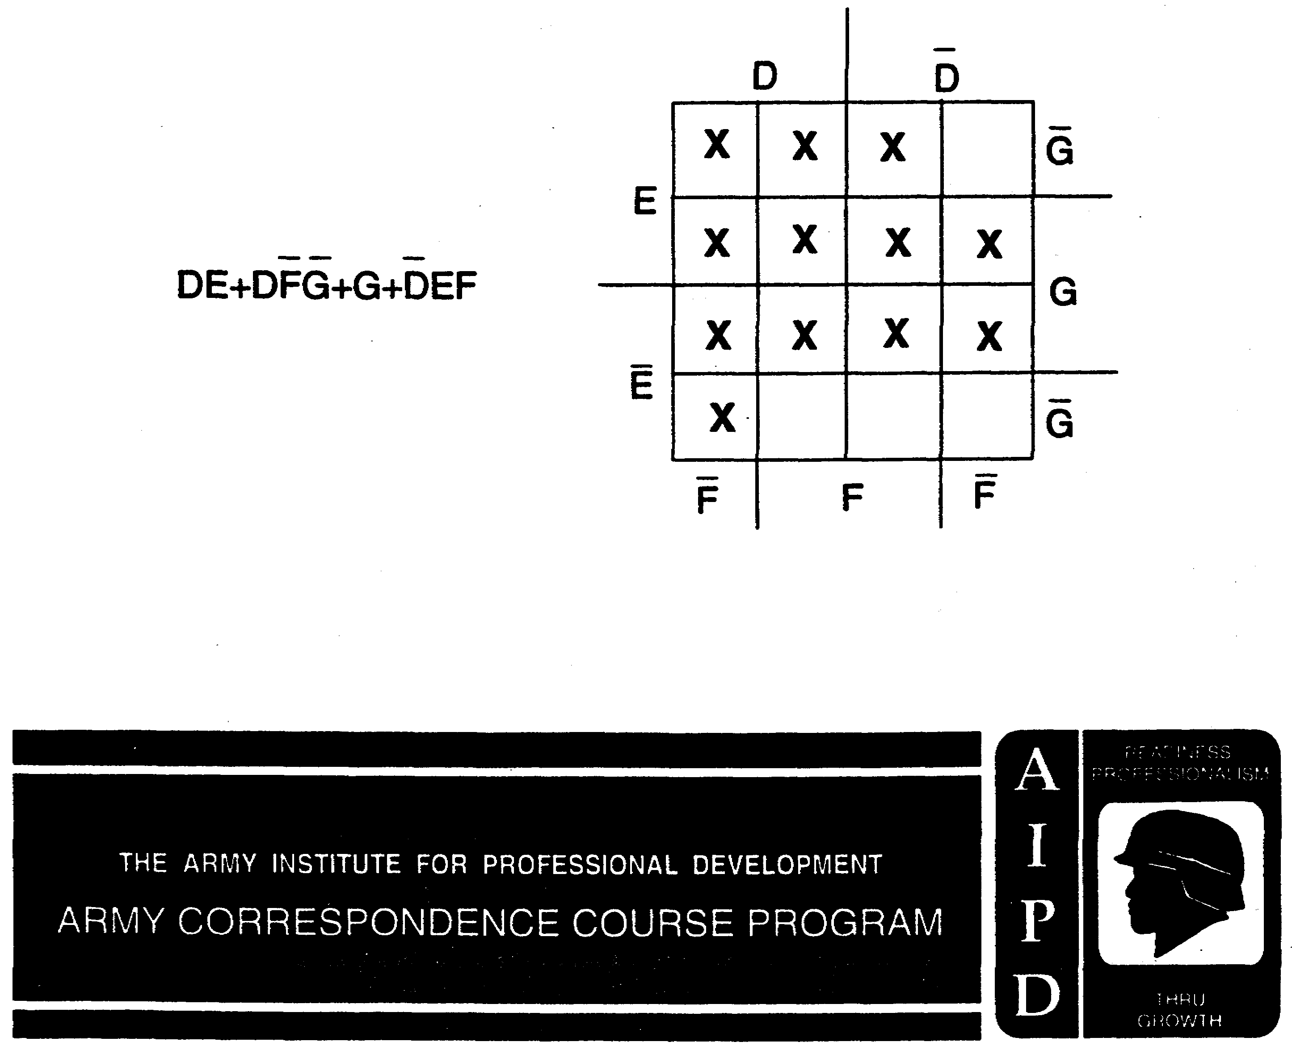

BOOLEAN SIMPLIFICATION, VEITCH DIAGRAMS

Subcourse Number IT0345

EDITION A

U.S. ARMY INTELLIGENCE CENTER
FORT HUACHUCA, AZ 85613-6000

5 Credit Hours

Edition Date: January 1997

SUBCOURSE OVERVIEW

This subcourse is designed to teach you how to simplify Boolean expressions using Veitch diagrams.

Subcourses IT 0342, IT 0343 and IT 0344 are prerequisites for this subcourse.

This lesson replaces SA 0715.

TERMINAL LEARNING OBJECTIVE

ACTION: Simplify Boolean expressions by reducing the expressions to minterm form, plot the resulting expressions in Veitch diagrams, and extract the simplified expressions from the Veitch diagrams.

CONDITION: Given Boolean expressions with up to four variables.

STANDARD: To demonstrate competency of this task, you must achieve a minimum of 70% on the subcourse examination.

i IT0345

TABLE OF CONTENTS

Section Page

Subcourse Overview i

Lesson: Veitch diagrams 1-1

Basic Laws and Common Identities 1-70

Student Inquiry Sheet

IT0345 ii

LESSON

BOOLEAN SIMPLIFICATION, VEITCH DIAGRAMS

OVERVIEW

LESSON DESCRIPTION:

Upon completion of this lesson, you will be able to simplify Boolean expressions using Veitch diagrams.

TERMINAL LEARNING OBJECTIVE:

ACTION: Simplify Boolean expressions.

CONDITION: Given the information in this lesson.

STANDARD: To demonstrate competency of this task, you must achieve a minimum of 70% on the subcourse examination.

INTRODUCTION

This lesson is designed in the frame format. Throughout the lesson, the pages are normally divided into two sections. The left section is the answer/response section, and the right section is the lesson section. In the left section, the answer for the previous frame (if required) is printed there. In addition to the normal layout, some frames have a detailed explanation and answer, and the answer/response section indicates the pages for the detailed answers.

Veitch Diagrams are an additional tool to simplify Boolean expressions. Some people have a difficult time reducing Boolean expressions using just mathematics, and after using Veitch diagrams, they understand the reduction process more clearly. From the instructional point of view, you may be able to use the Veitch diagram method to help a soldier learn other methods of reducing Boolean expressions.

1-1 IT0345

1. Veitch diagrams provide a quick-and-easy way for simplifying Boolean expressions. A Veitch diagram is a system of squares on which a given Boolean expression is plotted in order to arrive at the simplest form of the expression.
Veitch diagrams are used to____________ Boolean expressions.

simplify 2. A MINTERM is defined as "the Boolean product of a number of variables." No OR operations are contained in a minterm, but all the given variables must be included.
If there are three variables, A, B, and C, the following are three possible minterms: CAB, ABC, ACB. If there are four variables, L, M, N, and X, the following are three possible minterms: LMNX, XMLN, NLMX.
If there are five variables, X, Y, Z, P, and D, which of the following are minterms?

a. X+Y+Z+P+D f. DPZXY

b. ZYPXD g. X+XYZPD

c. YZPX h. XY+D(P+Z)

d. YP+XZD I. ZDP XY

e. XYZPD J. YPZDX

IT0345 1-2

b. 3. A system of squares, known as a Veitch
e. diagram, is used to____________________
f. ____________________expressions.
i.
j.

simplify 4. A MINTERM-TYPE TERM is a minterm with one or
Boolean more of its variables missing. For example, for the four variables R, S, T, and A, each of the following is a minterm-type term: RST, SA, S., ART, A, RT, RAT, etc.
For the four variables P, D, Q, and T, select the minterms and the minterm-type terms by placing a checkmark in the appropriate column.

MINTERM MINTERM-TYPE
TERM

a. Q ____ ____
b. PDT ____ ____
c. PQ ____ ____
d. PDQT ____ ____
e. TQDP ____ ____
f. PD(QT) ____ ____
g. QPTD ____ ____
h. QT ____ ____

1-3 IT0345

MINTERM MINTERM- 5. Which of the following are minterms
TYPE representing the variables A, B, C, and D?
TERM
d. a. a. ABCD
e. b. b. A+B+CD
f. c. c. A(B+CD)
g. h. d. DCAB
e. BACD
f. CDAB

a. 6. An expression in MINTERM FORM is composed
d. entirely of minterms, minterm-type terms, or
e. both, connected with OR signs-but does not
f. contain parentheses, vinculum which extend over more than one variable, or more than one vinculum over any one variable. For example, AB+CDE+ F G , H+K +J, CD+N, GI+R+LS, and XYZ+ZY+X are expressions in minterm form.
Which of the following expressions are in minterm form?

a. XY+RST+V d. LMN+MN+LL
b. P+A+X e. PDQ+PQ
c. N(A+X+C) f. EFRX+EFRX+FREX

IT0345 1-4

a. 7. An expression is not in minterm form until all vincula extending over more than one
variable are broken, all parentheses have
been removed, and any variable which has more
than one vinculum over it has had the extra vincula removed.
Which of the following expressions are in minterm form?
a. R+ST+A d. XC+P+D
b. YZ+LMN+B e. AB+CDE+ABCDE
c. PQ+AB+CDE f. RJFB+FBJR+F(B+J+R)

b. 8. Which of the following are minterm-type terms
c. representing variables V, W, X, Y, and Z?
e. a. VW+Y f. VZ
b. XYZV g. X(Y+ZW)
c. WX+Y(Z+W) h. VWXYZ
d. W i. XWYZ
e. YZW j. X

b. 9. TEST FRAME
d. State the reason for using Veitch diagrams.
e.
f.
i.
j.

NOTE: To aid the soldier in reaching the objectives of the remainder of this program, a list of the "Basic Laws and Common Identities of Boolean Algebra" is contained on page 1-70. The soldier is encouraged to remove the page and use it, as necessary, to successfully complete the program.

1-5 IT0345

Veitch diagrams are 10. Any expression can be converted to
used to simplify minterm form by using the. following process:
Boolean expressions
a. Break or remove the vincula: J+K=JK; C=C.
b. Remove the parentheses: A(B+C) -AB+AC.
c. Simplify within the term: ABCA=ABC; ABCA=O. The basic laws of Boolean algebra (De Morgan's theorem, the indempotent law, the associative law, etc.) are used to complete this process. Do not continue to simplify. After these steps are completed, the expression is in minterm form.
Convert the following expressions to minterm form.
a. X+Y+AB

b. JGPZ+G(J+P)

c. R(S+T+U)+V+RST+UTV

IT0345 1-6

SOLUTIONS:

a. XY+AB b. JGPZ+GJ+GP c. VR+VSTU+RST+UTV
X+Y +AB JGPZ +G(J+P) R(S+T+UJ)+V +RST+ UTV
De Morgan's Distributive De Morgan's Double
theorem theorem neg.

XY + AB JGPZ + GJ+GP (R+STU)V + RST + UTV
Distributive
VR+VSTU + RST + UTV
Double
neg.
VR+VSTU + RST + UTV

11. Which of the following expressions are in minterm form?

a. A(B+CD) e. ABC+ACB+BC+AC
b. XY+X+W f. HOT+DOG
c. AB+AB g. H+R+AY
d. EAS+Y h. S(T+OP)

b. 12. TEST FRAME
c. Which of the following minterms are
e. representing the variables E, F, H, J, and L?
f. a. HLEJF e. JHFLE
b. EFHJL f. J+H+L(E+F)
c. (EF+H)JL g. HELJF
d. HJ h. JELFH

1-7 IT0345

a. 13. For a given number of variables, there are a
b. given number of possible minterms. For three
c. variables, there are eight possible minterms.
g. For. example, for the variables A, B, and C,
h. the truth table and minterms are shown below.

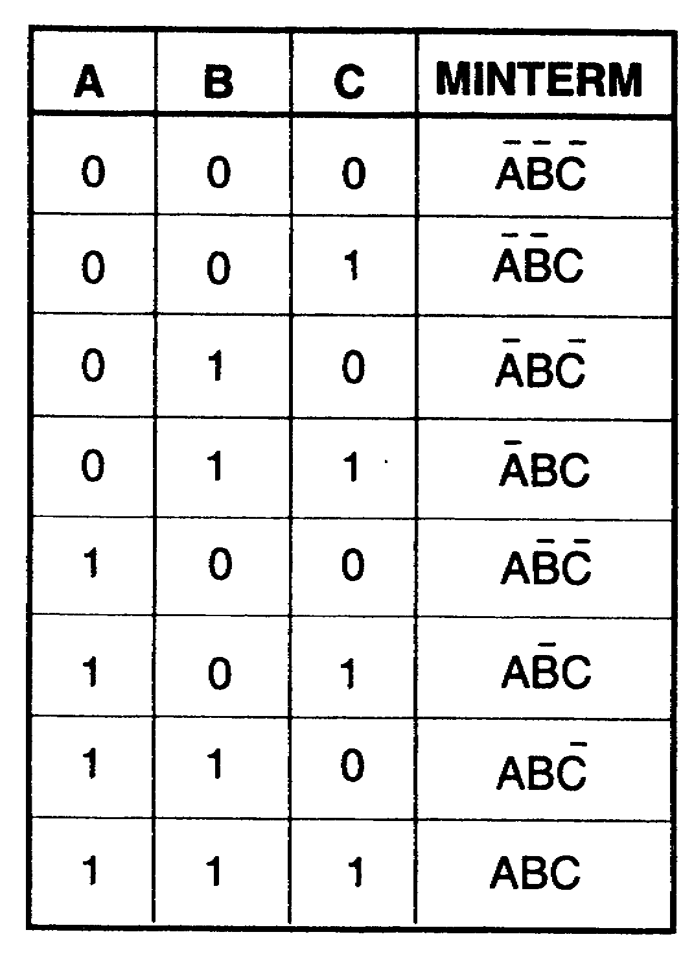

In order to construct a VEITCH diagram, it is necessary to know the number of possible minterms. A Veitch diagrams is a block of squares on which an expression is plotted. A simplified expression is then extracted from the plotted squares. Determine the number of variables in an expression and use this number as a power of two. For example, the expression JG+JF+JGF+F has three variables. J, G, and F. To find how many possible minterms there are for this expression, use the number of variables (3) as a power of two (2): 2³ = 8 minterms.

IT0345 1-8

13. (Continued)
How many possible minterms are there for the variables in each expression listed below?

___ a. AC+A+AC+C ___d. F+AB+FAB+BA+A
___ b. X+YZ+XY+AXYB+Z+B ___ e. D+AC+BD
___ c. LM+Z+CLM+MZ+MLZ ___ f. IT+IS+OK

a. 4 (2²) 14. On a Veitch diagram, there is one square for
b. 32 (2⁵) each minterm.
c. 16 (2⁴) For example:
d. 8 (2³) For a two-variable expression, there are four
e. 16 (2⁴) minterms (2²); thus, a four-square Veitch
f. 32 (2⁵⁾ diagram is required.
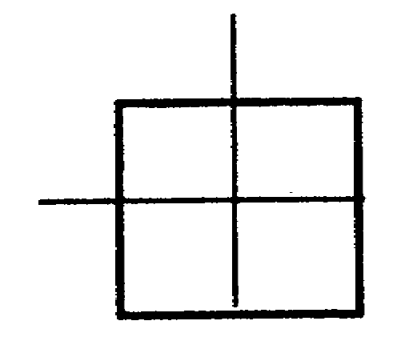

Four-square Veitch diagram

For a three-variable expression, there are eight minterms (2³); thus, an eight-square Veitch diagram is required.

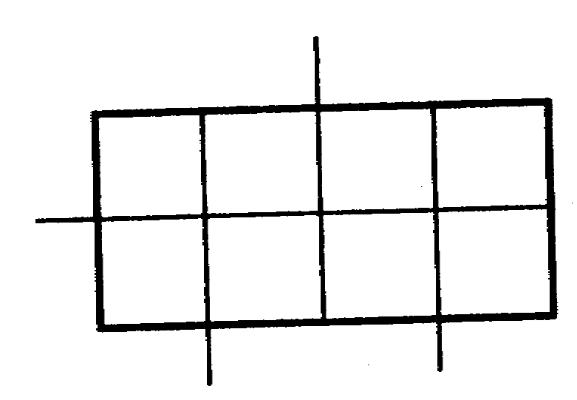

Eight-square Veitch diagram

1-9 IT0345

14. (Continued)
For a four-variable expression, there are 16 minterms (2⁴); thus, a 16-square Veitch diagram is required.
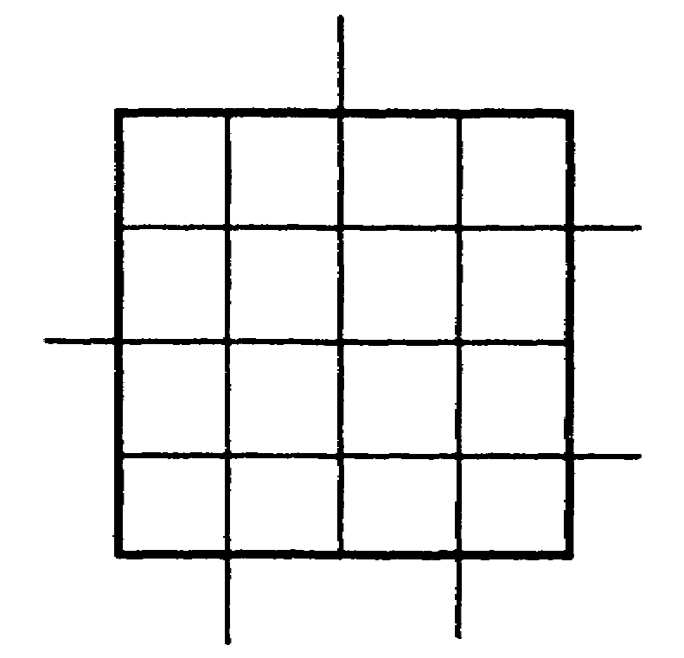

Sixteen-square Veitch diagram

How many squares must a Veitch diagram contain to plot the following expressions?

___ a. AC+A+C ___ d. CB+AC+BC+BA
___ b. AT+C+P+TAC+PAT+C ___ e. AX+XAQR
___ c. H+AB+BH+ABH+BA ___ f. X+XY+Y

a. 4 15. Convert the following expressions to minterm
b. 16 form.
c. 8 a. XY+BC c. BO+L+EA+N
d. 8
e. 16
f. 4 b. E+A+S+Y d. XYZW+R(S+T)

IT0345 1-10

a. XY+B+C 16. TEST FRAME
b. E+ASY Which of the following are minterm-type terms
c. B+O+L+EA+N representing the variables A, B, C, and D?
d. XYZW+RS+RT a. A+B(C+D) d. A+CB+D
b. DAB e. AB+BAC
c. CAD f. BC

b. 17. How many squares must a Veitch diagram
c. contain to plot each of the following?
f. a. A two-variable expression.
b. A three-variable expression.
c. A four-variable expression.
d. Expression A+B+ABC.
e. Expression X+XY+Y+YX.
f. Expression RST+VR+VST.

a. 4 18. TEST FRAME
b. 8 Which of the following expressions are in
c. 16 minterm form?
d. 8 a. ABCD+ABC+ADB+ACD
e. 4 b. A+B+C(DA+BA+A)
f. 16 c. XY+Z(XY+Z)
d. ABK+ABK+ABK+ABK

1-11 IT0345

a. 19. TEST FRAME
d. Convert the following expressions to minterm form.
a. AB+X+Y
b. RS+CD+AB+EFG+L
c. WXYZ+P(Q+R)
d. A(B+C+D)+E

a. AB+XY 20. TEST FRAME
b. RS+CD+AB How many squares must a Veitch diagram
+EFG+L contain to plot the following expressions?
c. WXYZ+PQ+PR a. ABC+ABC+AB+ABCD+AD
d. EA+EBCD b. T+R+RT+RT
c. C+AT+CAT
d. XY+YZ+XZ

IT0345 1-12

a. 16 21. It is conventional practice to label a Veitch
b. 4 diagram counterclockwise in alphabetical
c. 8 order. The Veitch diagram will be labeled
d. 8 with each variable and the complement of each
variable as follows:

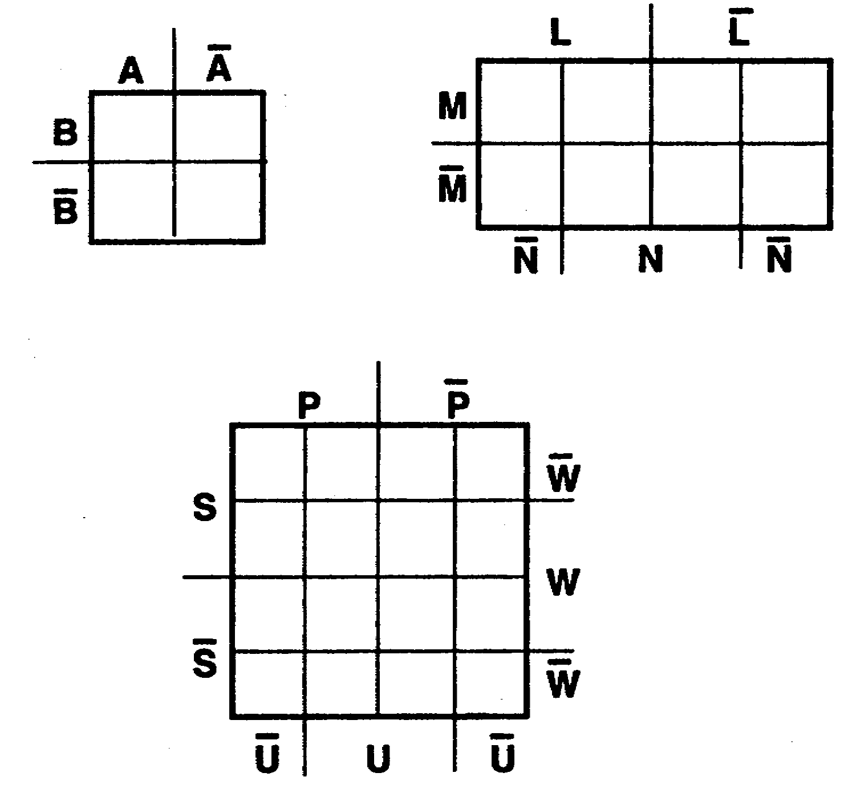

Using the conventional practice, label the diagram below for variables D, G, and F.
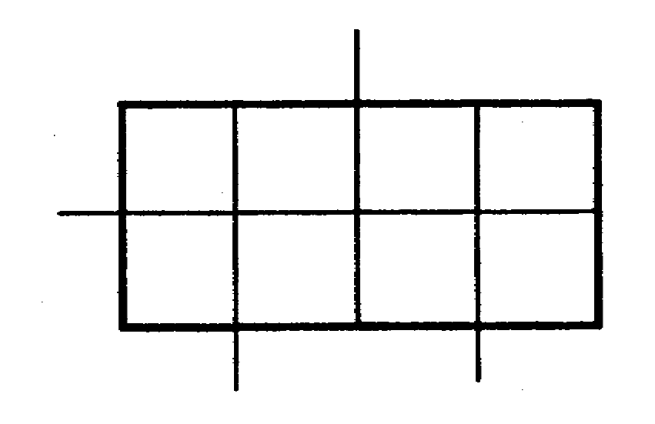

1-13 IT0345

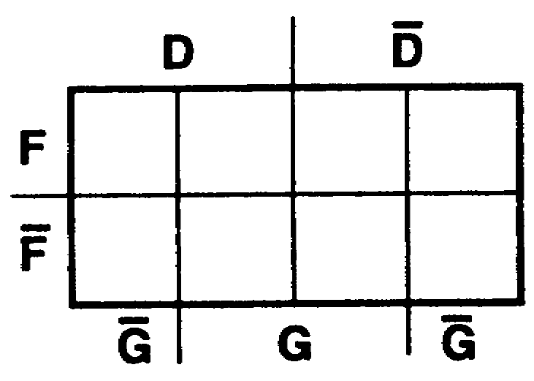
22. An expression can be plotted on a Veitch diagram only after the expression has been converted to minterm form and the correct diagram drawn corresponding to the number of possible minterms. For simplicity, the variables in each term should be arranged in alphabetical order. The Veitch diagram below is for two variables, A and B.
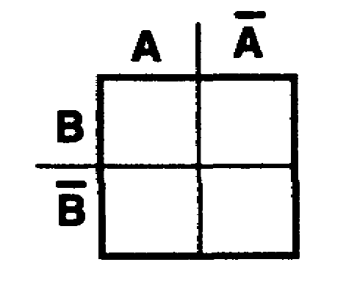

Half of the total squares are assigned to each variable; and half, to the complement of each variable. Each variable overlaps every complement but its own. A Veitch diagram for two variables contains______________ squares.

four 23.
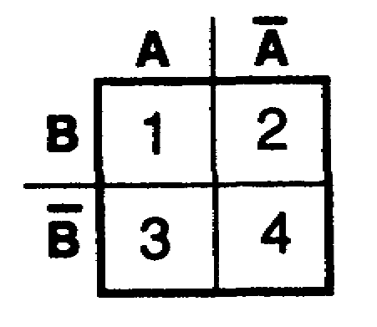

Which squares above are assigned to the following variables?
____ a. A ____ c. A
____ b. B ____ d. B

IT0345 1-14

a. 1 and 3 24. To plot the expression A+B on a Veitch
b. 1 and 2 diagram, start with the first term on the
c. 2 and 4 left and mark the squares assigned to
d. 3 and 4 the variable (A) of that term as shown below.
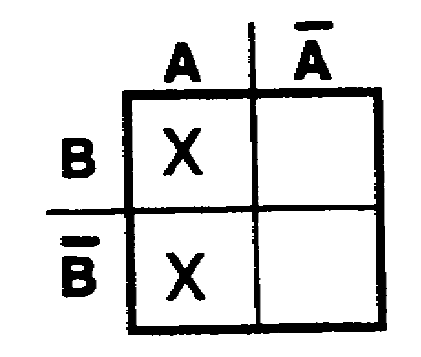

Next, on the same diagram, mark the squares assigned to the variable (B) of the second term, as shown below.
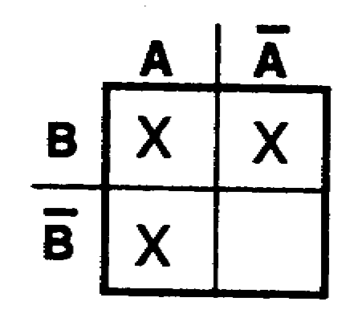

Note that one square of variable B had been marked from the plotting of variable A. The expression A+B has been plotted on a four-square Veitch diagram, and the completed diagram is shown below.
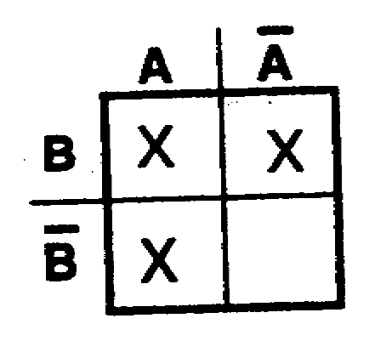

Plot the expression A+B on the Veitch diagram below.
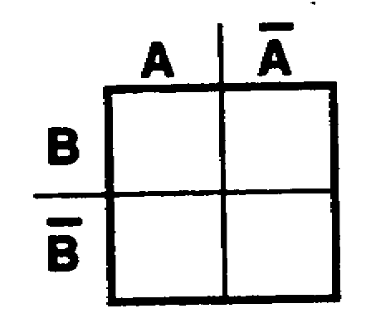

1-15 IT0345

25. Plot the expression R+T.
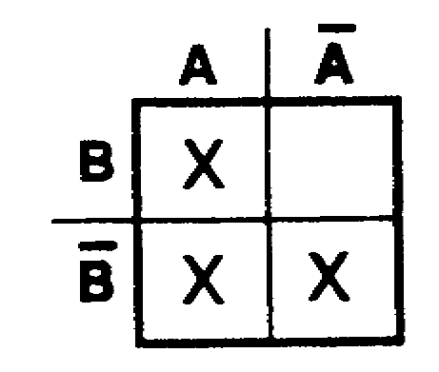

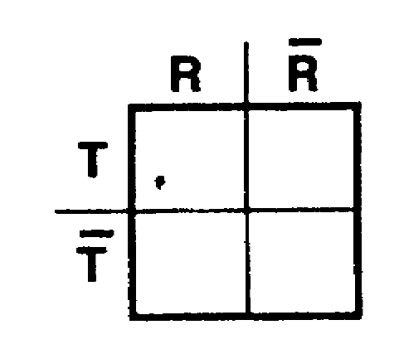

26. Plot the expression L+A
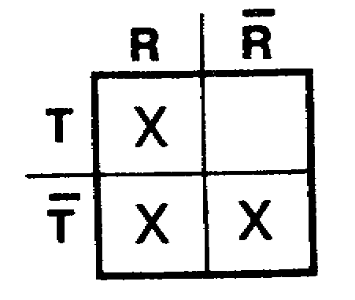

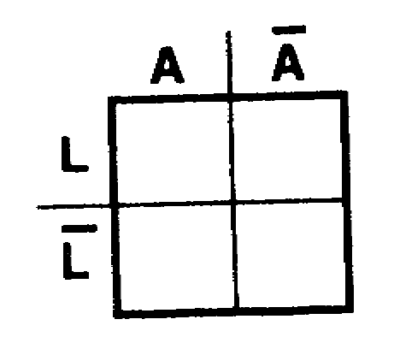

27. Plot the expression J+C.
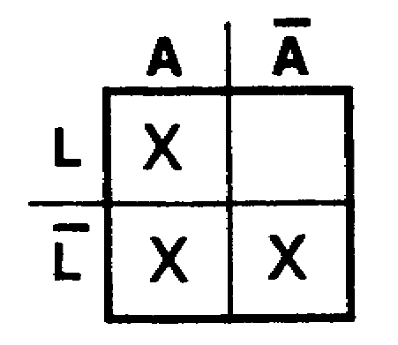

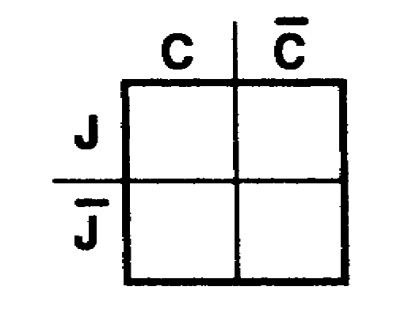

IT0345 1-16

28. Plot the following expressions:
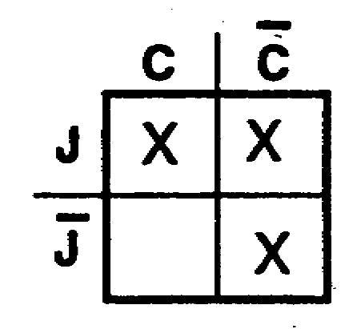
a. A+L
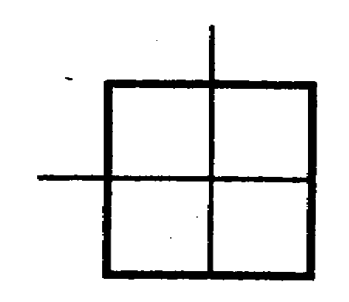

b. I+S
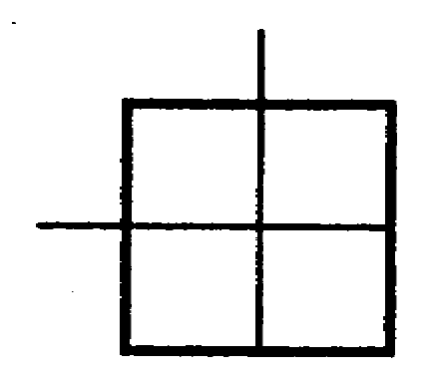

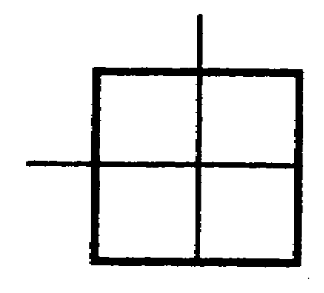
c. P+U

a. 29. On a four-square Veitch diagram a one-variable term such as A, B, A, F, etc., occupies two squares. Since a four-square Veitch diagram is used to plot only two-variable expressions (such as A+B), half of
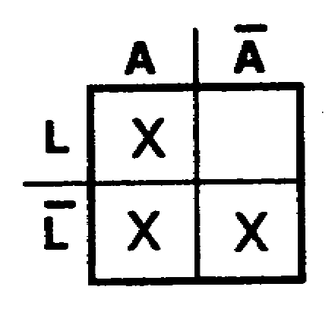
b. the squares are assigned to each variable; and half, to the complement of the variable. In the expression X+Y, variable X is assigned __________squares on a four-square Veitch diagram; variable Y is assigned_____________
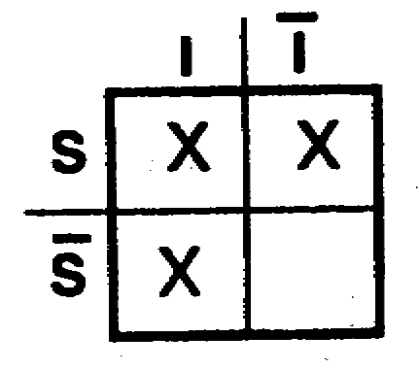
c. squares.
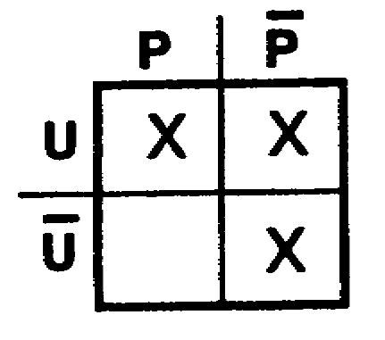

1-17 IT0345

two 30. On a four-square Veitch diagram, a two-
two variable term, such as AB, CA, EB, OK, AC, etc., occupies only one square. For example, the expression AB+AB contains two terms (AB and AB). Each term contains two variables; therefore, each two-variable term will occupy only one square on a four-square Veitch diagram.
For the expression XY+XY, each term contains ______________ variables, and each term will occupy_____________________________ on a four-square Veitch diagram.

two 31. To plot the expression AB+AB on a Veitch
one square diagram, work only one term at a time. Start with the first term on the left (AB). As stated previously, a two-variable term occupies only one square on a four-square Veitch diagram. To determine the proper square, take each variable of the term (AB) and determine which square is common to both variables as follows:

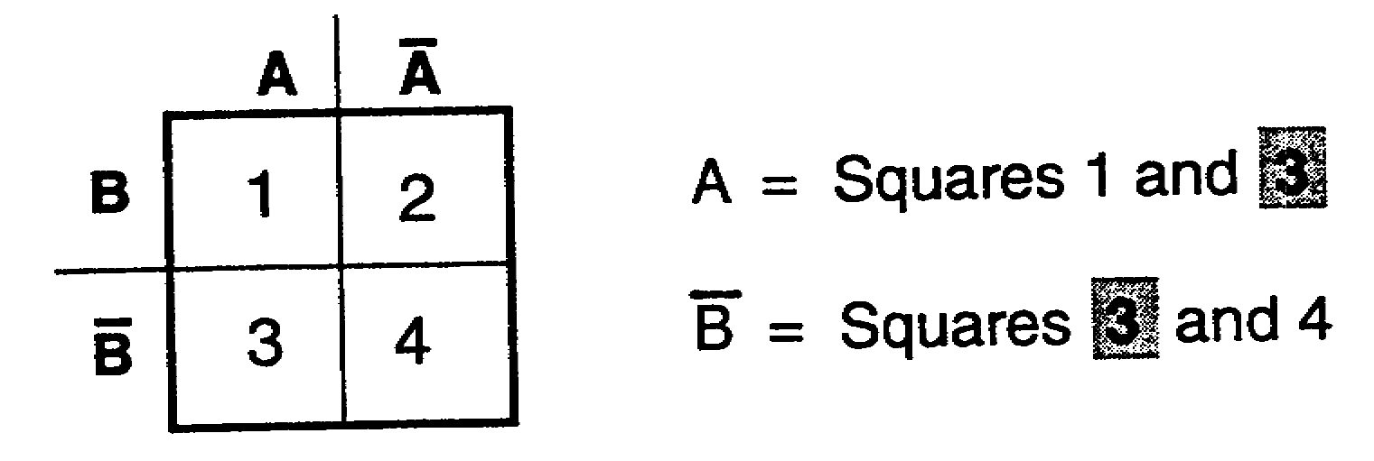

IT0345 1-18

31. (Continued)
Square 3 is common to both the A plot and the B plot (it is common to AB). Therefore, the plot for the term AB is square 3, as shown below.
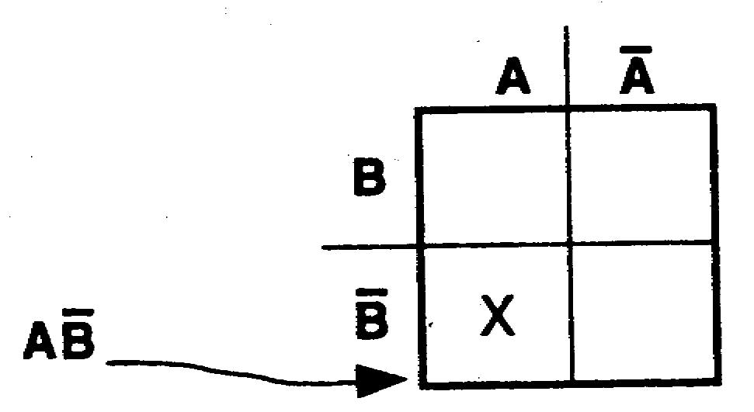

To complete the plot of the expression AB+AB, the second term (AB) must still be plotted. Plot the second term (AB) in the diagram above.

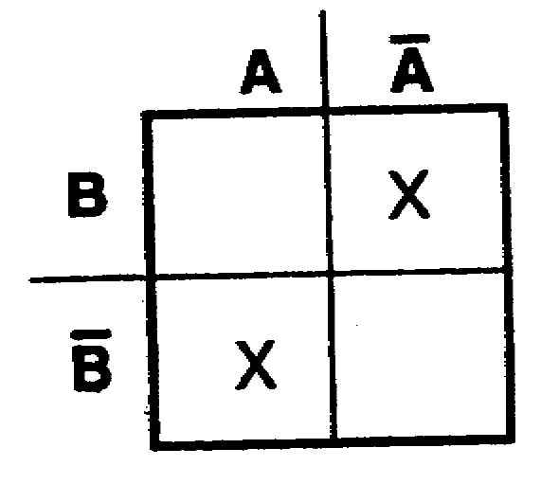
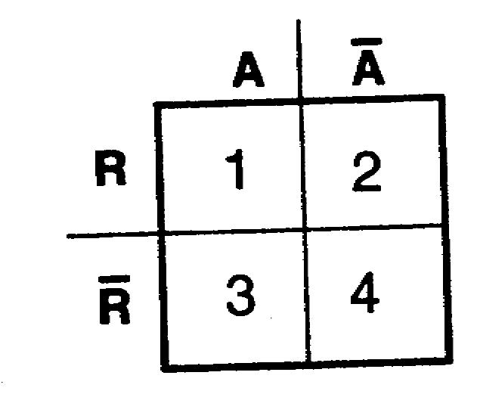
32.

Which squares above are assigned to the following variables?
____ a. AR ____ c. AR
____ b. AR ____ d. AR

a. 1 33. Plot the expression RA+ RA on the Veitch
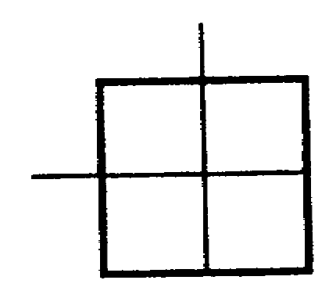
b. 3 diagram below.
c. 2
d. 4

1-19 IT0345

34. On a four-square Veitch diagram, a one-variable term occupies two squares; a two-variable term occupies only one square. On a four-square Veitch diagram, for the expression A+BA, the A term occupies _________ ___________; the BA term occupies ___________ _____________.
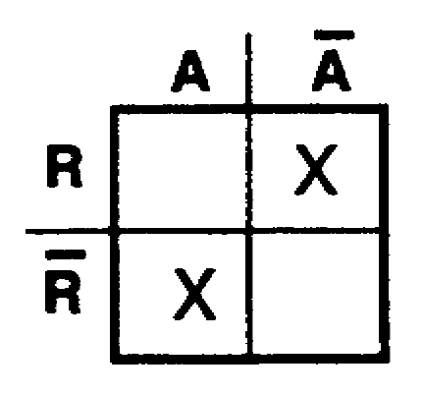

two squares 35. Plot the expression A+BA.
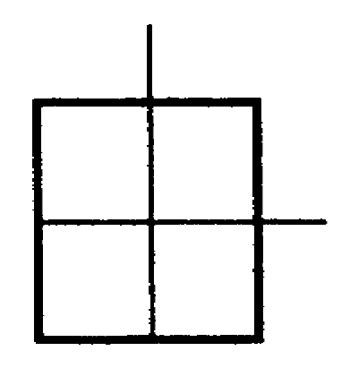
one square

36. Plot the expression BA+BA.
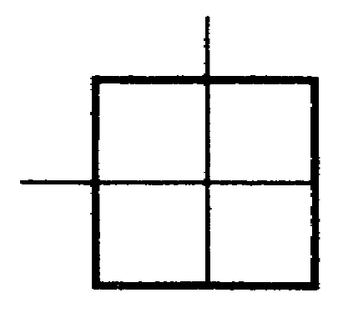
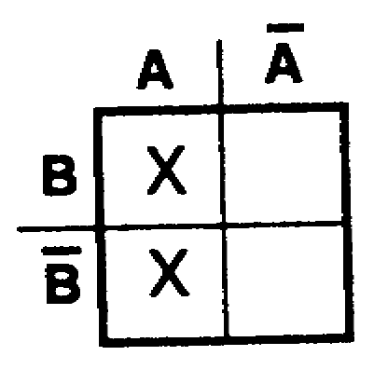

37. Plot the expression S+RS+S+SR+R.
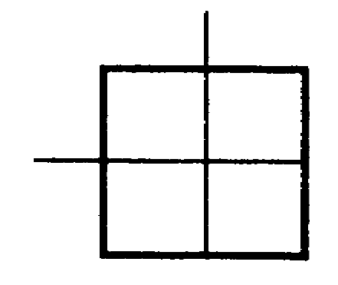
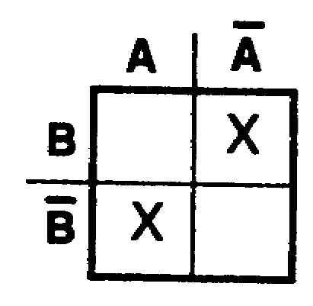

38. Plot the expression PQ+Q.
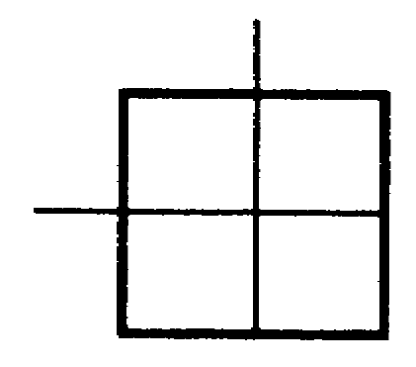
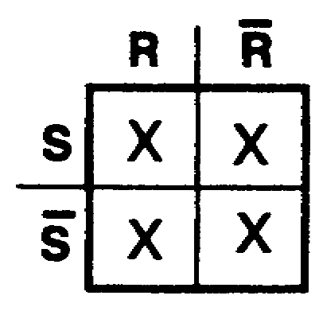

IT0345 1-20

39. TEST FRAME
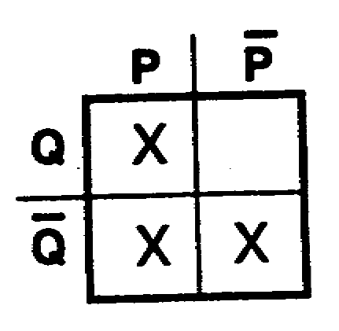
Plot the following expressions:
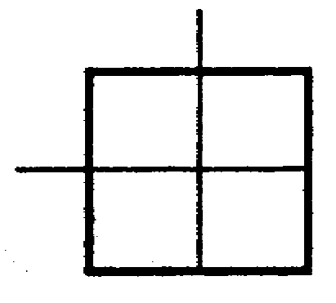
a. AB+B+AB+BA

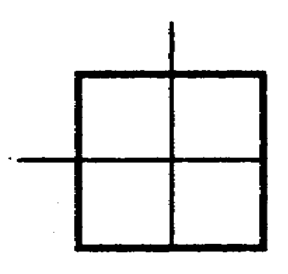
b. XY+XY

c. A+LA
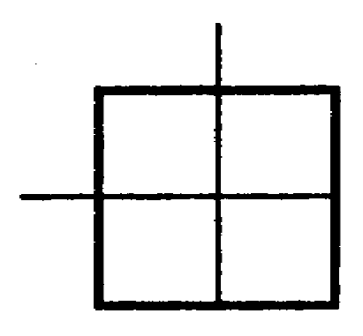

40. An expression can be plotted on a Veitch
a. diagram only after the expression has been converted to minterm form and the correct diagram drawn corresponding to the number of possible minterms. For simplicity, the
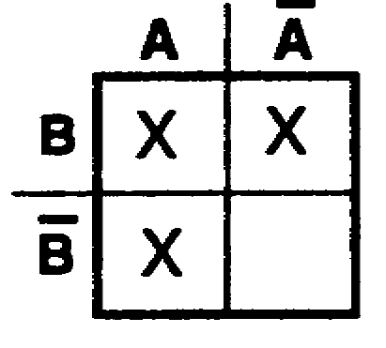
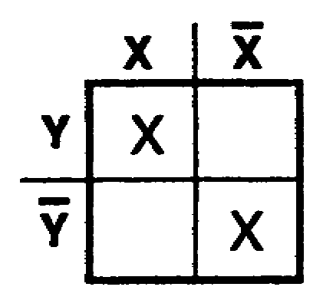
b. variables in each term should be arranged in alphabetical order. The conventional way to label a Veitch diagram for the three variables A, B, and C is shown below.
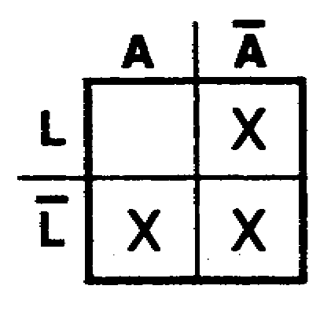
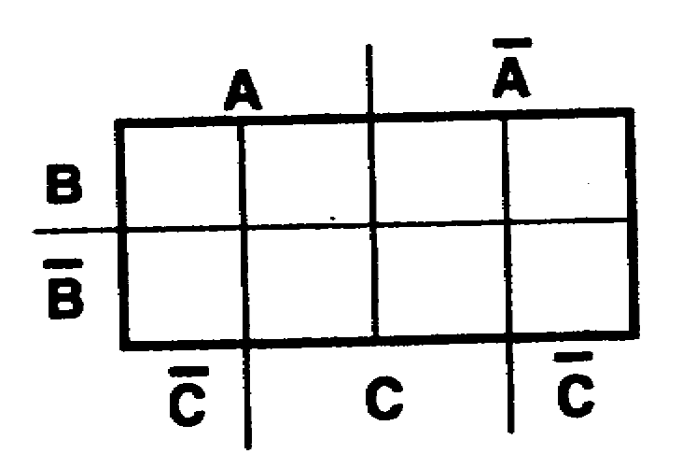
c.

Half of the total squares are assigned to each variable; and half, to the complement of each variable. Each variable overlaps every other variable and overlaps every complement but its own. A Veitch diagram for three variables contains ______________ squares.

1-21 IT0345

eight 41. To plot expression A+B+C on a Veitch diagram, work with only one term at a time until all terms have been plotted. First, put an X in the four squares assigned to variable A, as shown below.
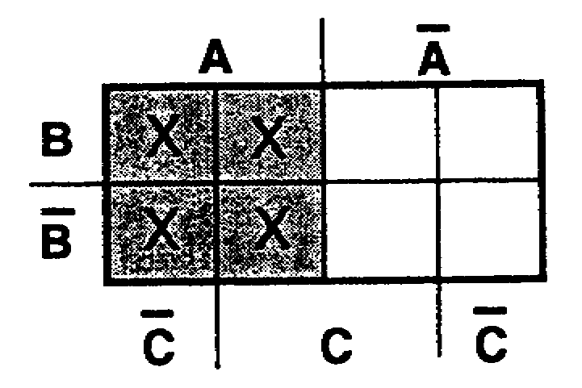

On the same diagram, plot the four squares assigned to variable B by placing an X in the four squares, as shown below.
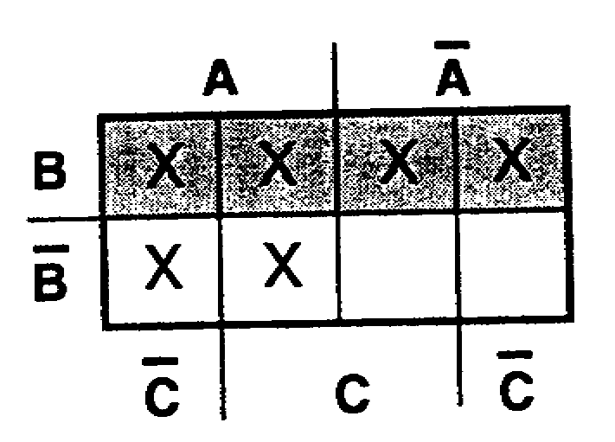

Note that some squares are already plotted because of overlapping.

On the same diagram, plot the four squares that are assigned to the final variable to be plotted, variable C, as shown below.
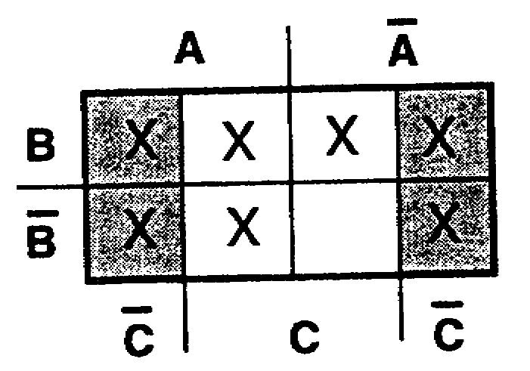
Note again that some squares are already plotted because of overlapping.

Plot the expression A+B+C on the Veitch diagram below.
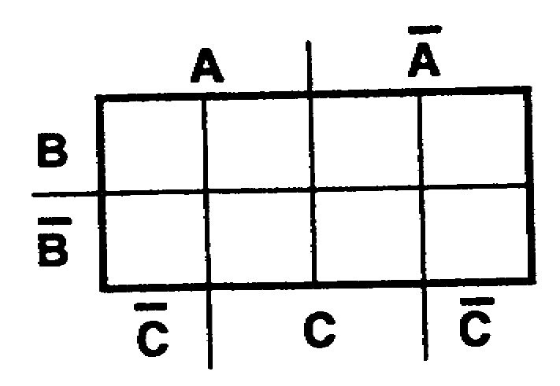

IT0345 1-22

42. Plot the expression X+Y+Z.
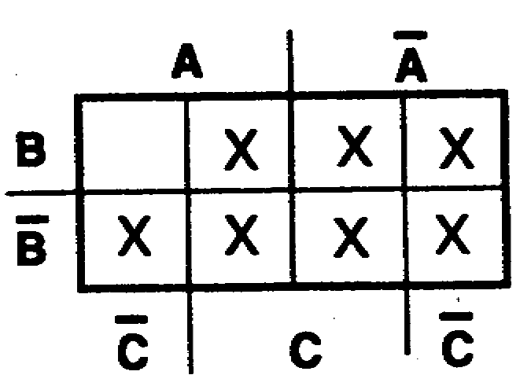
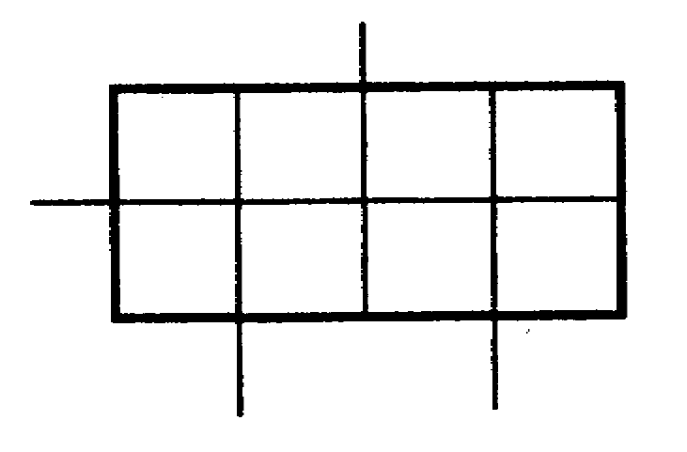

43. Plot the expression L+M+K.
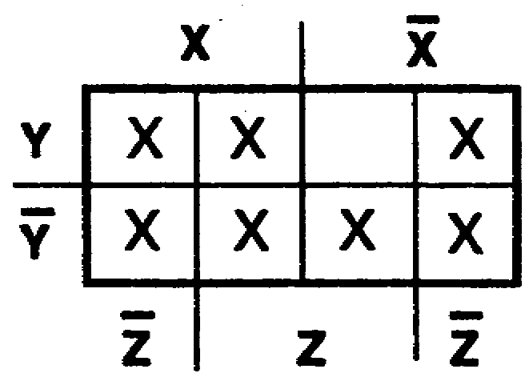
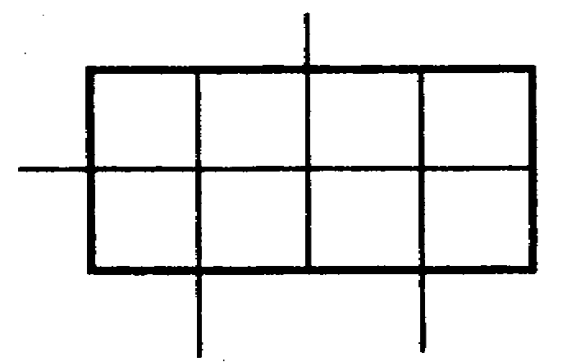

44. Plot the expression A+A+B+B+C+C.
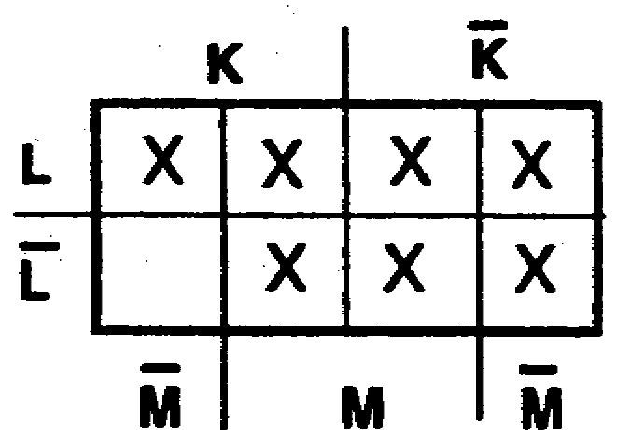
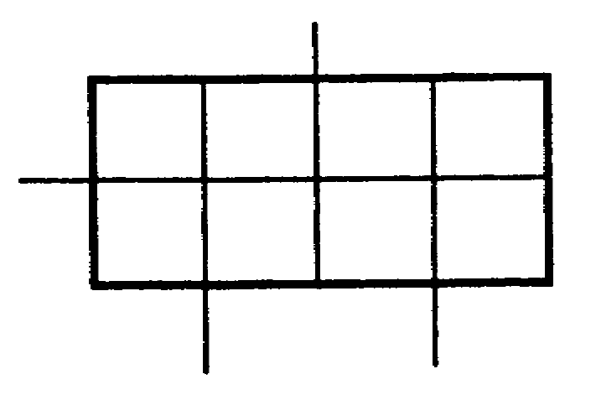

This plot is equal to 1. When all squares in a Veitch diagram are plotted, the expression is equal to 1.
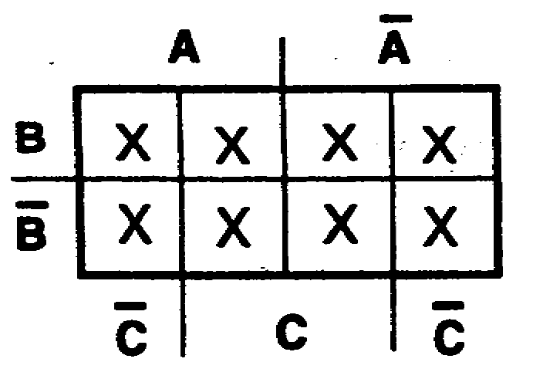

1-23 IT0345

45. Plot the following expressions:
a. R+P+Q
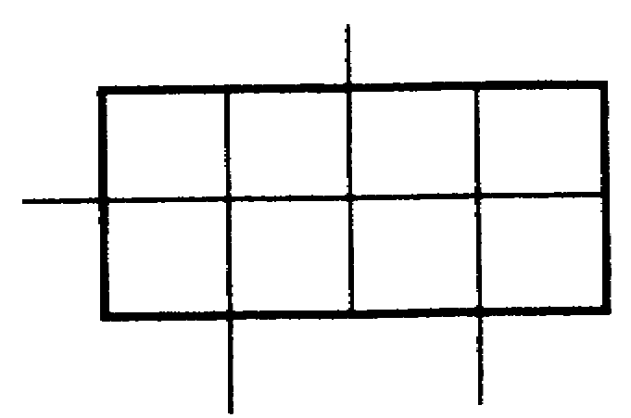

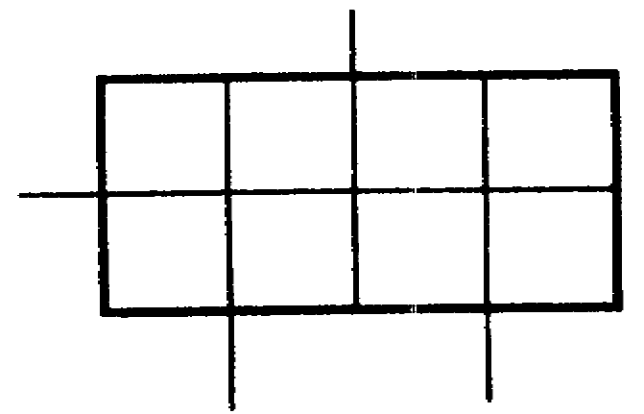
b. C+B+A

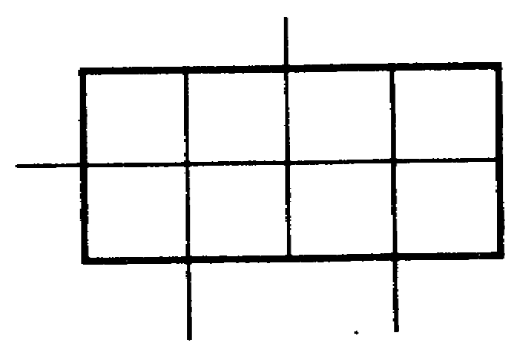
c. B+A+C

a. 46. On an eight-square Veitch diagram, a one-variable term, such as R, S, A, R, P, etc., occupies four squares; a two-variable term, such as AB, SR, ZP, JD, LM, etc., occupies two squares; a three-variable term, such as ABC, XYZ, LA B, ARC, etc., occupies only one square.
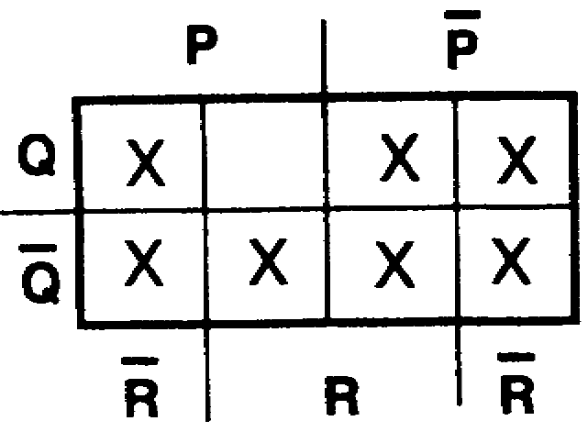
b. On an eight-square Veitch diagram for the expression A+BC+ABC, the A term occupies ________________________; the BC term occupies __________; and the ABC term occupies _____________ _____________.
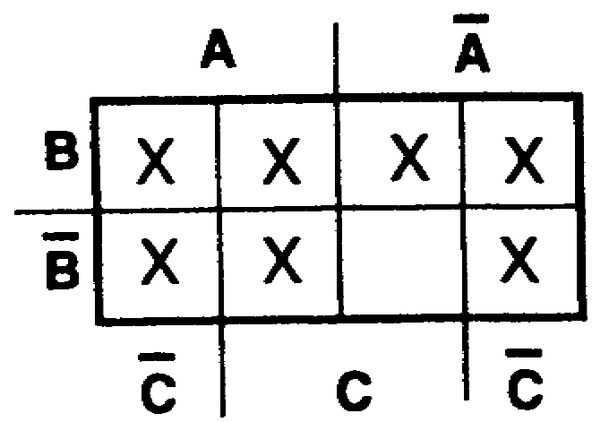
c.
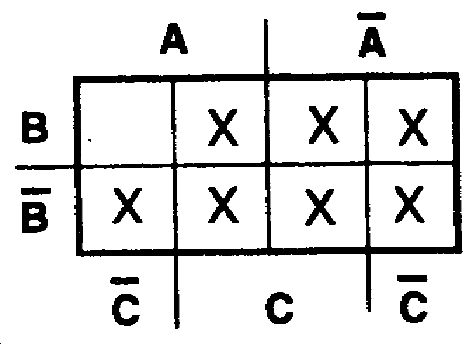

IT0345 1-24

four squares 47. To plot the expression RS+RT on an eight-
two squares square Veitch diagram, work with only one
one square term at a time. Start with the first term on the left (RS). As stated previously, a two-variable term occupies two squares on an eight-square Veitch diagram. To determine the proper squares, take each variable of the term (RS) and determine which squares are common to both variables, as follows:

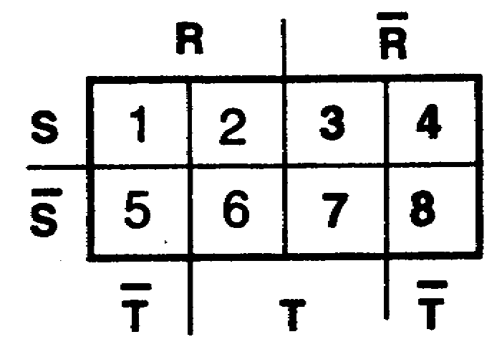
R = squares 1,2, 5, and 6
S = squares 1, 2, 3, and 4

Squares 1 and 2 are common to both the R plot and the S plot (they are common to RS). Therefore, the plot for the term RS Is squares 1 and 2, as shown below.
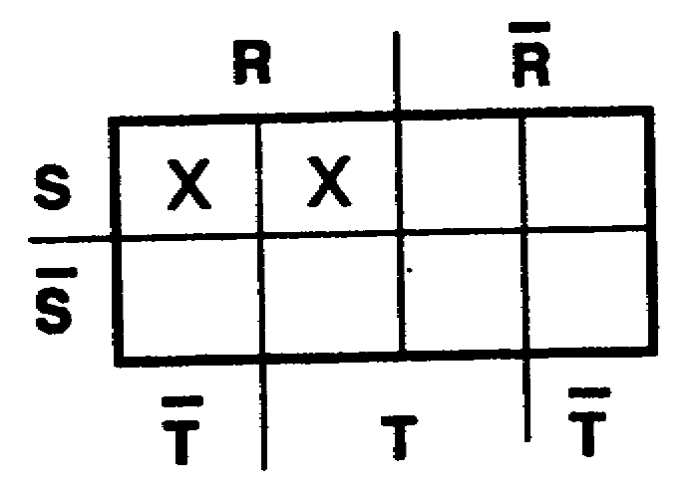

To complete the plot of the expression RS+RT, the second term (RT) must still be plotted. Plot the second term (RT) in the diagram above.

1-25 IT0345

48.
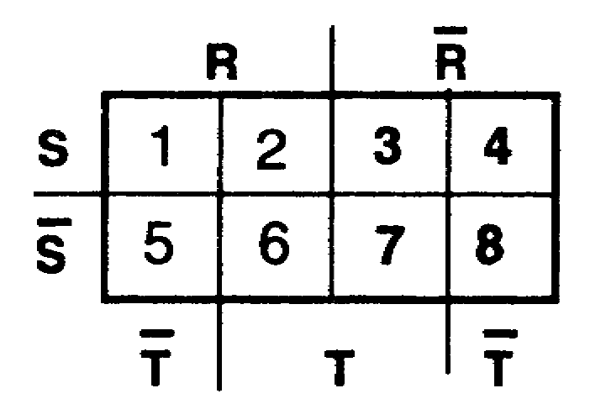
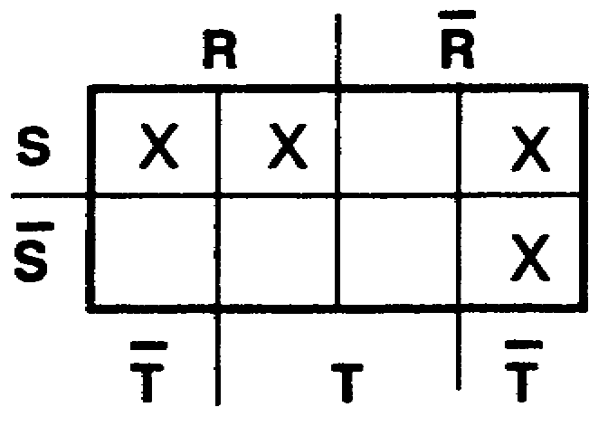

Which squares above are assigned to the following variables?

____ a. RS ____ g. RT
____ b. RS ____ h. RT
____ c. RS ____ i. ST
____ d. RS ____ j. ST
____ e. RT ____ k. ST
____ f. RT ____ l. ST

a. 1 and 2 49. Plot the expression AB+AC on the Veitch
b. 5 and 6 diagram below.
c. 3 and 4
d. 7 and 8
e. 2 and 6
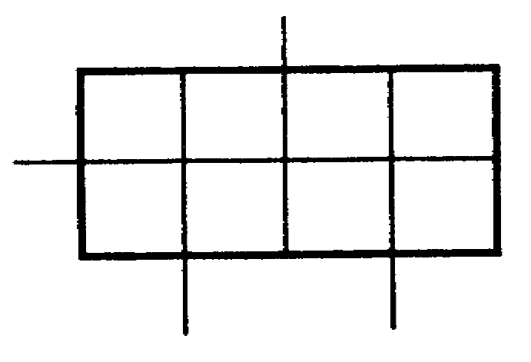
f. 1 and 5
g. 3 and 7
h. 4 and 8
i. 2 and 3
j. 1 and 4
k. 6 and 7
l. 5 and 8

IT0345 1-26

50. Plot the expression X+YZ.
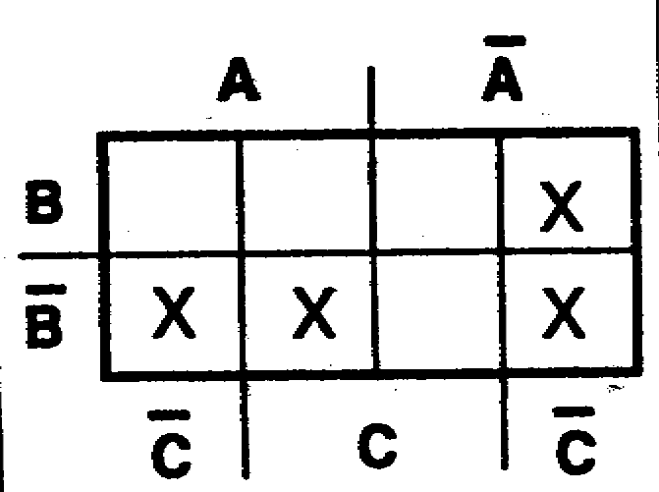
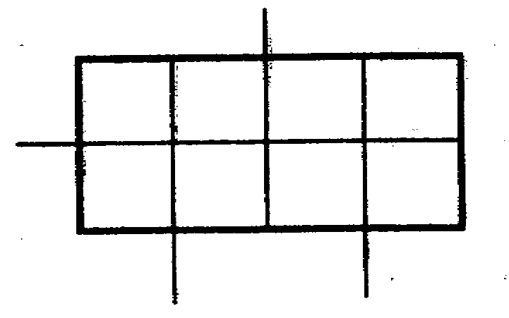

51. Plot the following expressions
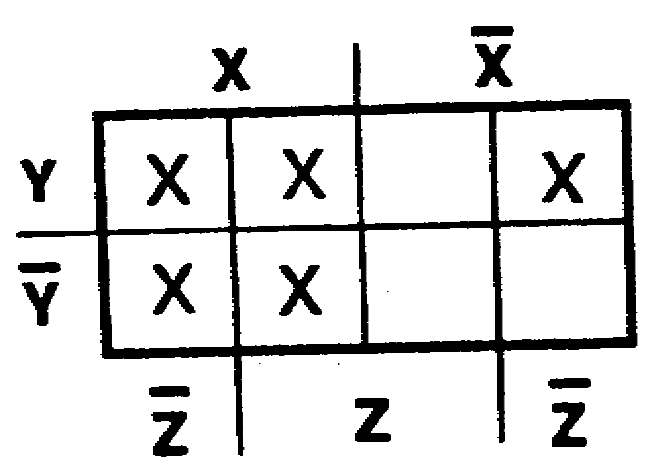
a. VW+WU

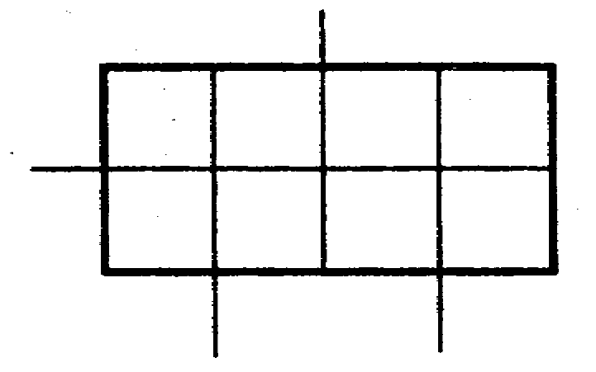

b. EF+GF
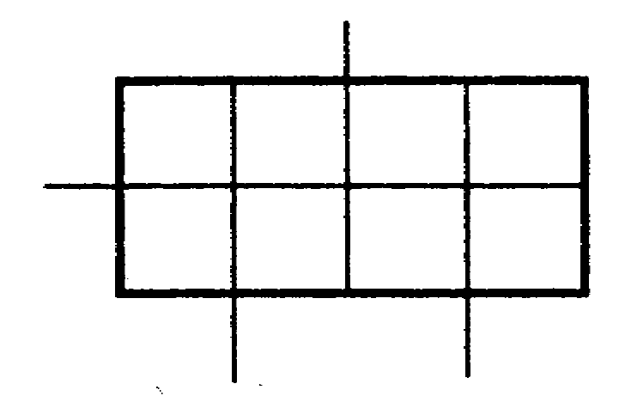

c. BA+C+AC+B
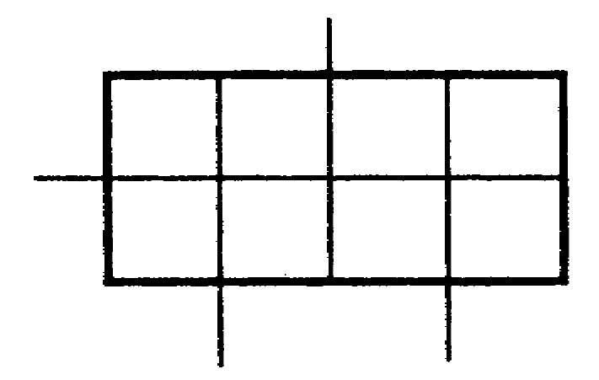

1-27 IT0345

52. On an eight-square Veitch diagram, a one-
a. variable term occupies four squares; a two-variable term occupies two squares; a three-variable term occupies only one square. To plot the expression DPQ+DPQ, work with only one term at a time. Start with the first term on the left (DPQ). To determine the
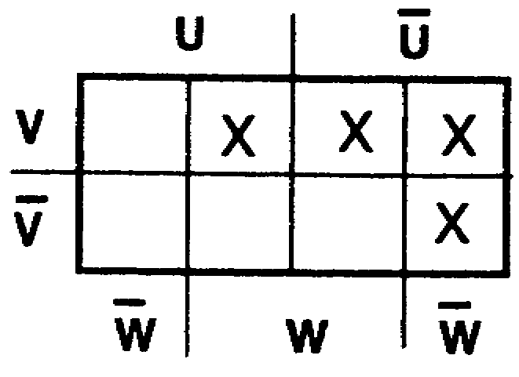
b. proper square, take each variable of the term (DPQ) and determine which square is common to all three variables, as follows:
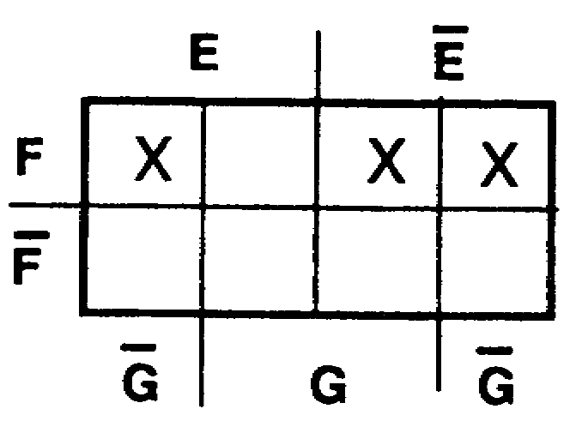

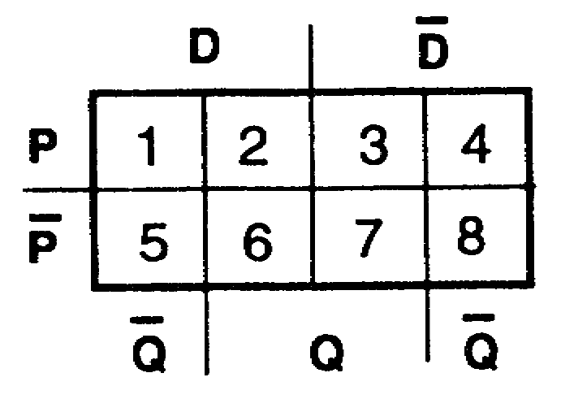

D = squares 3, 4, 7, and 8
P = squares 1,2, 3, and 4
c. Q = squares 1, 5, 4, and 8
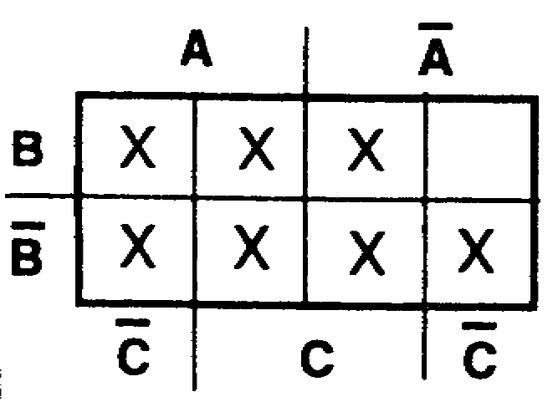

Square 4 is common to all variables of the term DPQ. Therefore, the plot for the term DPQ is square 4, as shown below.
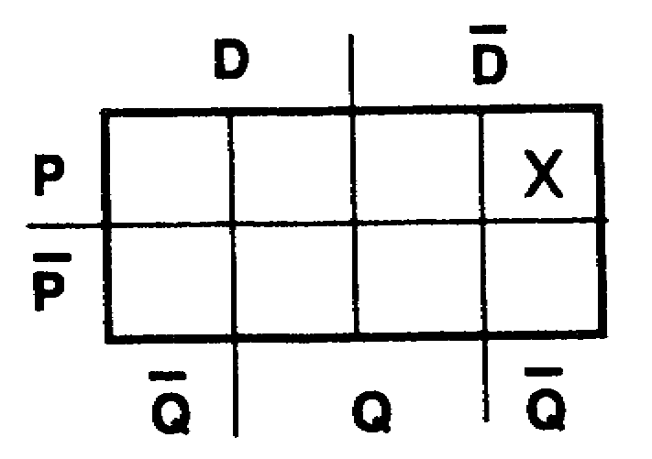

To complete the plot of the expression DPQ+DPQ, the second term (DPQ) must still be plotted. Plot the second term (DPQ) in the diagram above.

IT0345 1-28

53.
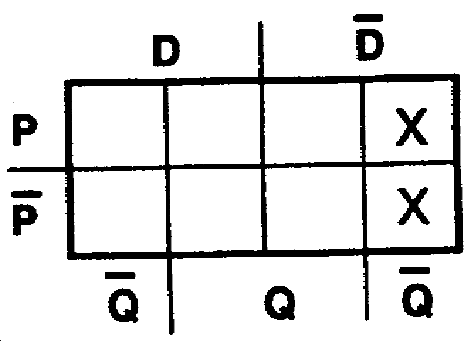
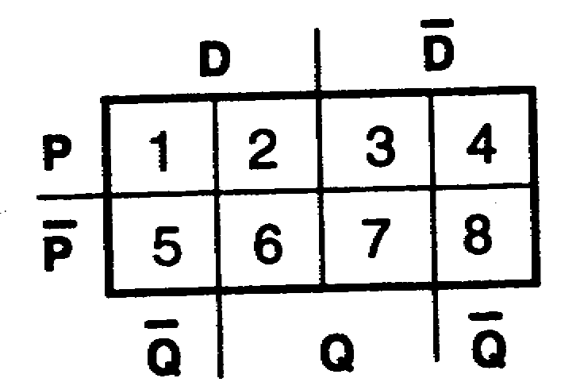

Which squares above are assigned to the following variables?

____ a. DPQ ____ e. DPQ
____ b. DPQ ____ f. DPQ
____ c. DPQ ____ g. DPQ
____ d. DPQ ____ h. DPQ

a. 1 54. Plot the expression DPQ+DPQ.
b. 2
c. 5
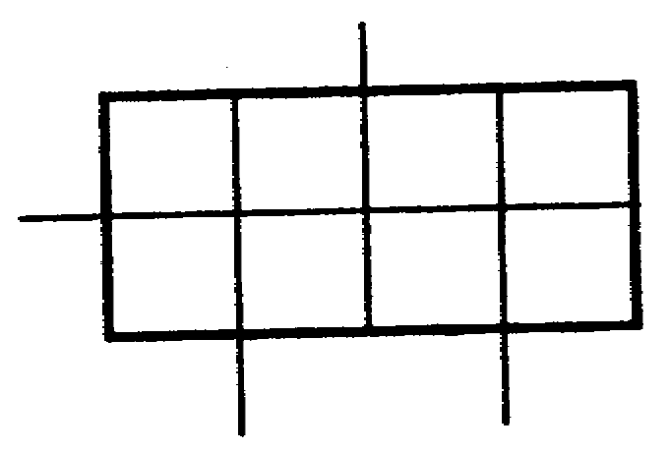
d. 8
e. 7
f. 6
g. 3
h. 4

55. Plot the expression KLM+KLM+KLM+KLM.
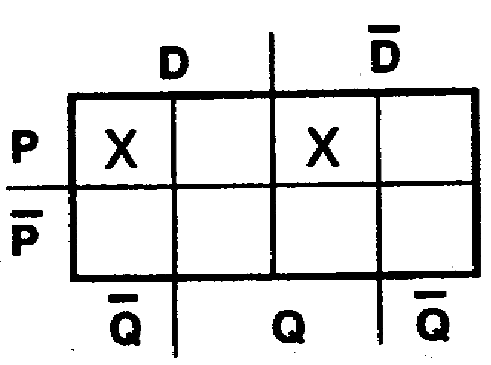
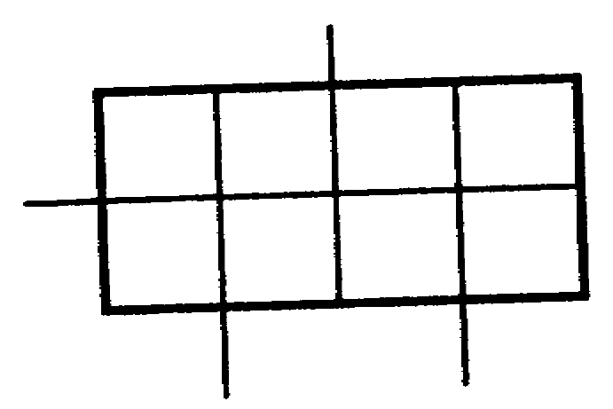

1-29 IT0345

56. Plot the expression ABC+BC+B.
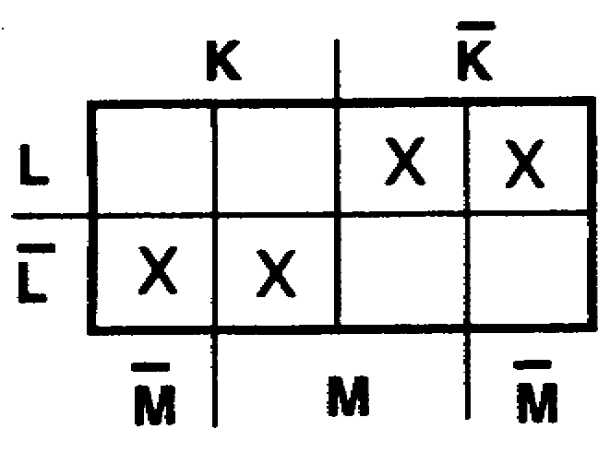
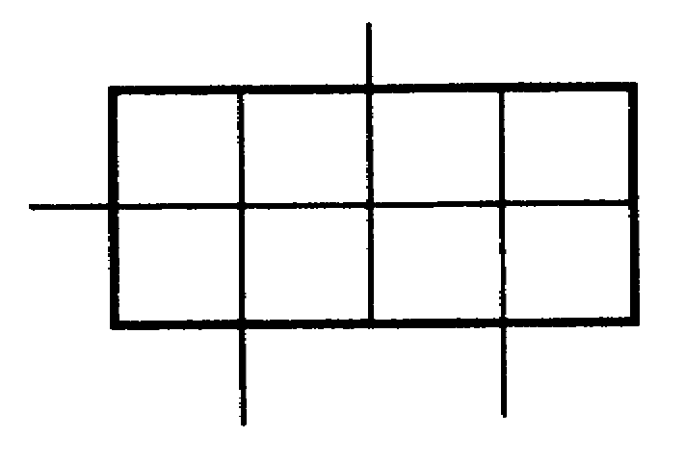

57. TEST FRAME
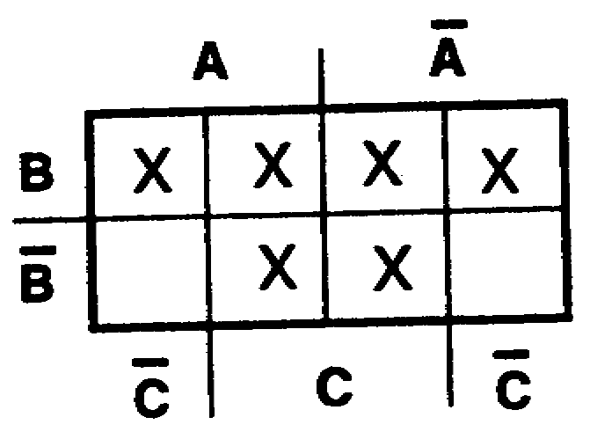
Plot the following expressions:
a. XYZ+ZYX+ZXY+YZX

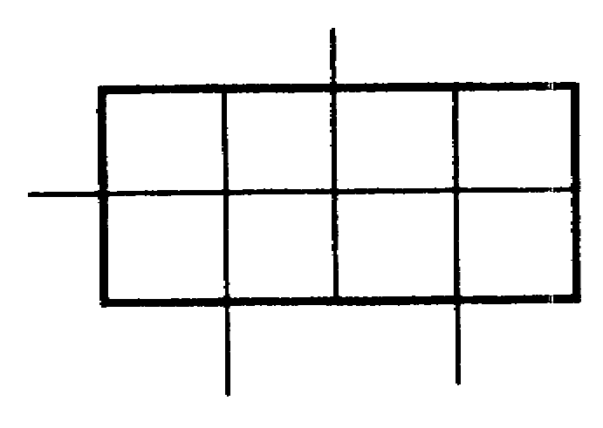

b. A+BC+ABC

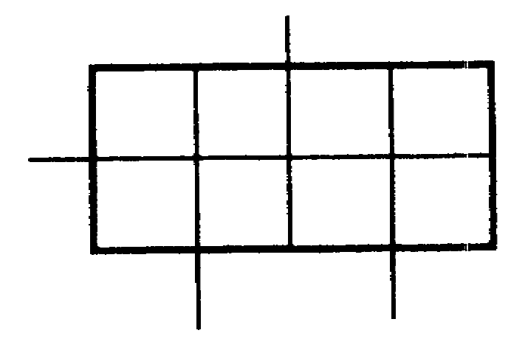

c. RST+RST+RT
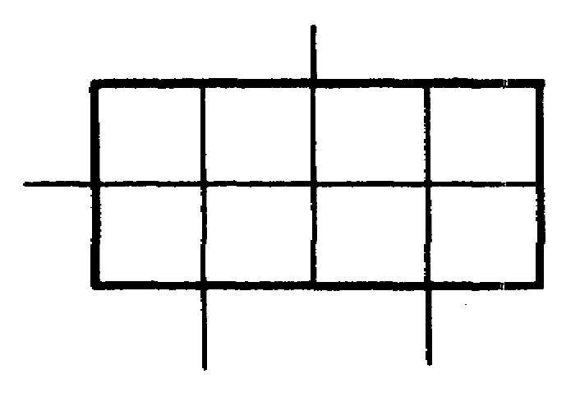

IT0345 1-30

a. 58. On an eight-square Veitch diagram, a one-variable term, such as X, Y, B, A, A, R, etc., occupies four squares.
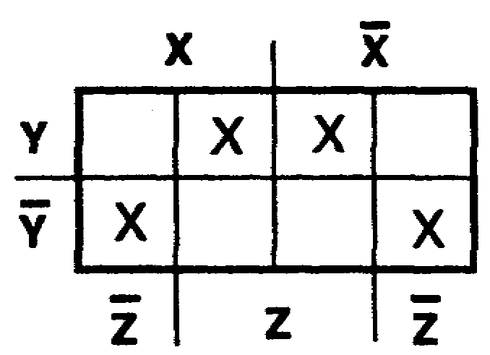
For the expression ABC+AC+A, the term A occupies _______________ _____________.

b.
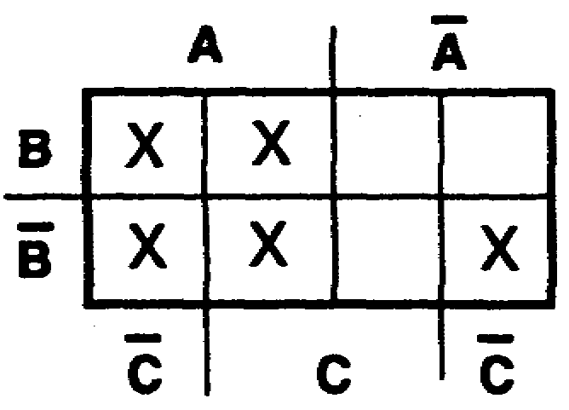

c.
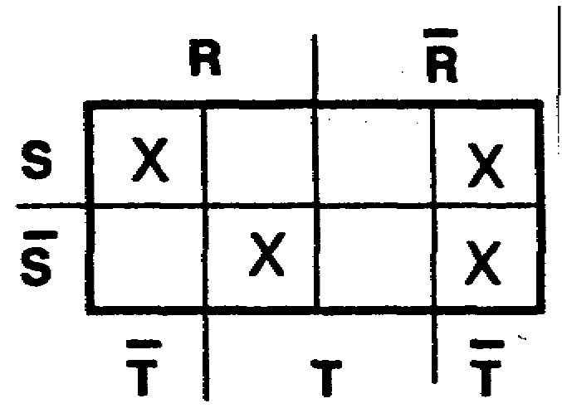

four squares 59. On an eight-square Veitch diagram, a two-variable term, such as XY, AZ, AQ, TD, WM, etc., occupies two squares. For the expression ABC+AC+A, the term AC occupies _________________ __________________.

two squares 60. On an eight-square Veitch diagram, a three-variable term, such as ABC, XZY, TPY, XYZ, etc., occupies only one square.
For the expression ABC+AC+A, the term ABC occupies _______________ ______________.

1-31 IT0345

one square 61. In a three-variable Veitch diagram (eight squares), how many squares will each of the following terms occupy?

a. LXY
b. Z
c. Z
d. HJ
e. UP
f. EYZ

a. 1 62. TEST FRAME
b. 4 How many squares will each of the following
c. 4 occupy in an eight- square Veitch diagram?
d. 2 a. A three-variable term___________.
e. 2 b. A two-variable term_____________.
f. 1 c. A one-variable term_____________.

a. 1
b. 2
c. 4

IT0345 1-32

THIS PAGE LEFT INTENTIONALLY BLANK

1-33 IT0345

63. After an expression has been properly plotted on a Veitch diagram, a simplified expression is easily extracted. Learn to describe the plotted squares with as few terms as possible. First, look for patterns of four plotted squares which describe a one-variable term, as follows:

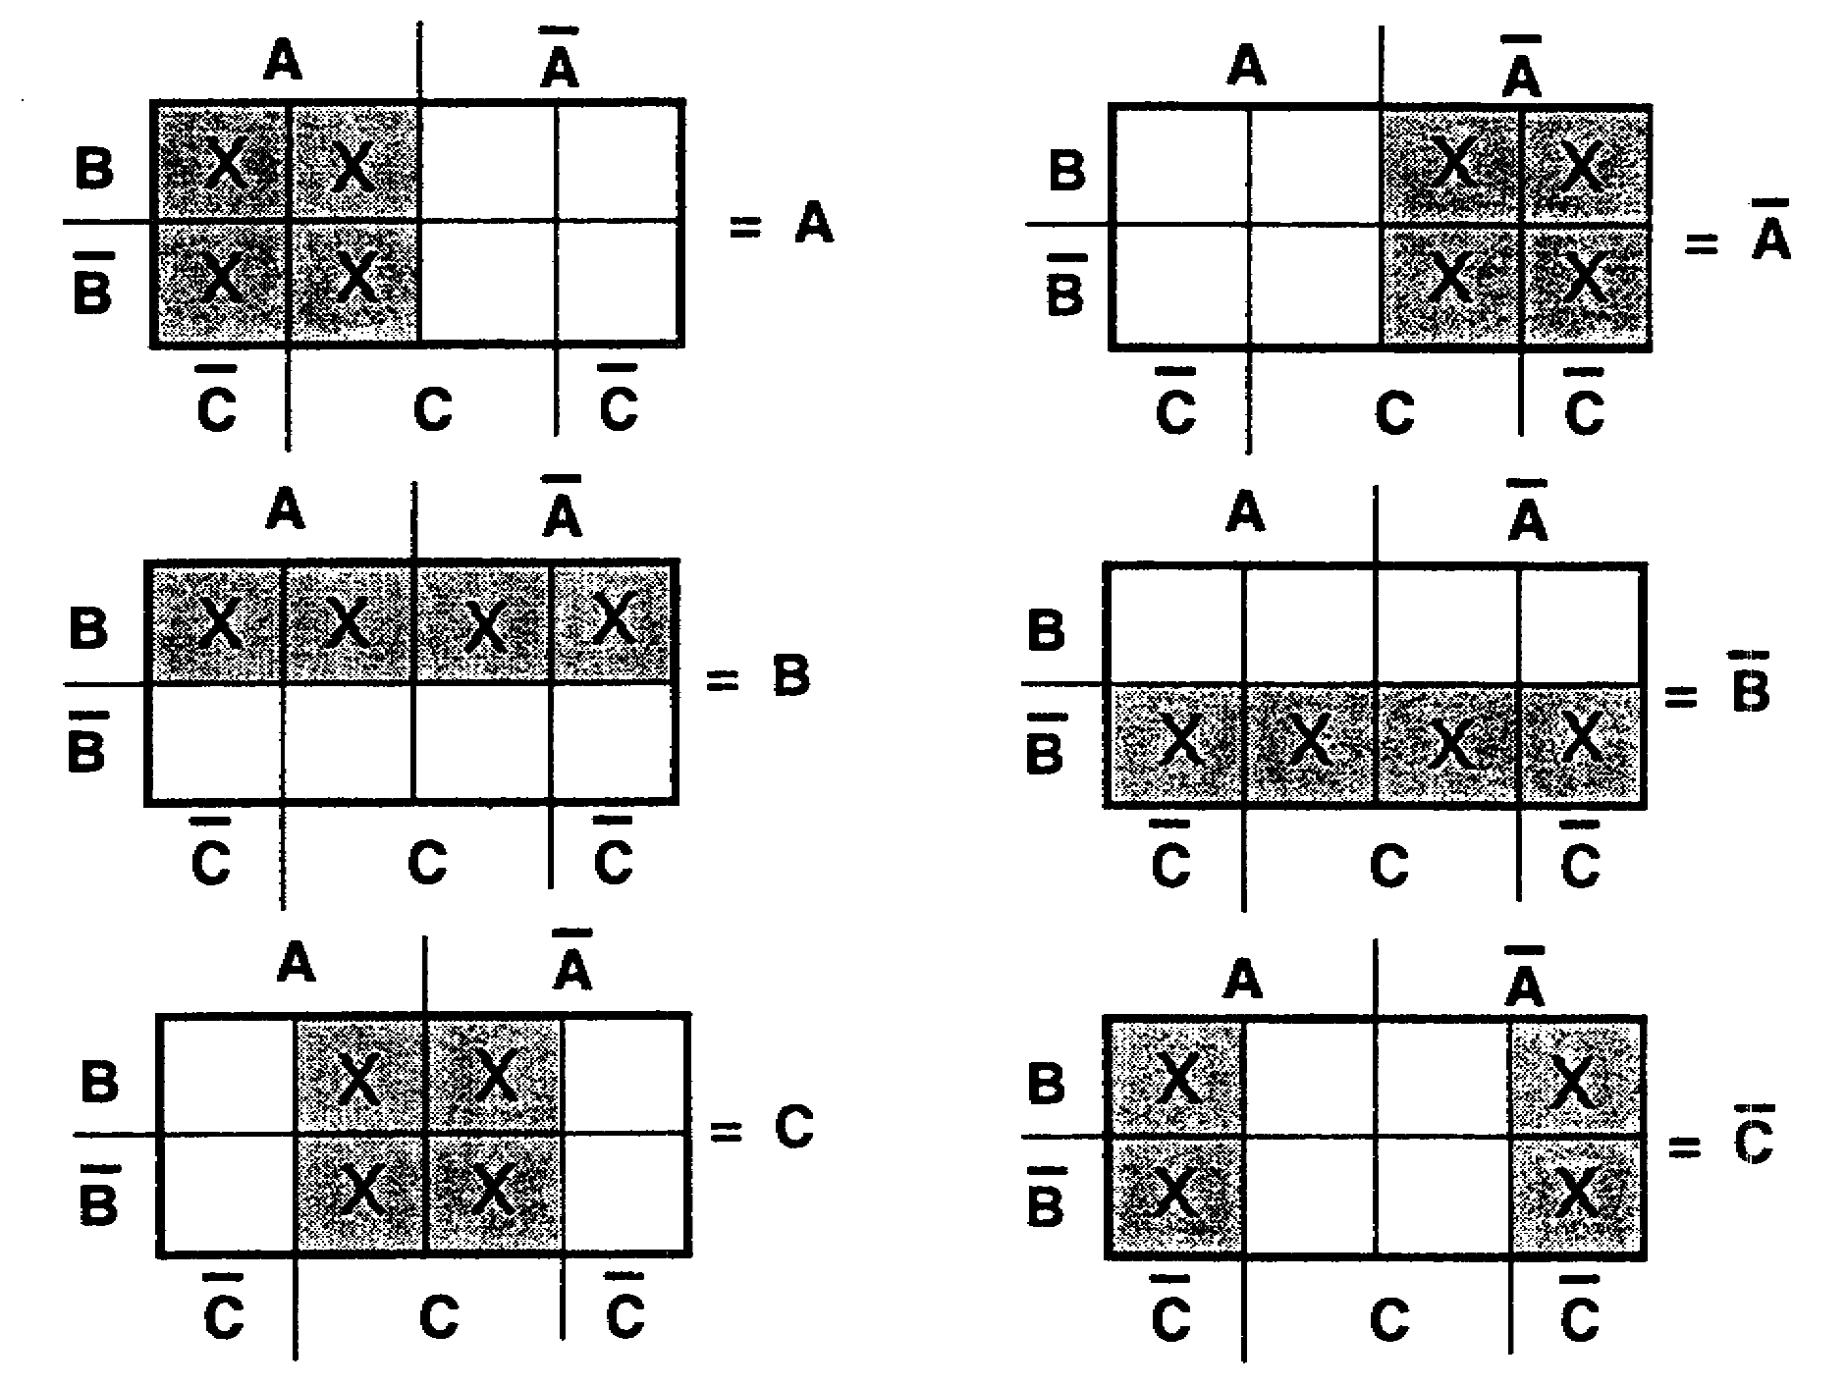

As indicated by the diagrams above, when the four plotted squares cover all the squares assigned to one variable, the plot can be represented by that one variable. The expression ABC+ABC+AB is plotted as follows:

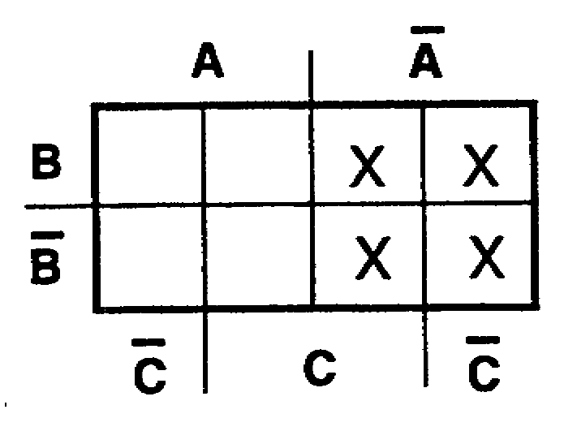

It is evident that the four plotted squares include all the squares assigned to A. Therefore, the expression ABC+ABC+AB can be simplified by extracting the term which is common to these four squares--in this case, A.

IT0345 1-34

63. (Continued)

The expression BC+ABC+ABC is plotted below.

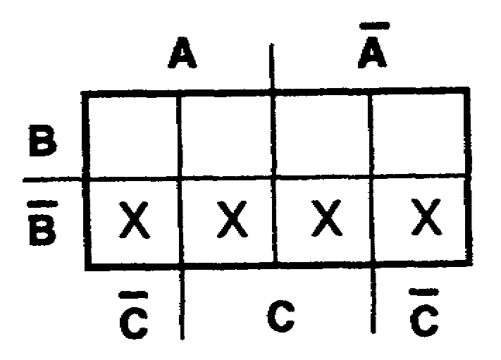

a. The term which is common to the four plotted squares above is ___________________.
b. The simplest expression which can be extracted from this Veitch diagram is ____________________.

a. B 64. Extract the simplest expression from each of
b. B the Veitch diagrams below.

a. c.
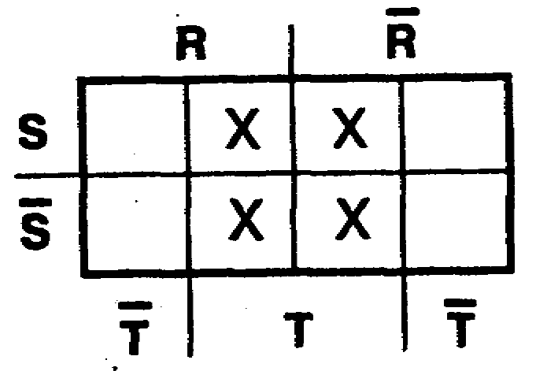
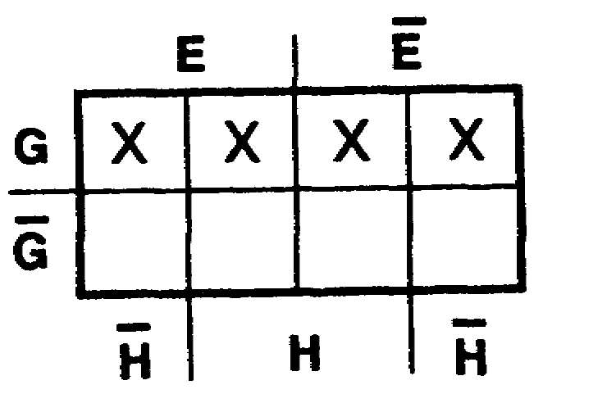

b. d.
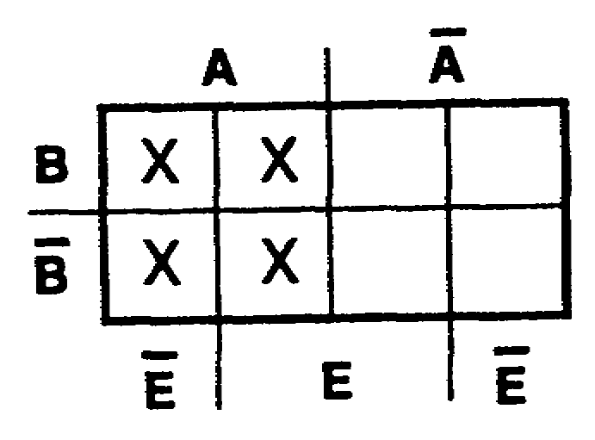
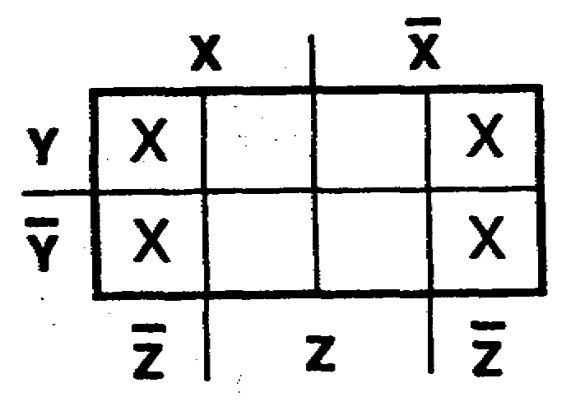

1-35 IT0345

a. T 65. When extracting the simplest expression from
b. Z an eight-square Veitch diagram, if there are
c. G no patterns of four plotted squares, look for
d. A patterns of two adjacent plotted squares which describe a two- variable term. Some examples are shown below.

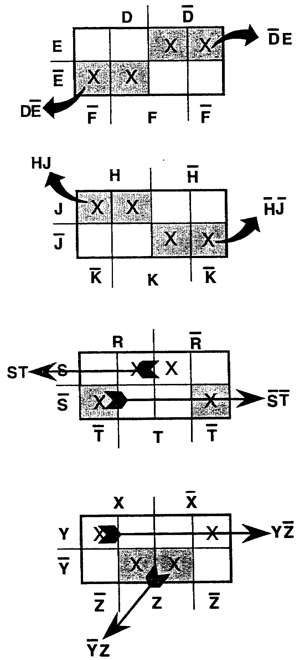

IT0345 1-36

65. (Continued)
Extract the simplest expression from each of the Veitch diagrams below.
a. b.
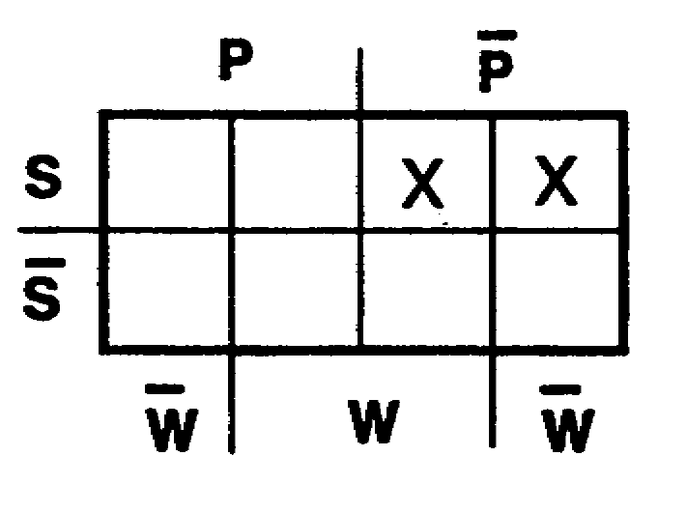
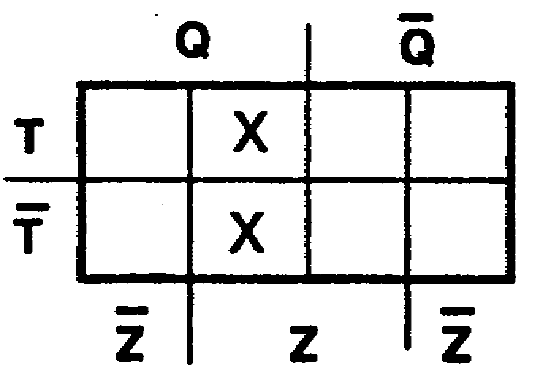

c.
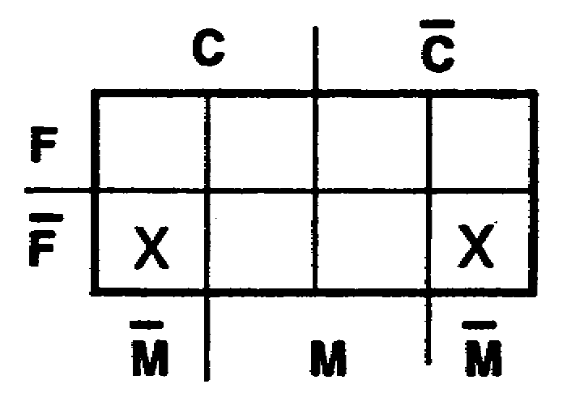

a. PS 66. If there are no patterns of four or two
b. QZ plotted squares, the next thing to
c. FM look for is single plotted squares. One
plotted square represents a three-variable term, as shown below.

a.
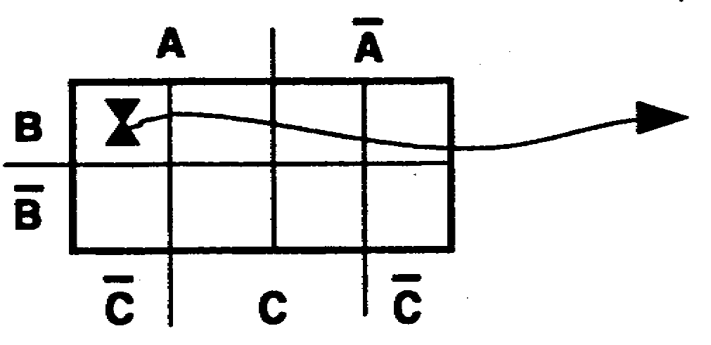
This plot represents the three-variable term ABC.

b.
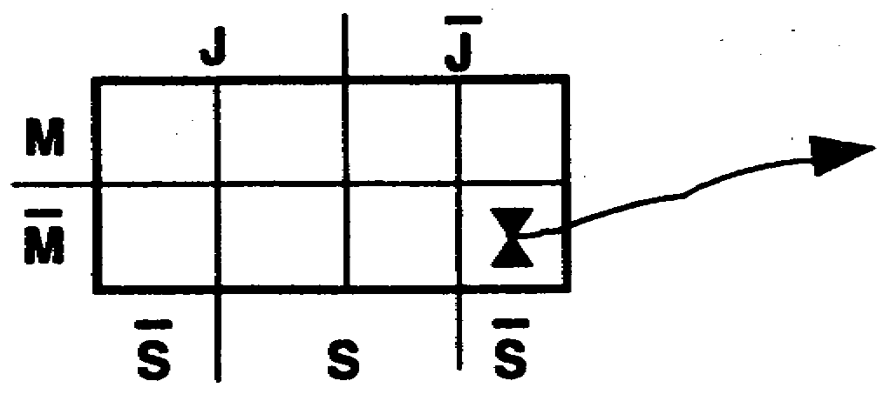
This plot represents the three-variable term JMS.

1-37 IT0345

66. (Continued)
Extract the simplest expression from each of the following Veitch diagrams:
a.
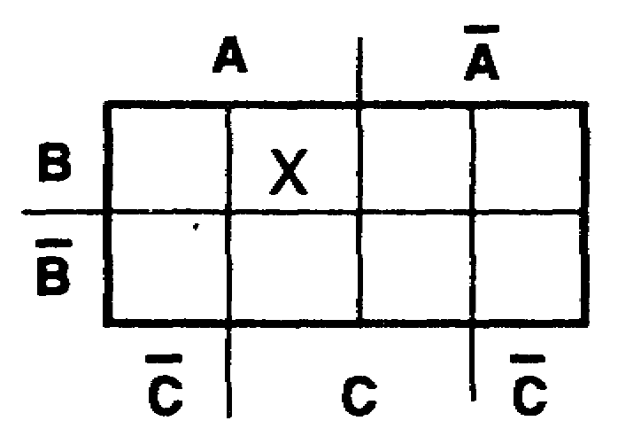

b.
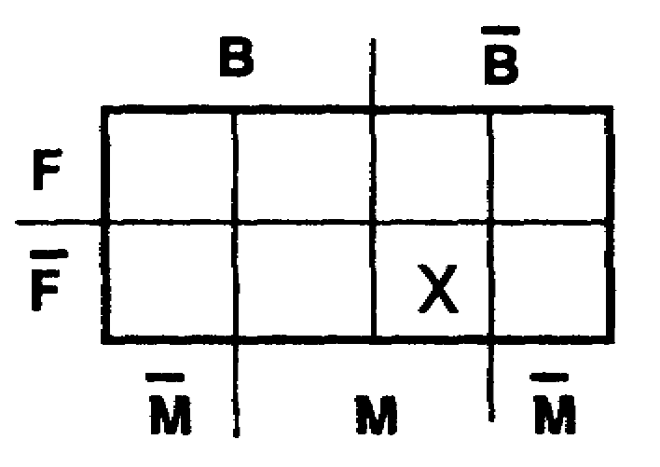

a. ABC 67. Up to this point, all plotted squares in the
b. BFM Veitch diagrams could be identified with just one term, such as A, GF, LTD, etc. It is often necessary to use more than one term to describe a plot. In these cases, the terms must be joined with OR signs. For example, expression ABC+ABC+ABC+ABC is plotted on the Veitch diagram below.
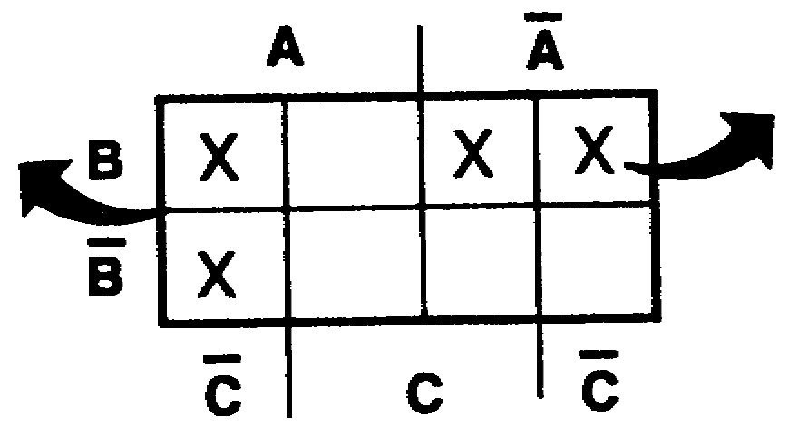
These squares These squares
represent the represent the
term AC. term AB.

To describe the plot above in simplified form, join the two terms (AC and AB) with an OR sign. Expression ABC+ABC+ABC+ABC is described in simplified form as AC+AB.

IT0345 1-38

67. (Continued)
Describe the following plots in simplified form.

a.
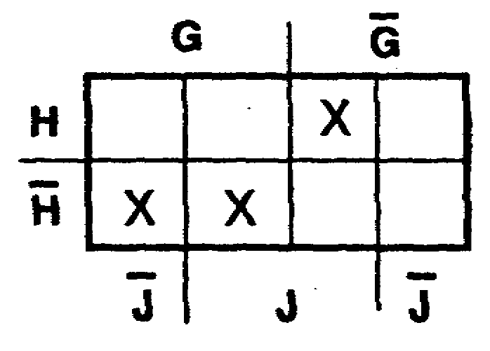

b.
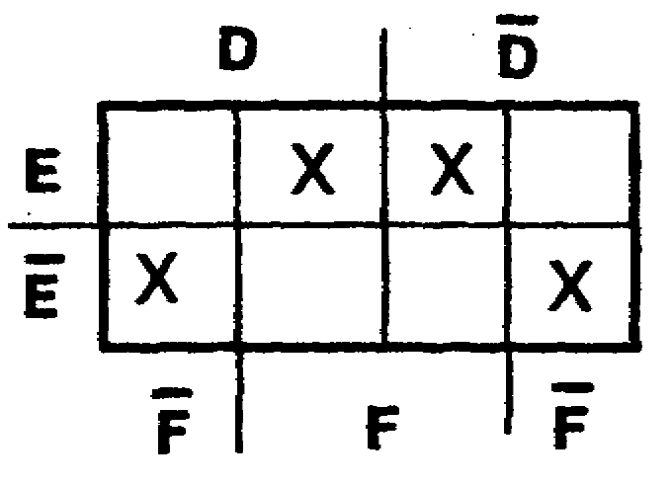

a. GHJ+GH 68. To describe the plotted squares in an eight-
b. EF+EF square Veitch diagram, look for patterns of plotted squares in the following order of preference:

a. Four plotted squares which describe a _______________________-variable term.

b. Two plotted squares which describe a _______________________-variable term.

c. One plotted square which describes a _______________________-variable term.

1-39 IT0345

a. one 69. A plot should be described with as few terms
b. two as possible. Each term should contain as few
c. three variables as possible.
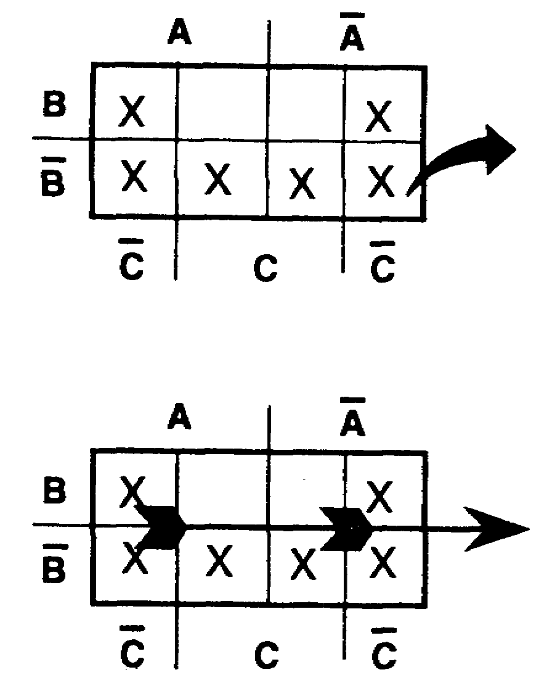

These four squares represent the term B.

On the same Veitch diagram, these four squares represent the term C.

All six plotted squares combined are described as B+C.
Notice that the lower corner squares are used twice, allowing two groups of four squares, each described by a one-variable term.
Referring to the top diagram above, this plot could have been described as follows: The shaded area is described as B. The two unshaded squares could be described as BC and would result in a plot described as B+BC. One term now contains two variables (BC).
Which of the following expressions is simpler?
a. B+C
b. B+BC

IT0345 1-40

a. 70. A plot should be described with as few terms as possible. Each term should contain as few variables as possible. This is accomplished by using one or more squares any number of times in combination with one or more squares not previously used to make groups of 4 or 2 squares.
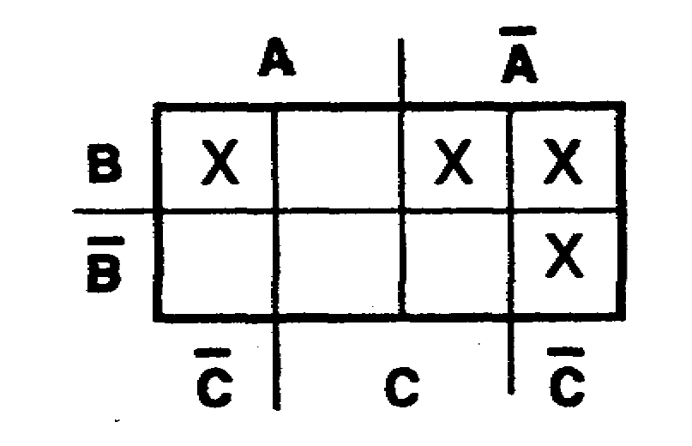

In the diagram above, there are no combinations of four potted squares. The plotted square in the upper right-hand corer can be combined with the plotted square directly beneath it to describe AC; it can also be combined with the plotted square immediately to the left to describe AB; and it can be combined with the plotted square in the upper left-hand comer to describe BC.
The simplest expression describing this plot is
a. ABC+AB+AC.
b. AB+AC+BC.
c. ABC+ABC+ABC+ABC.

1-41 IT0345

b. 71. At times, there are two equally simple ways to describe a plot. For example, in the Veitch diagram below, it is evident that there are no groups of four plotted squares. There are, however, three distinct groups of two plotted squares. This plot can be described two different ways as follows:

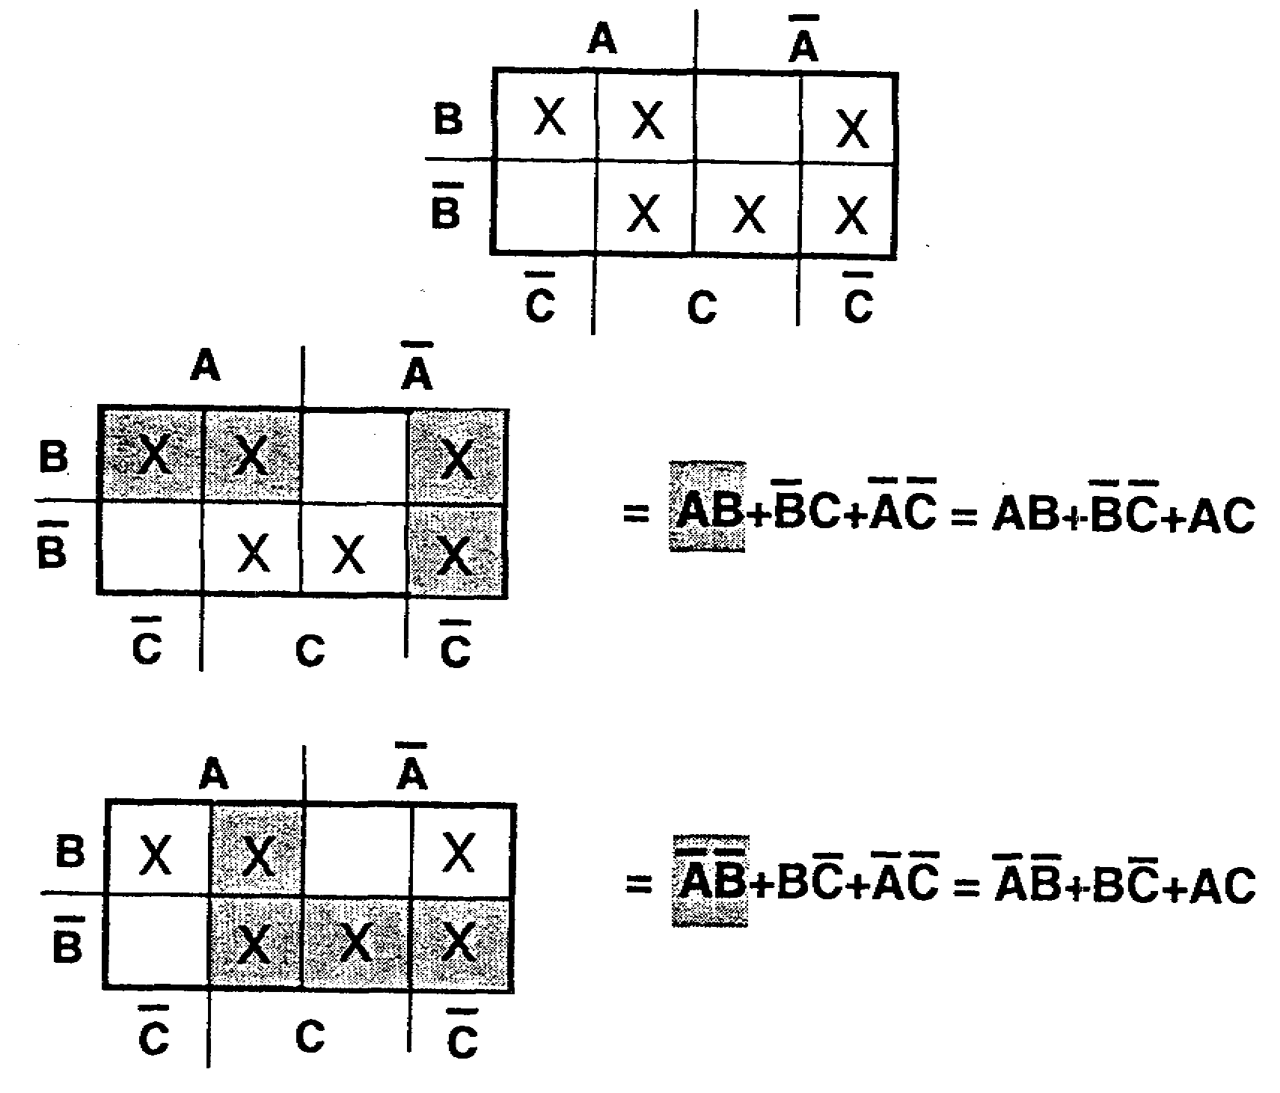

Either of the expressions above is correct. The number of terms and the variables are comparable; therefore, the two expressions are equally simple. Extract a simplified expression from the Veitch diagram below.
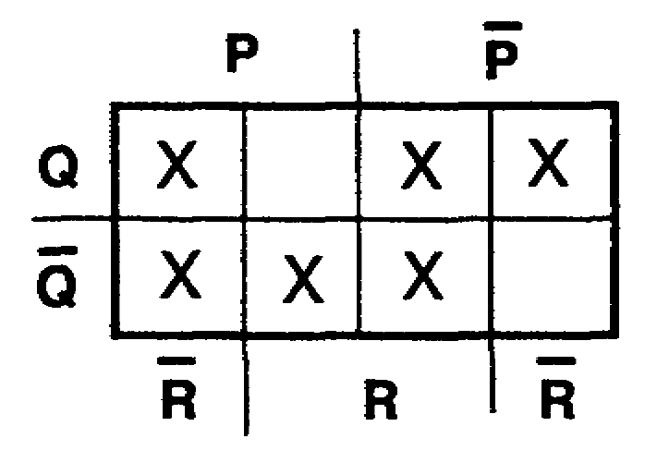

IT0345 1-42

PR+QR+PQ 72. TEST FRAME
or Extract the simplest expression from each of
QR+PQ+PR the Veitch diagrams below.

a. b.
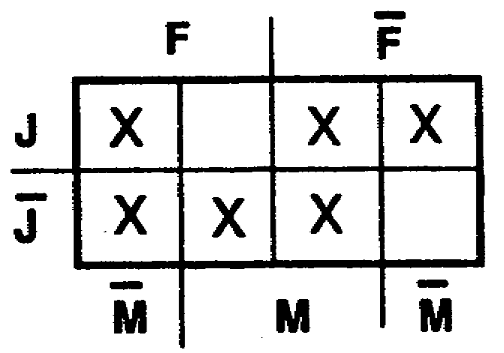
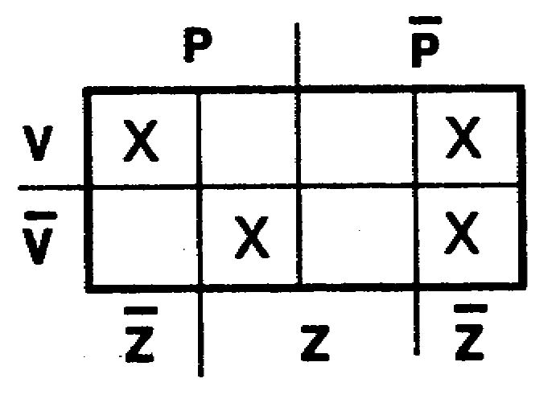

a. FM+FJ+JM 73. Simplify the following expressions, using the
or Veitch diagrams.
FM+FJ+JM a. FH+FGH+FGH+FG+FGH
b. PZ+VZ+PVZ
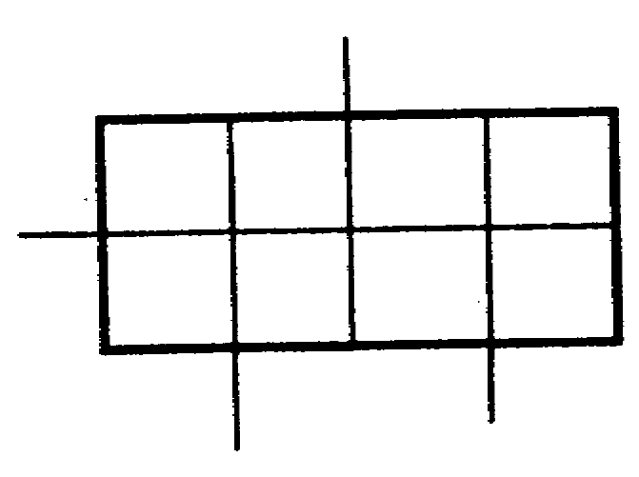

b. BCD+BCD+BC+BCD+BCD+BC
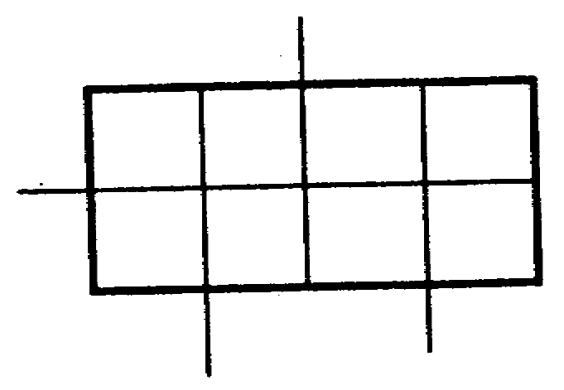

1-43 IT0345

a. H+F 74. TEST FRAME
b. BC+BC+BD Convert the following expressions to minterm
or form and simplify.
BC+BC+CD a. C(AB+AB) +ABC+A(BC+CA)
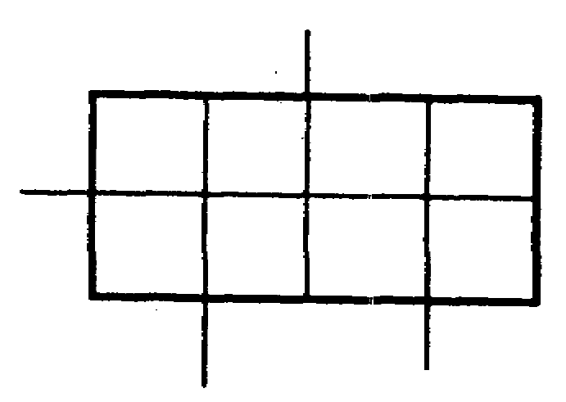

(Solutions on
page 1-62.)

b. D+E+F+D(EF+EF)+DEF+E(DF+DF)
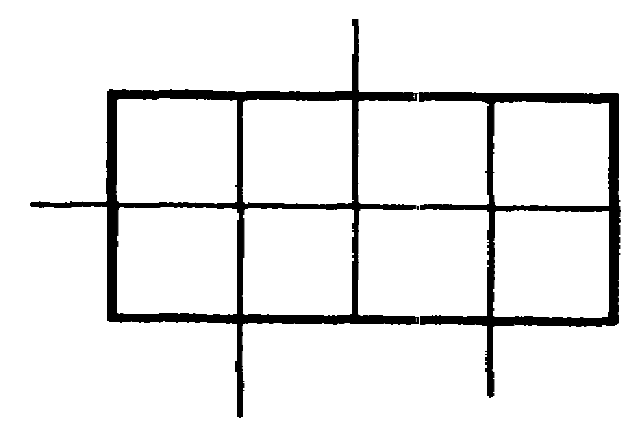

a. AB+BC+ABC 75. How many squares are there in a Veitch
b. DE+EF+DF diagram for four variables?
or
EF+DF+DE

(Solutions on
pages 1-63
and 1-64.)

IT0345 1-44

16 (2⁴) 76. As shown below, a Veitch diagram for four variables, A, B, C, and D, is labeled in the conventional manner (alphabetically, counterclockwise).
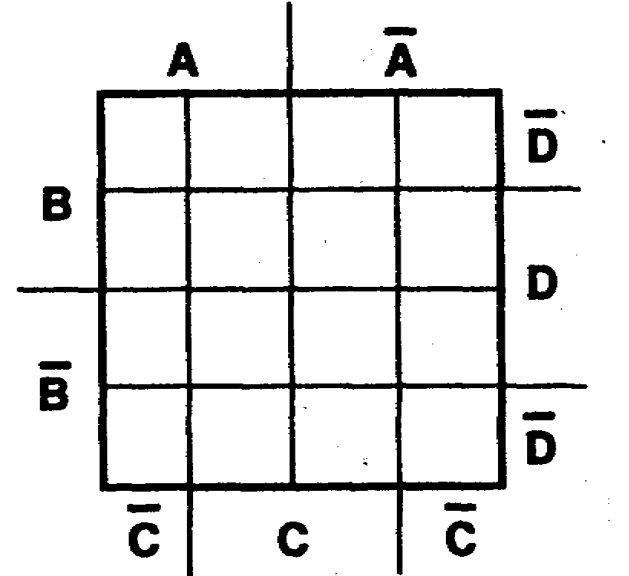

Half of the squares are assigned to each variable; and half, to the complement of each variable. In a four-variable Veitch diagram, how many squares are assigned to a one-variable term, such as B?

Eight. 77. Plot the following expressions:
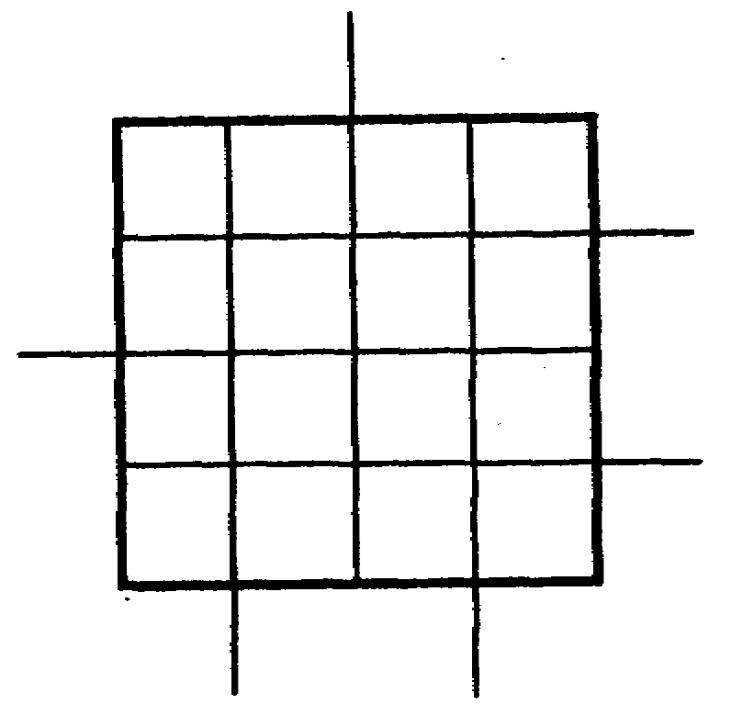
a. A+B+C+D

b. J+K+L+M
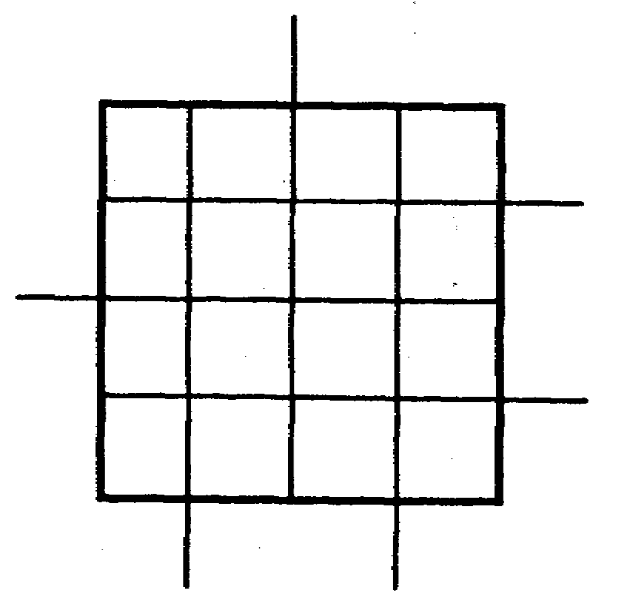

1-45 IT0345

a. b.
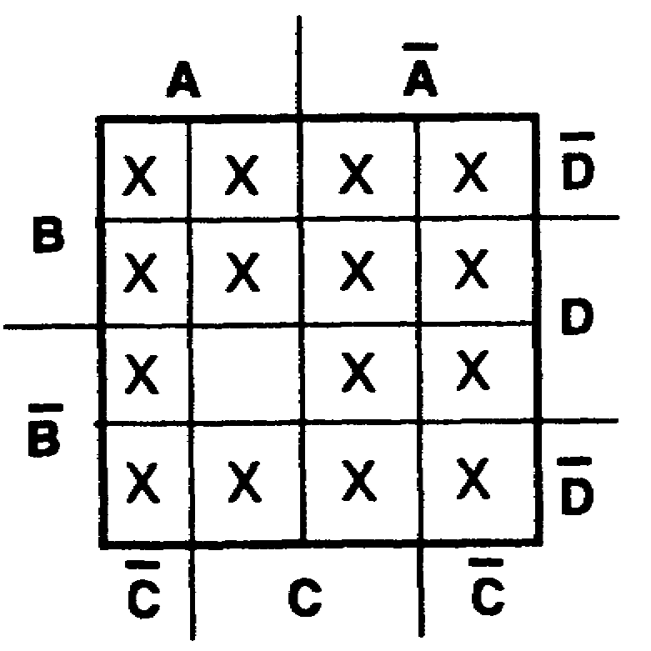
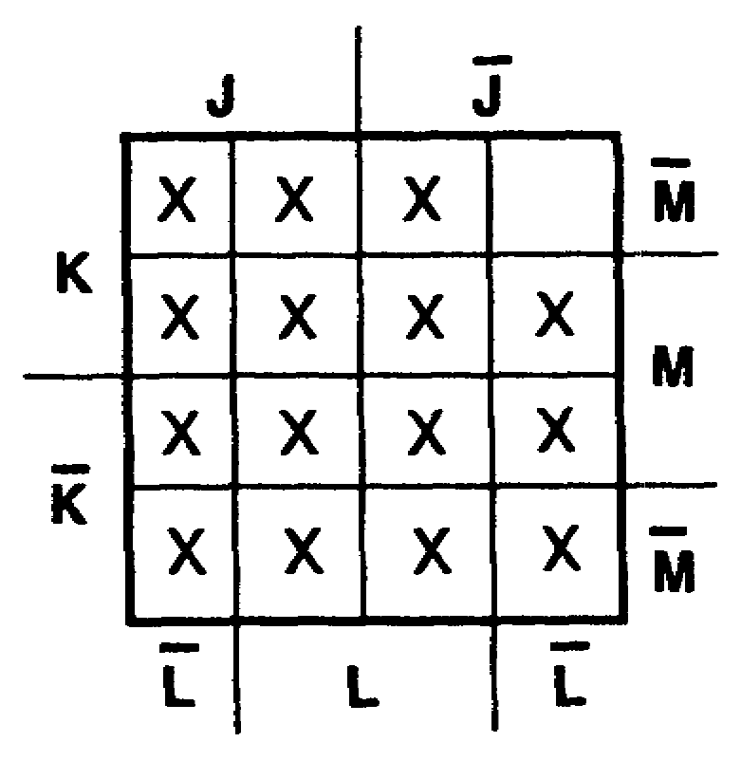

78. In a four-variable Veitch diagram, each one-variable term occupies eight squares. A two-variable term, such as AC, which occupies four squares, is plotted below.
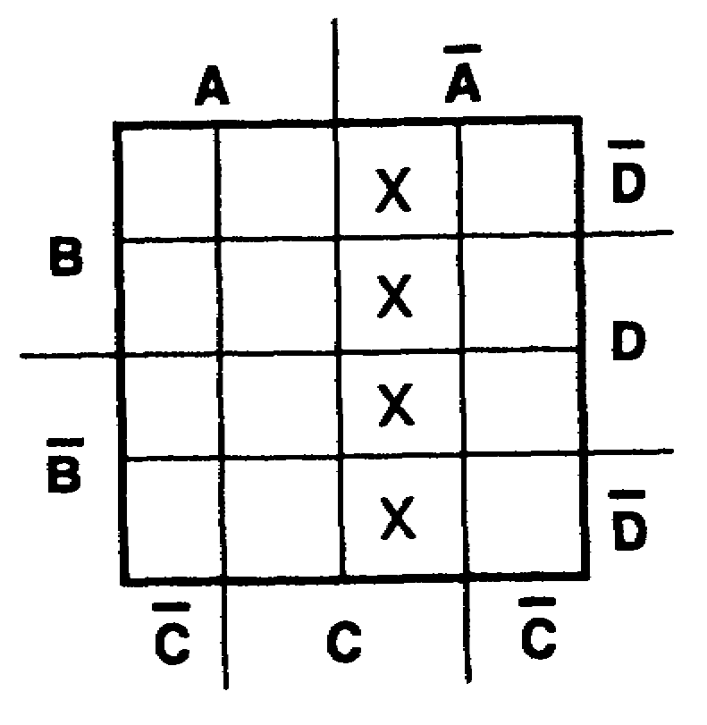

A two-variable term occupies __________ squares in a four-variable Veitch diagram.

IT0345 1-46

four 79. Plot the following expressions:
a. QT+RT+RS
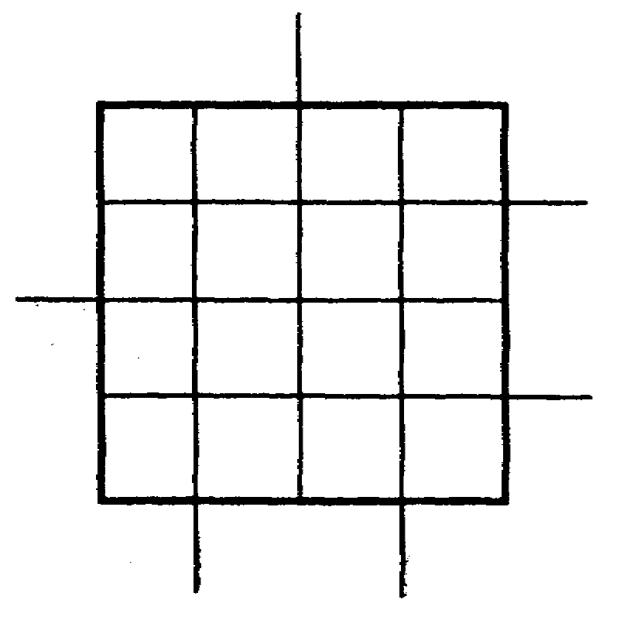

b. JK+L+JM+KL

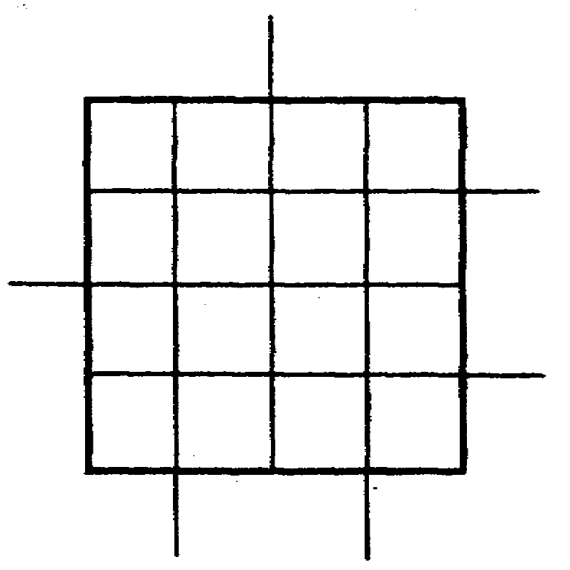

a. b.
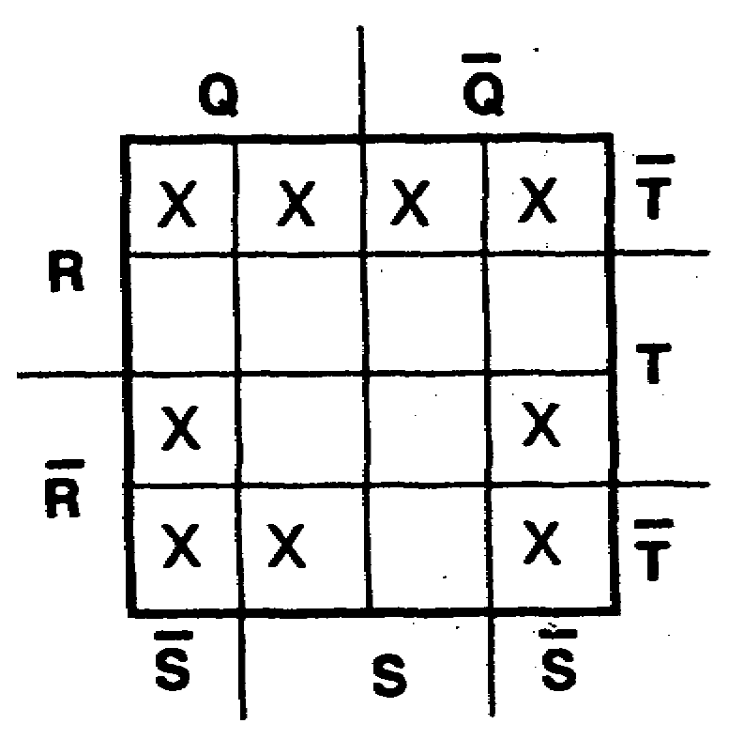
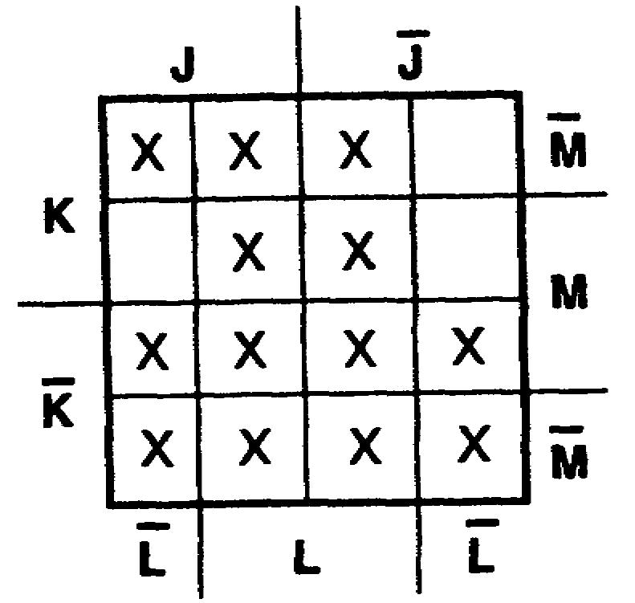

1-47 IT0345

80. A two-variable term, such as CD, which occupies four squares, is plotted below.

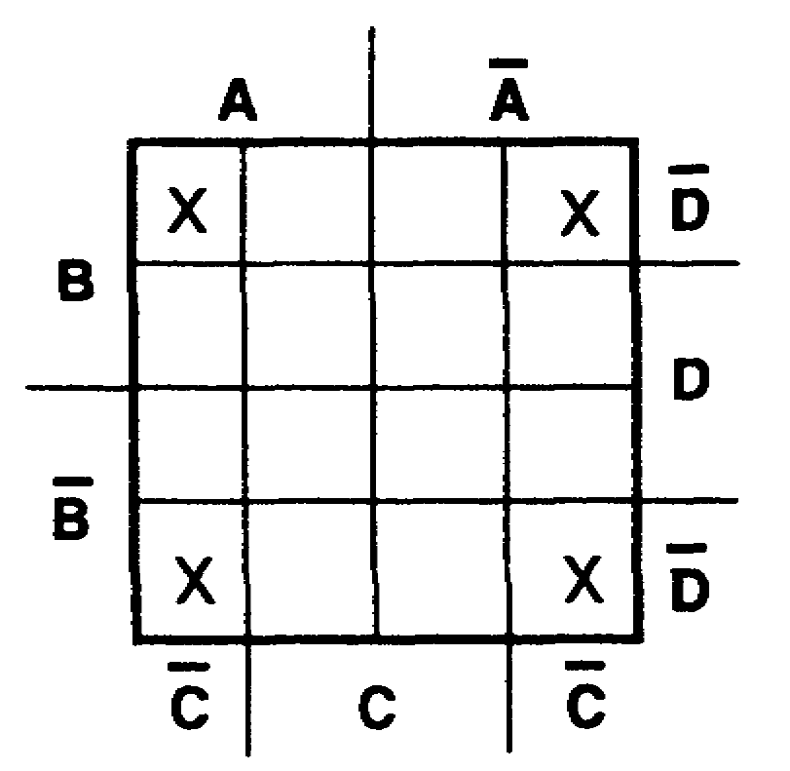

Notice that only the four corner squares are plotted. Although these four corner squares may not appear to be common, they are, in fact, common to variables CD and, in this case, represent the two-variable term CD.
Plot the following expression:
TZ+AB+AB

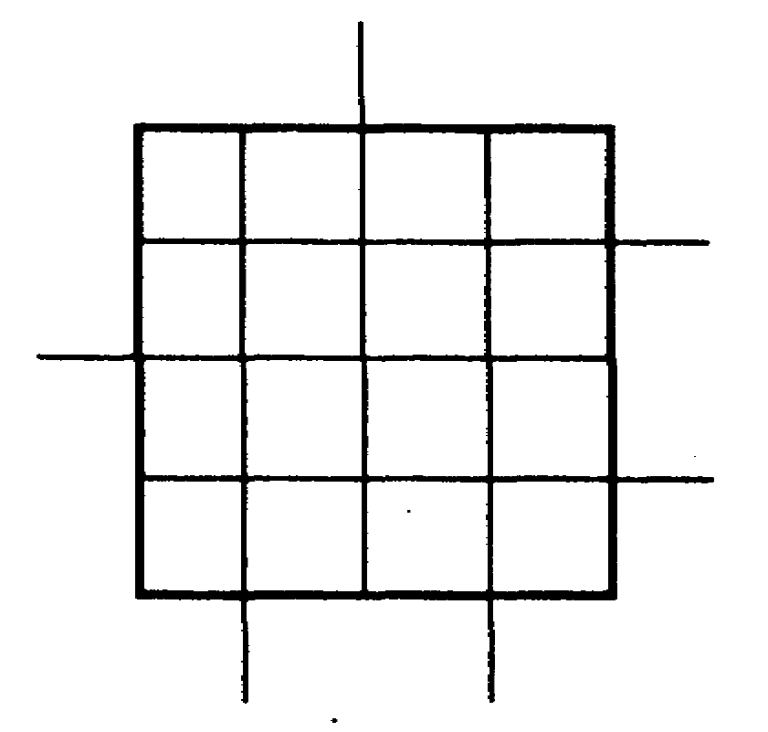

IT0345 1-48

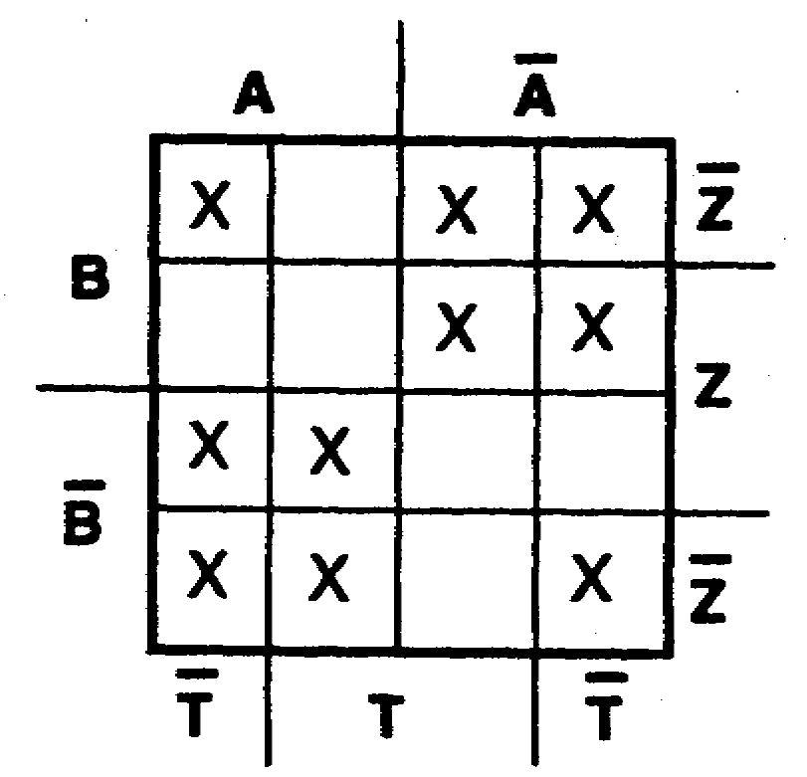

81. In a four-variable Veitch diagram, a one-variable term occupies eight squares; a two-variable term occupies four squares; a three-variable term occupies two squares. A three-variable term, such as ABC, is plotted below.
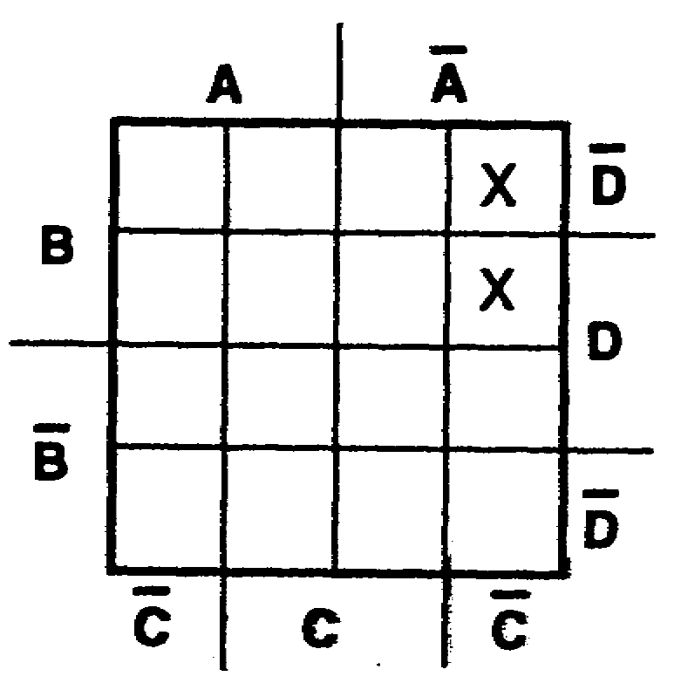

In a four-variable Veitch diagram, a three-variable term occupies ______________ squares.

two 82. Plot the following expressions:
a. ACF+CFH+AF+AH b. DE+DFG+G+DEF
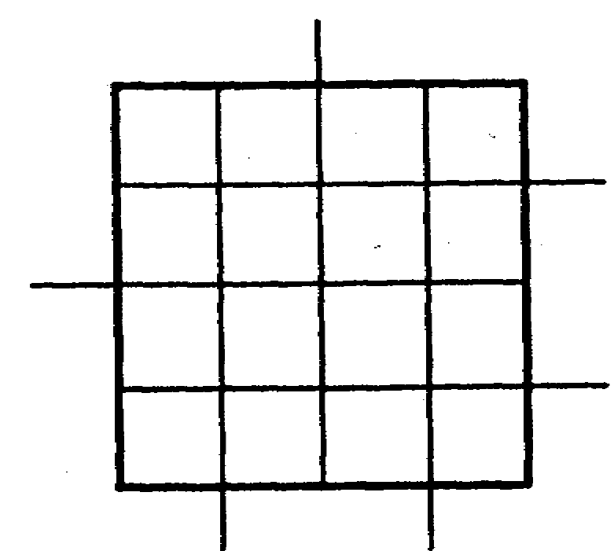
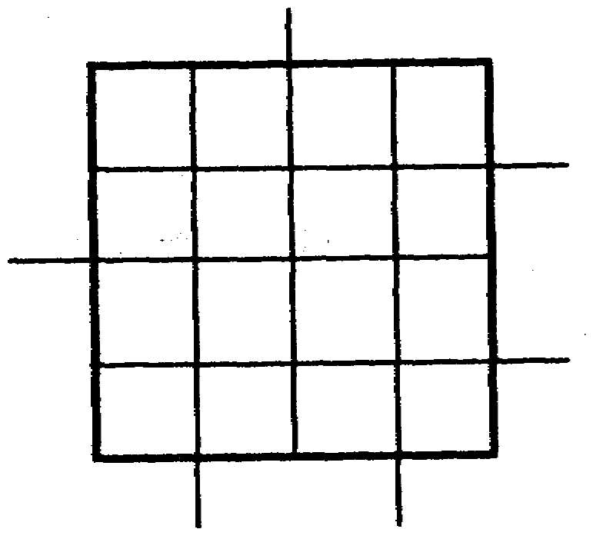

1-49 IT0345

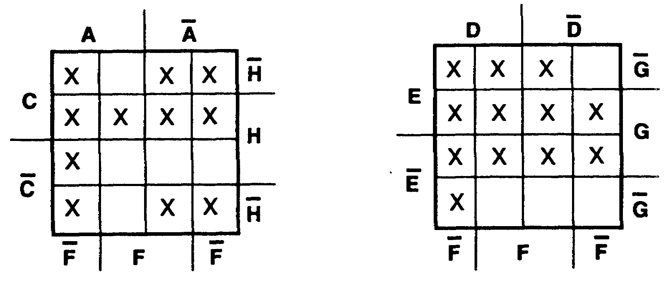

83. TEST FRAME

In a four-variable Veitch diagram, a four-variable term occupies only one square. For example, the term ABCD is plotted on the Veitch diagram below.
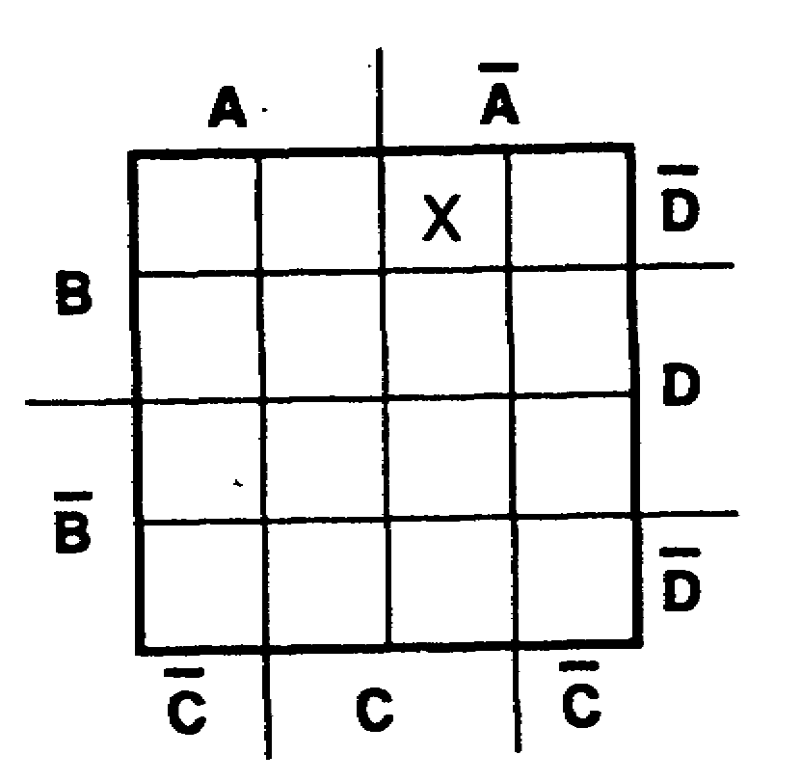

In a four-variable Veitch diagram,
a. a one-variable term occupies __________ square/s.
b. a two-variable term occupies __________ square/s.
c. a three-variable term occupies ________ square/s.
d. a four-variable term occupies __________ square/s.

IT0345 1-50

a. eight 84. TEST FRAME
b. four Plot the following four-variable expressions:
c. two a. ABCD+ABCD+ABCD
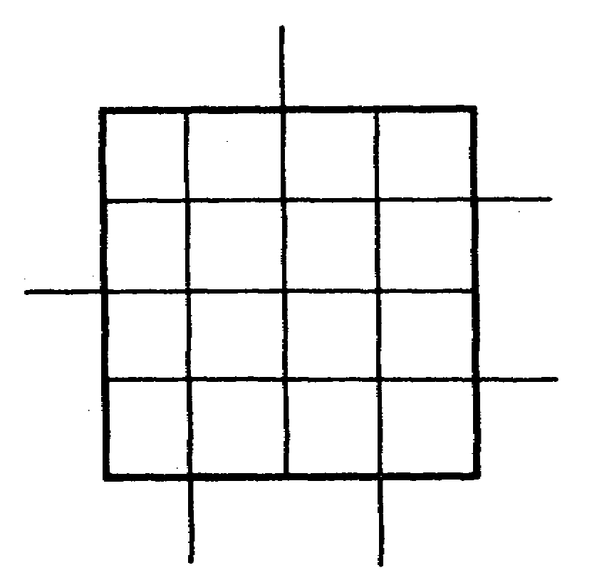
d. one

b. NPS+NPST+P+NS
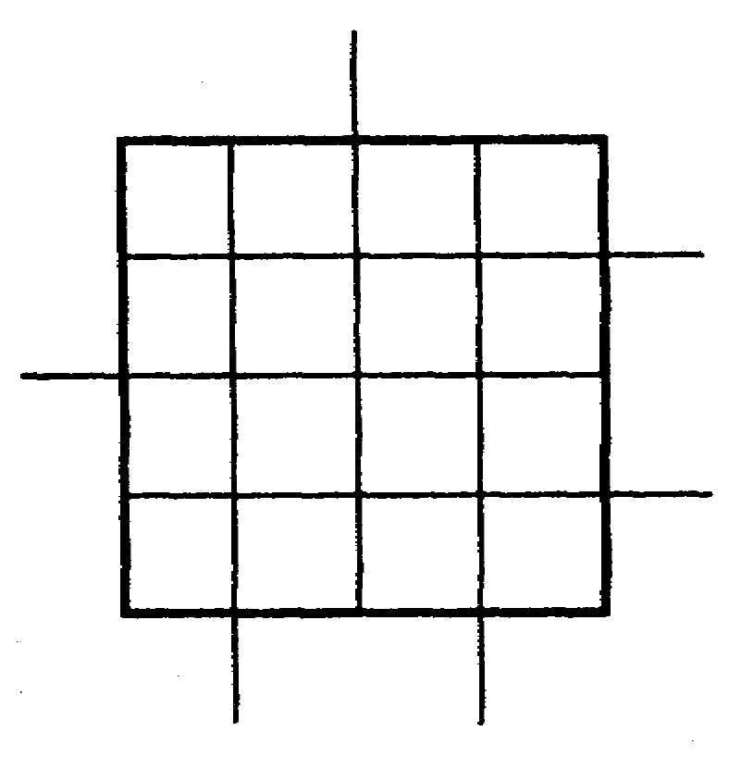

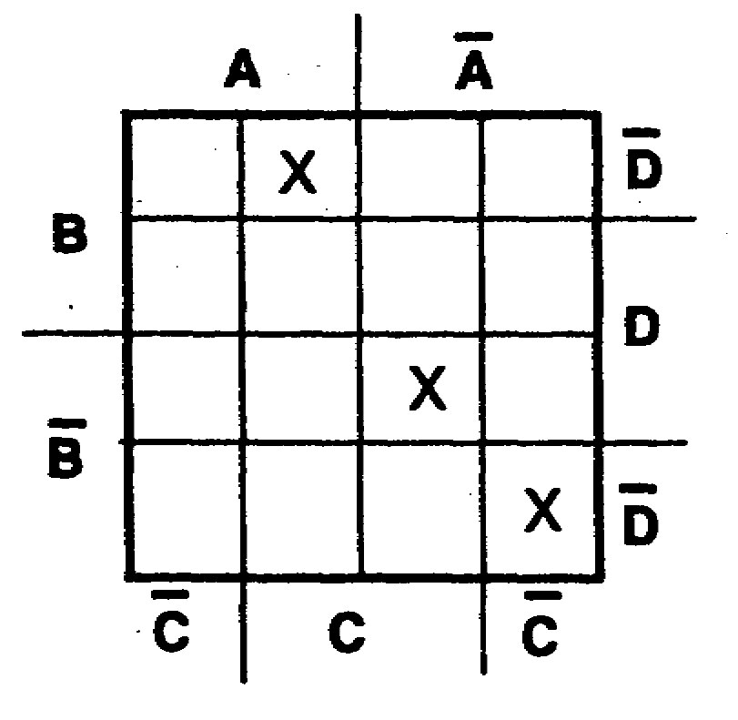
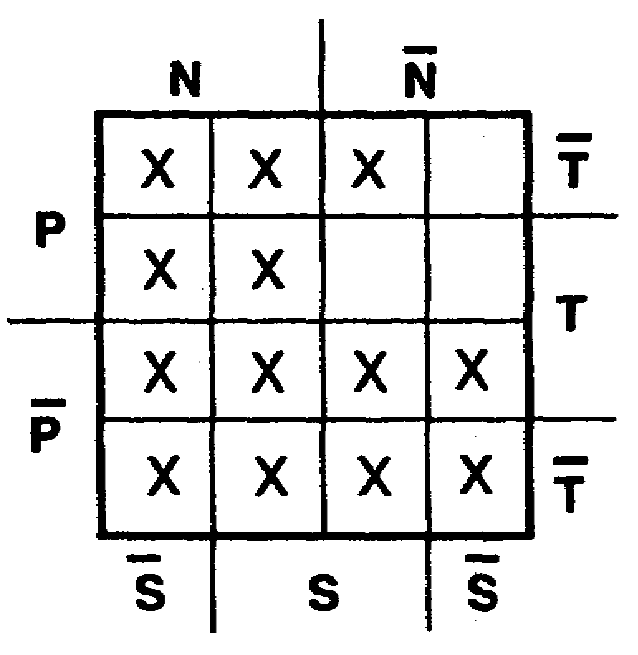

1-51 IT0345

85. It is more difficult to see patterns of plotted squares on a 16-square Veitch diagram than it is on an eight-square diagram. Look for patterns which are formed by adjacent squares or by squares at opposite ends of rows. Some examples are shown below.

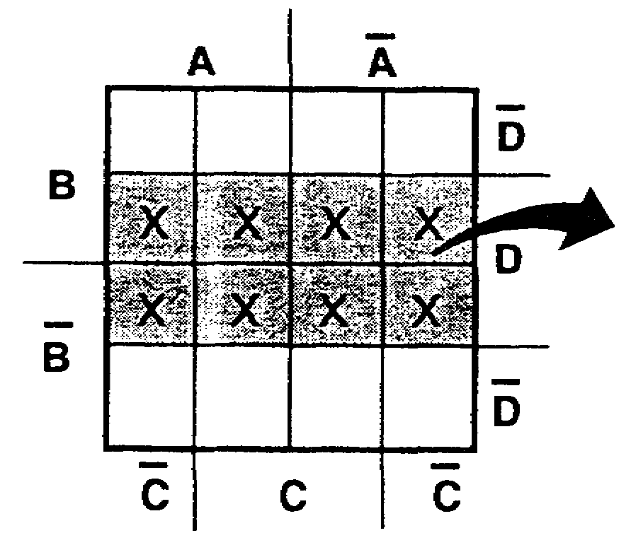

These eight squares are adjacent and common only to variable D.

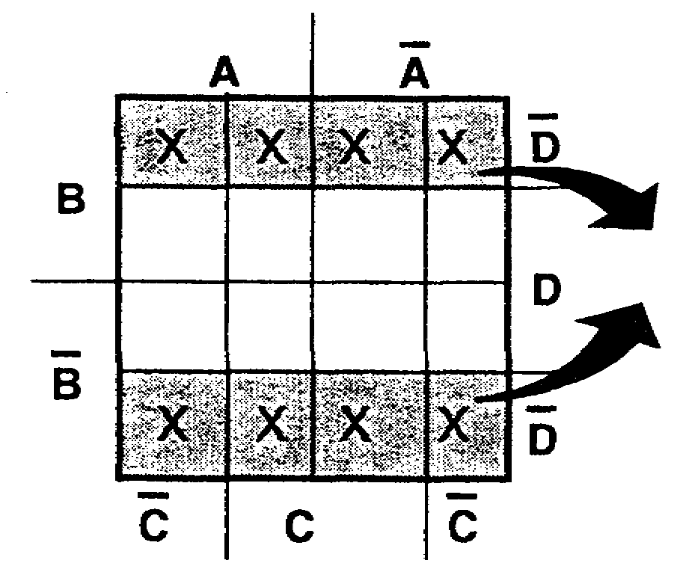
These eight squares are at opposite ends of rows and common only to variable D.

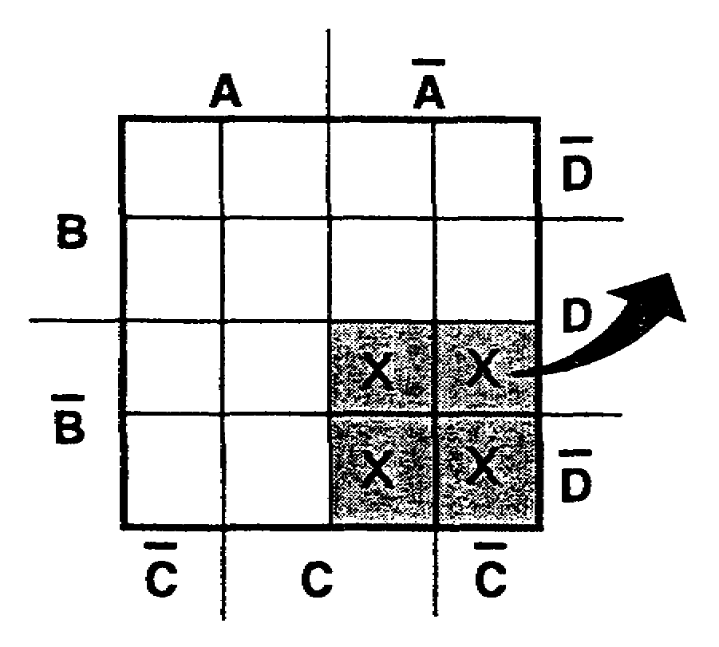

These four squares are adjacent and common only to variables AB.

IT0345 1-52

85. (Continued)

d.
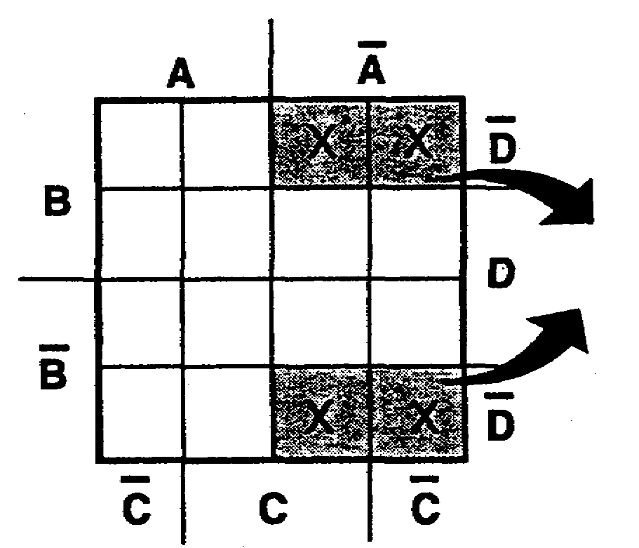

These four squares are at opposite ends of rows and are common only to variables AD.

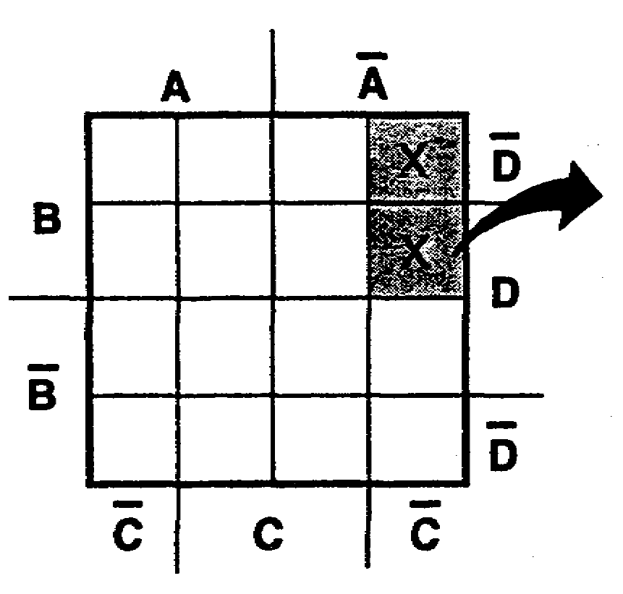
e.
These two squares are adjacent and common only to variables ABC.

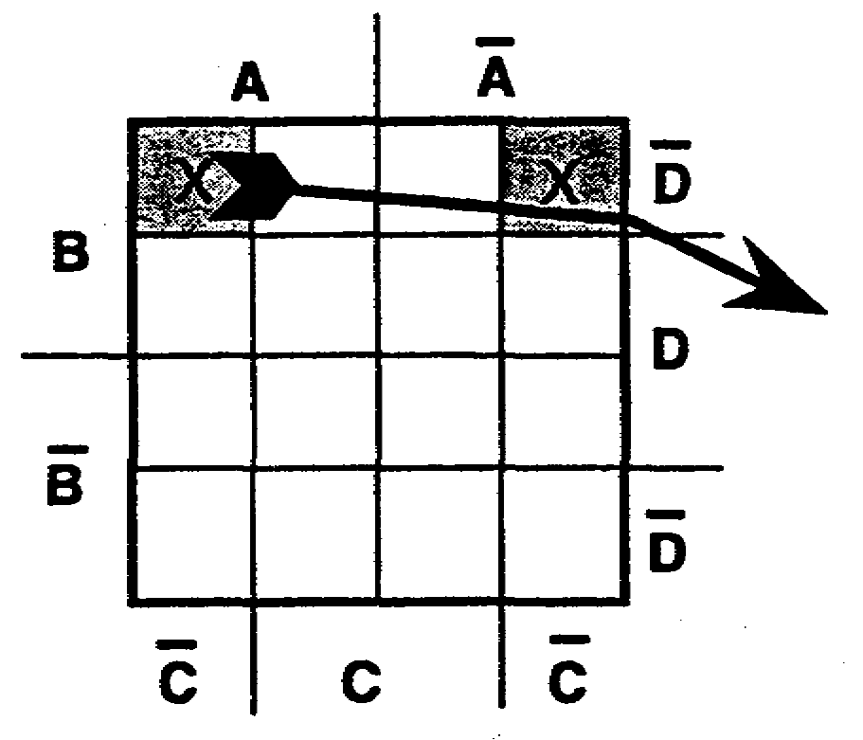

f. These two squares are at opposite ends of rows and common only to variables BCD.

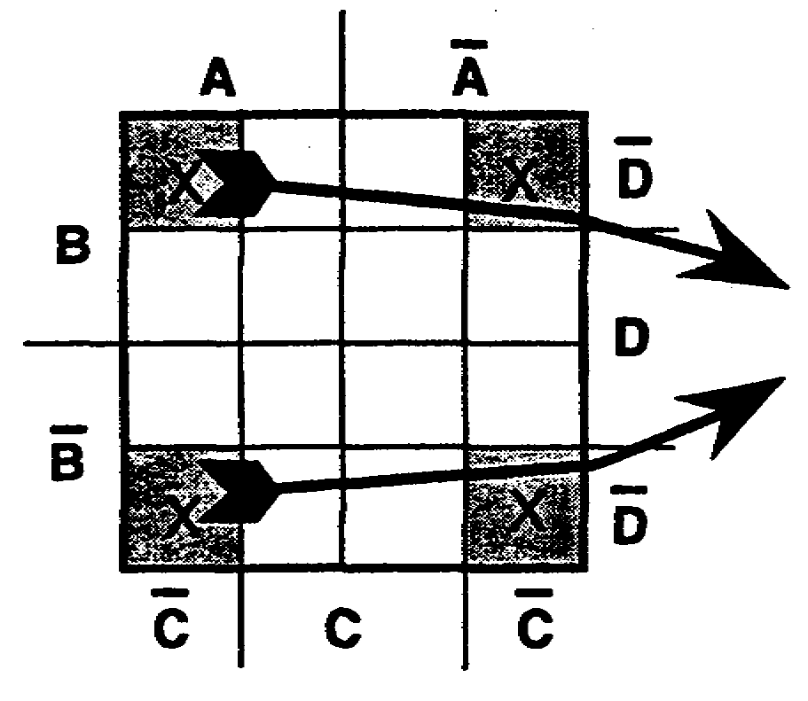
g. These four squares are at opposite ends of rows and common only to variables CD.

1-53 IT0345

85. (Continued)
Describe the following plots:
a. b.
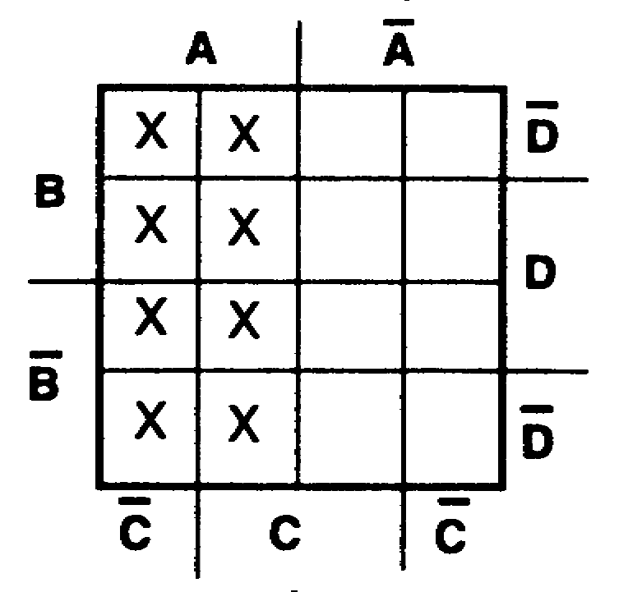
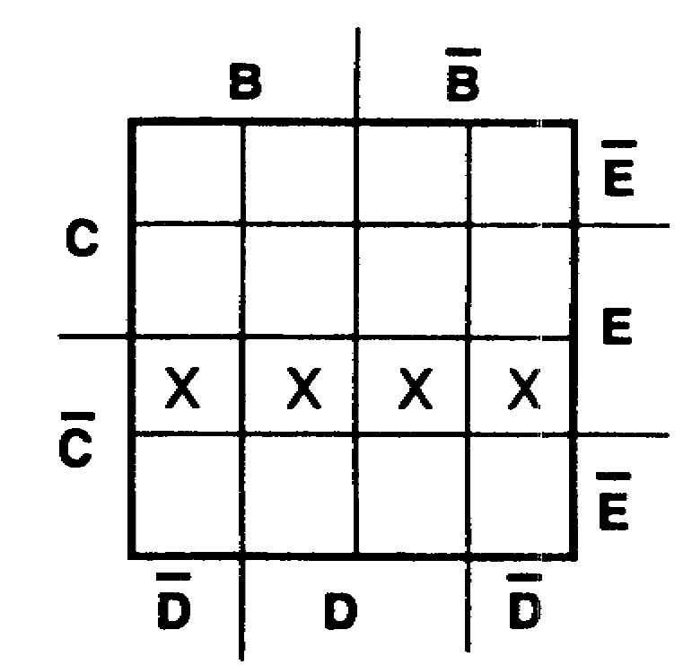

c. d.
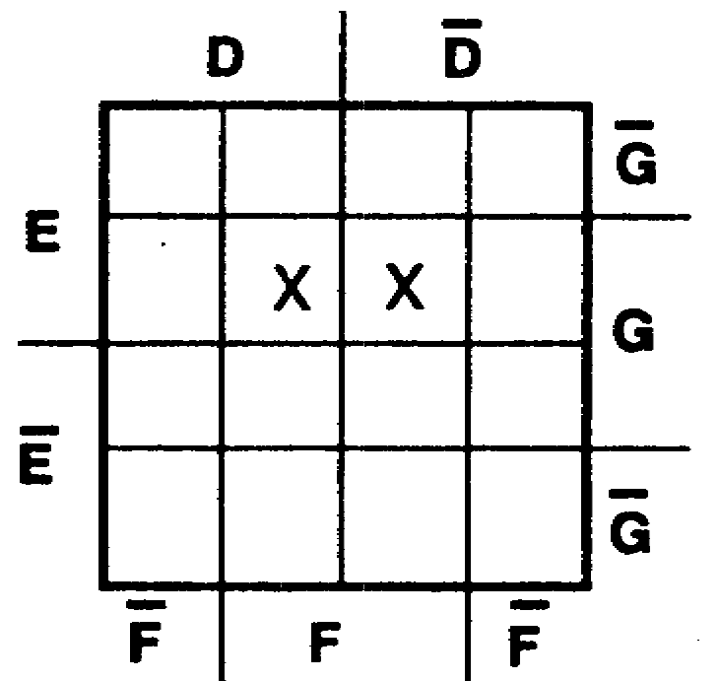
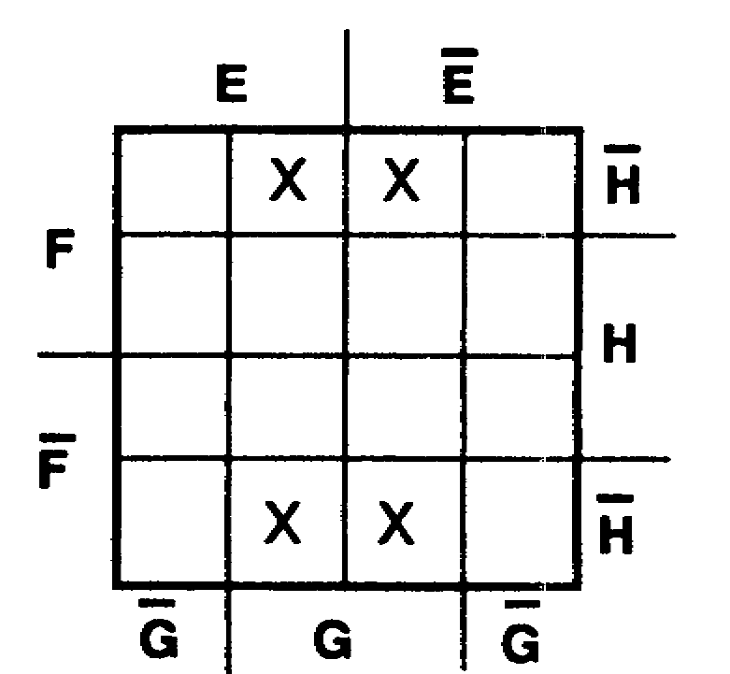

a. A 86. The same methods of extracting a simplified
b. CE expression are applied to a 16-square Veitch
c. EFG diagram as for an eight-square diagram. To
d. GH extract the simplified expression, describe the plot with as few terms and as few variables as possible. Look for patterns of plotted squares in the following order of preference:
a. Eight plotted squares which describe a one-variable term.
b. Four plotted squares which describe a two-variable term.
c. Two plotted squares which describe a three-variable term.
d. One plotted square which describes a four-variable term.

IT0345 1-54

86. (Continued)
Describe the following plots as simply as possible.

a. b.
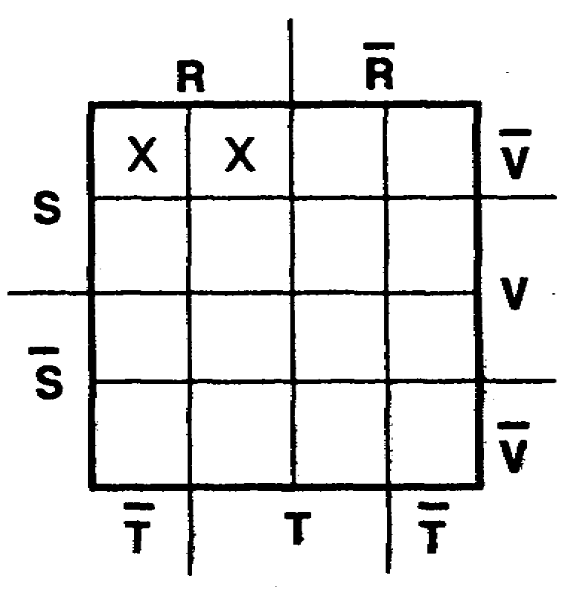
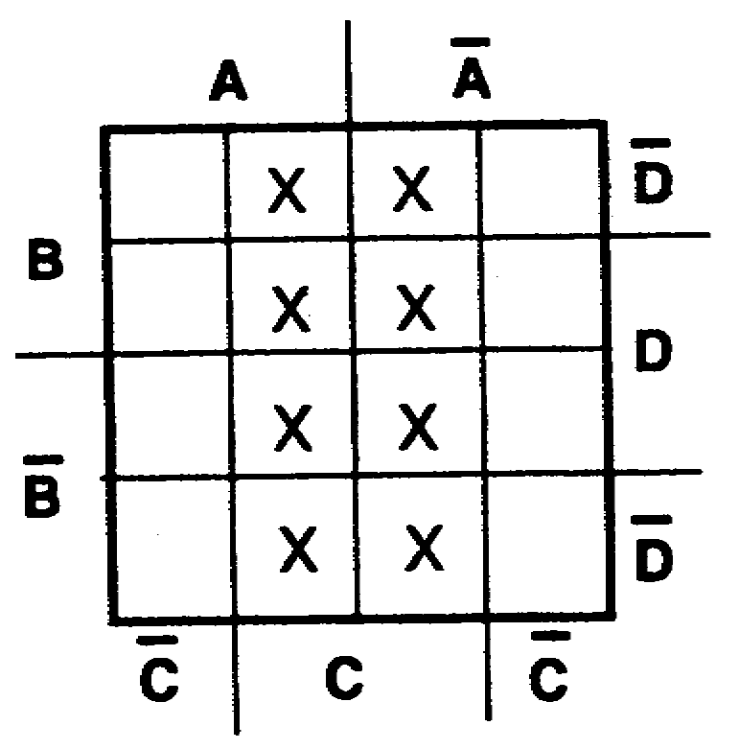

c. d.
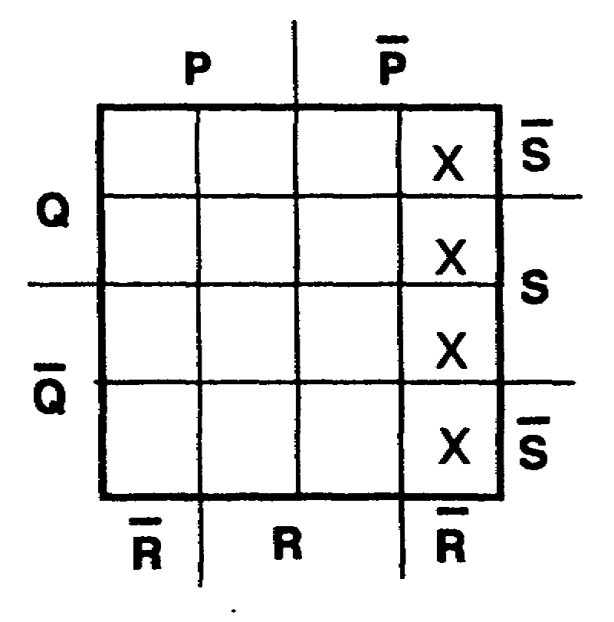
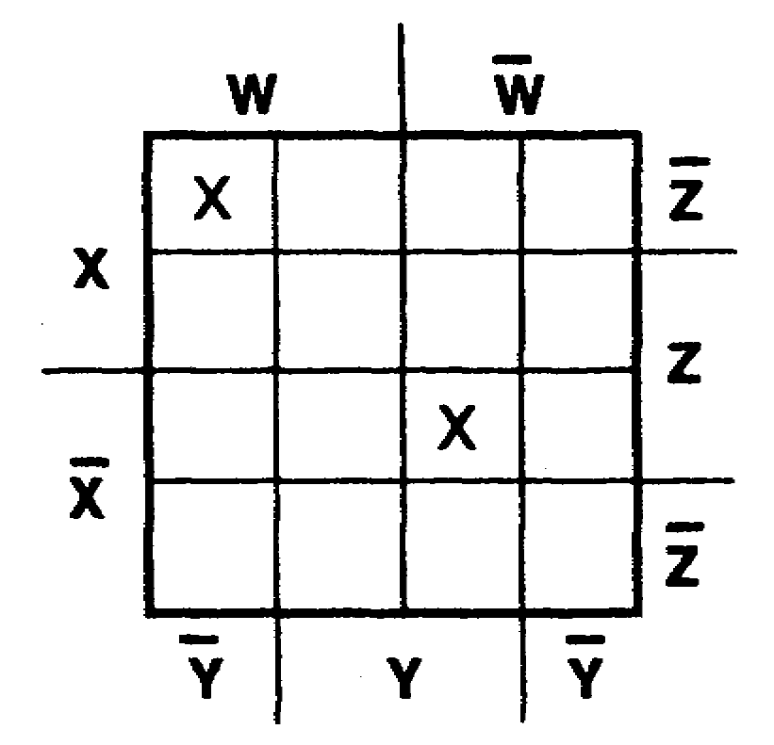

e. f.
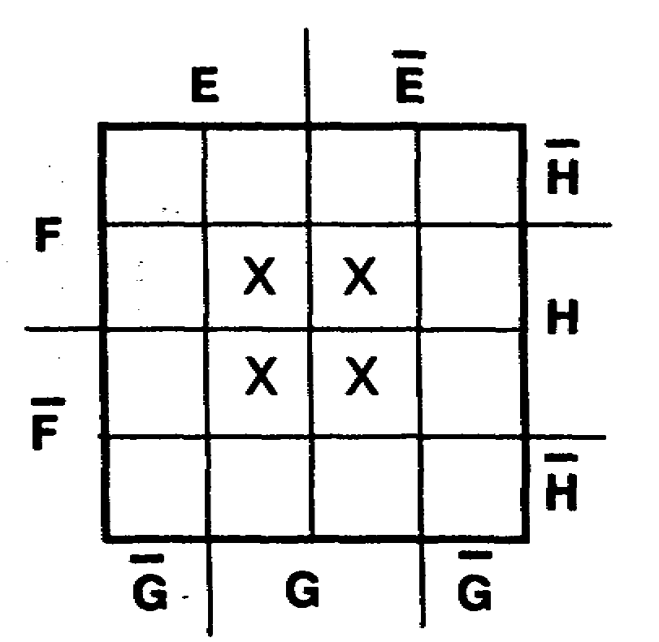
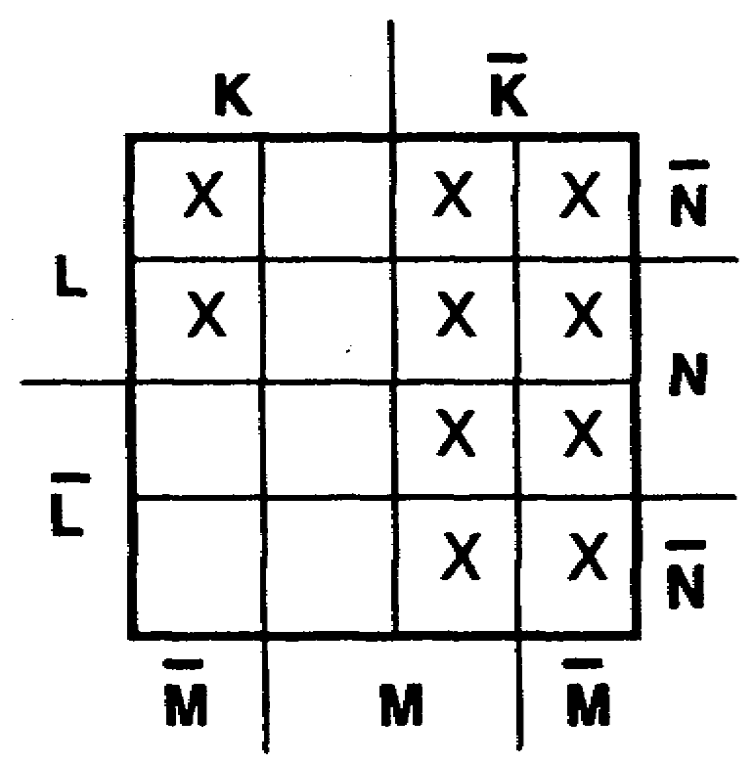

1-55 IT0345

a. C 87. Look for patterns of plotted squares and
b. RSV extract the simplest expressions from the
c. PR following plots. Describe each plot with as
d. WXYZ+WXYZ few terms and as few variables as possible.
e. GH
f. K+LM a. b.
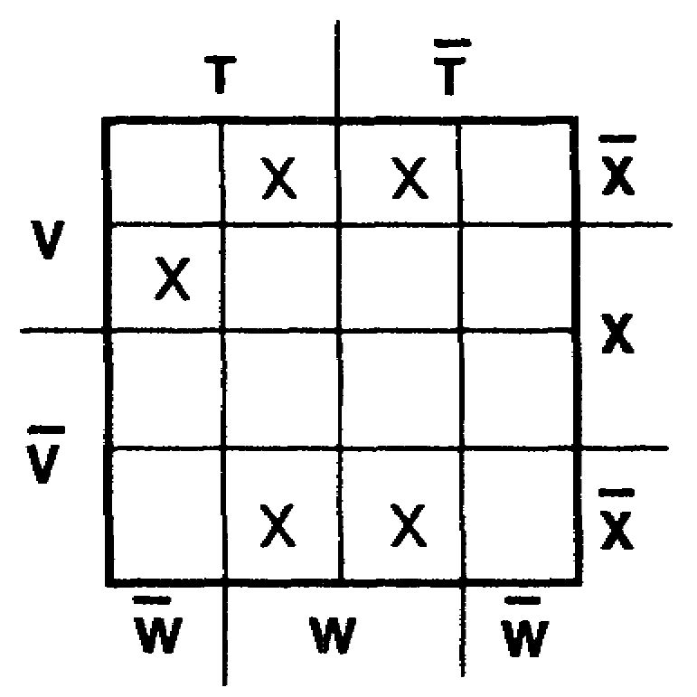
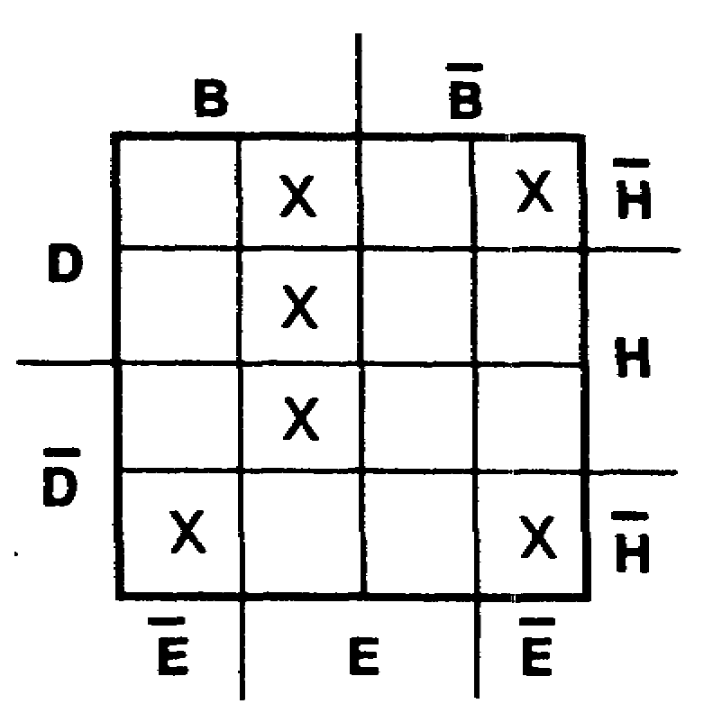

(Solutions on
pages 1-65 and
1-66.)

a. WX+TVWX 88. TEST FRAME
b. BDE+BEH Extract the simplest expression from each of
+DEH+BEH the Veitch diagrams below.

(Solutions on
page 1-67. a. b.
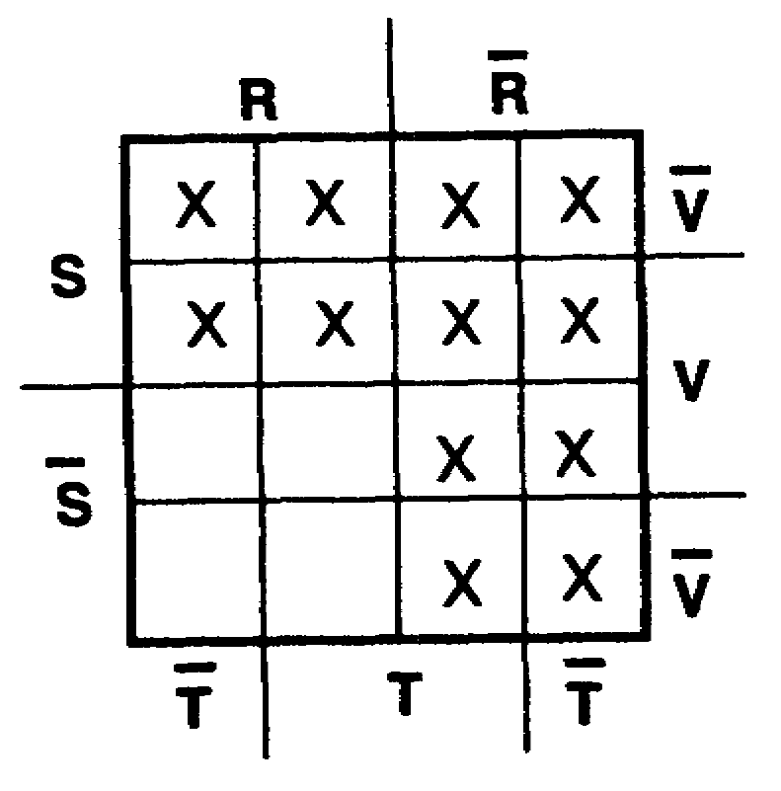
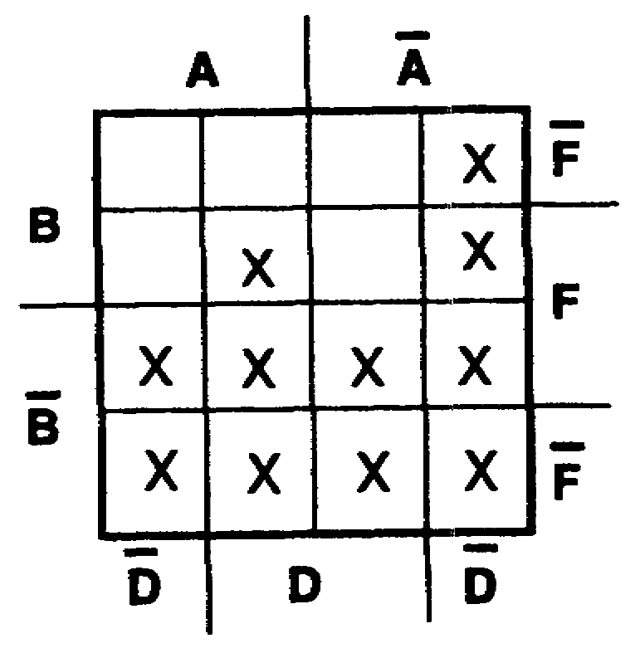

IT0345 1-56

a. R+S 89. To simplify a four-variable expression, using
b. B+AD+ADF the Veitch-diagram method, the expression must be in minterm form (all parentheses
(Solution on removed and all vincula broken). To simplify
page 1-68.) the expression (AB+AC)D+D+C+A+ABCD, first convert to minterm form, as shown below.

(AB+AC)D + D + C + A + ABCD
Distributive De Morgan's theorem
ABD + ACD + DCA + ABCD
Double
negative
ABD + ACD + DCA + ABCD
To simplify a four-variable expression, using the Veitch-diagram method, the expression must be in ___________________________ ___________________.

minterm form 90. TEST FRAME
After converting the expression to minterm form, the next step is to draw a Veitch diagram. For the expression ABD+ACD+DCA+ABCD, there are four variables; therefore, a 16-square Veitch diagram (2⁴ = 16) is required. The expression is plotted as follows:

Plot only one term at a time until all terms of the expression have been plotted: ABD+ACD+DCA+ABCD.

1-57 IT0345

90. (Continued)

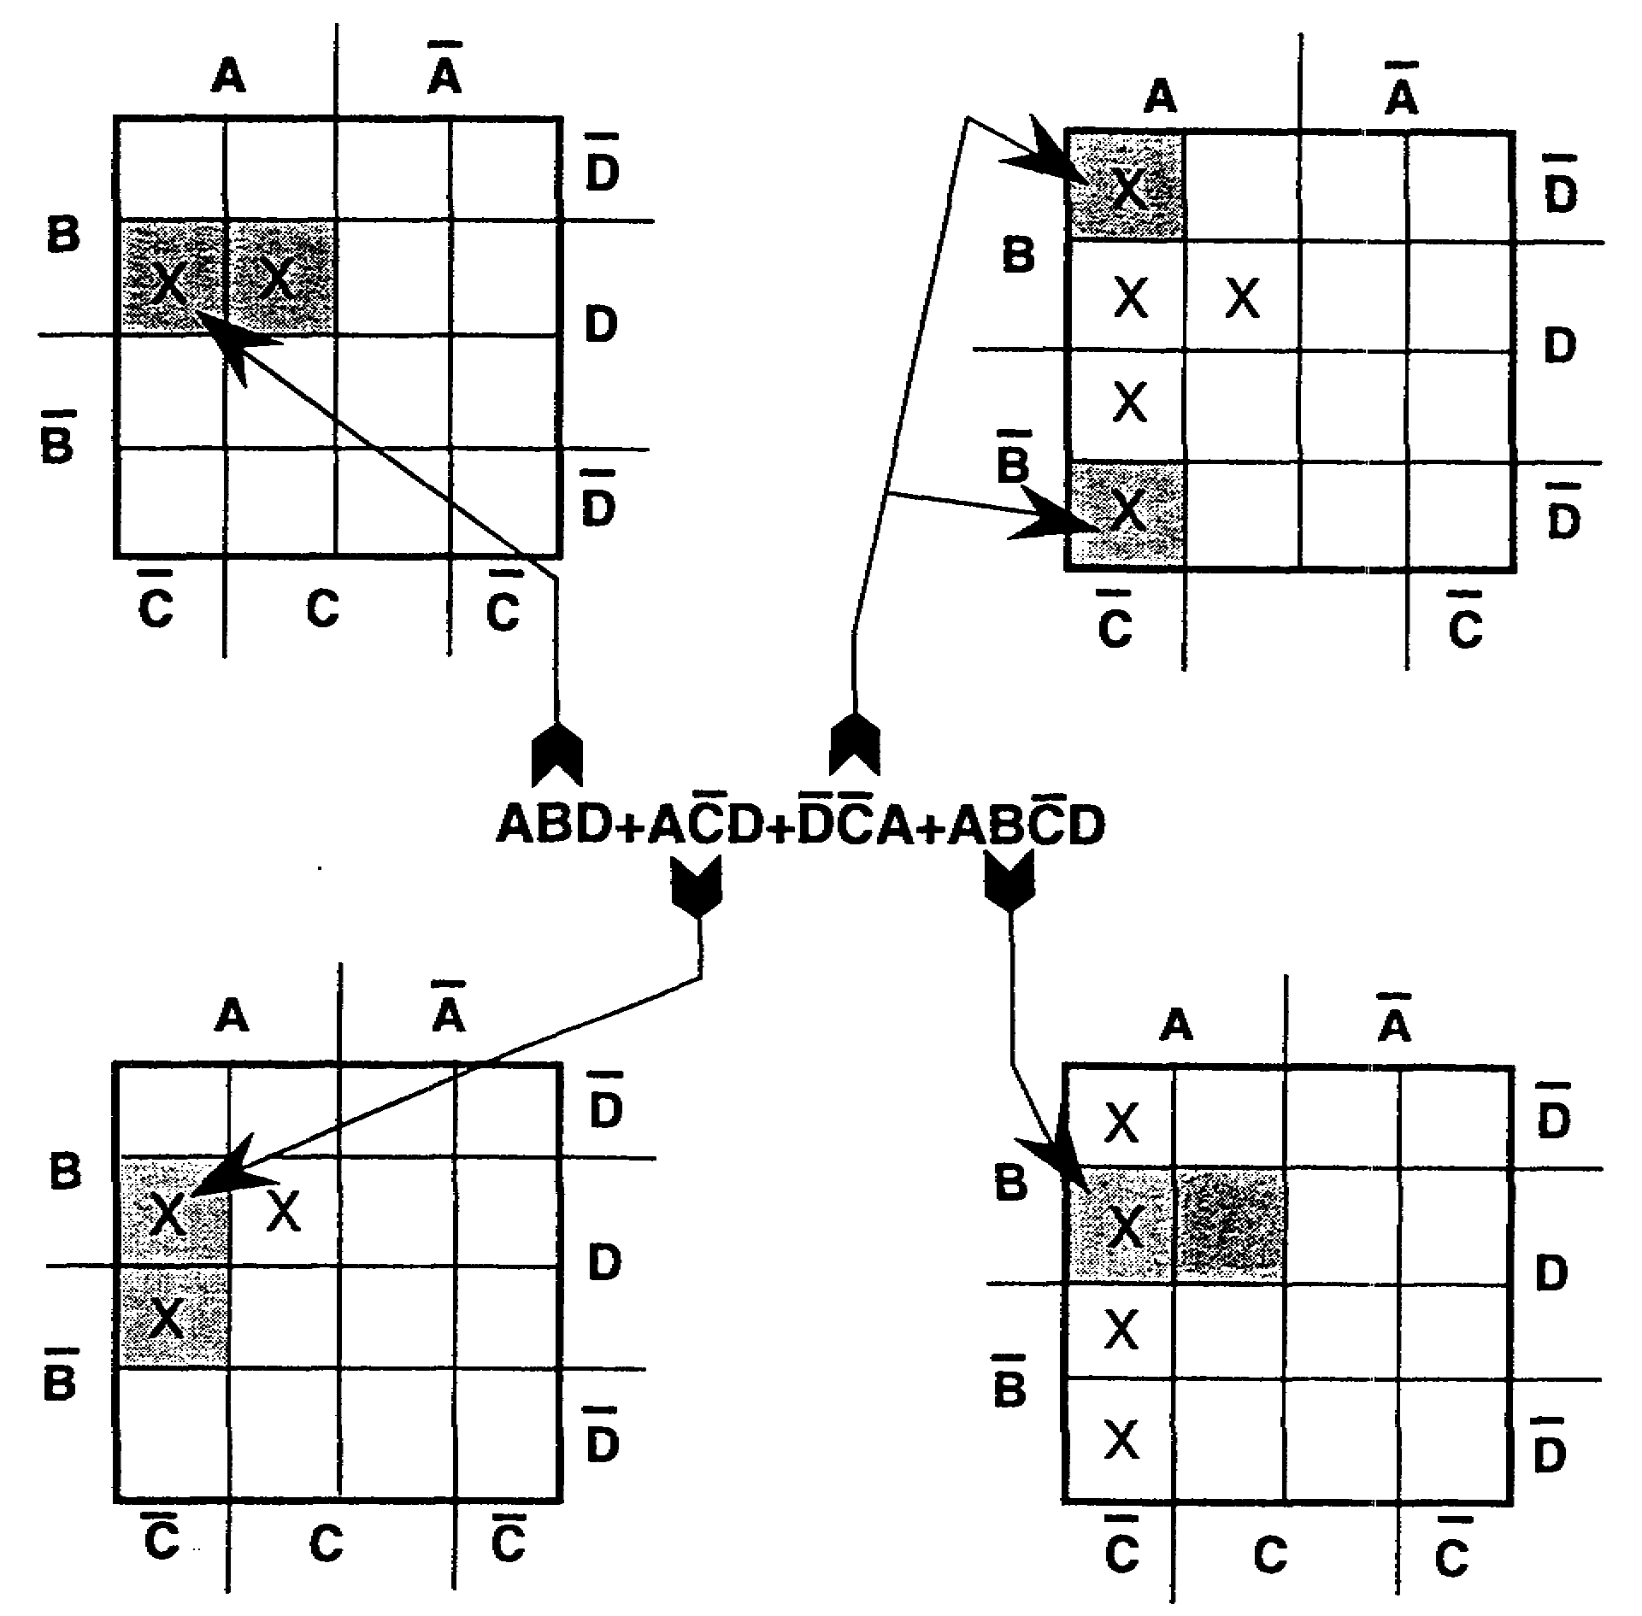

The preceding example was plotted only one term at a time, and each term was plotted in succession until all terms were plotted. The completed plot is shown below.
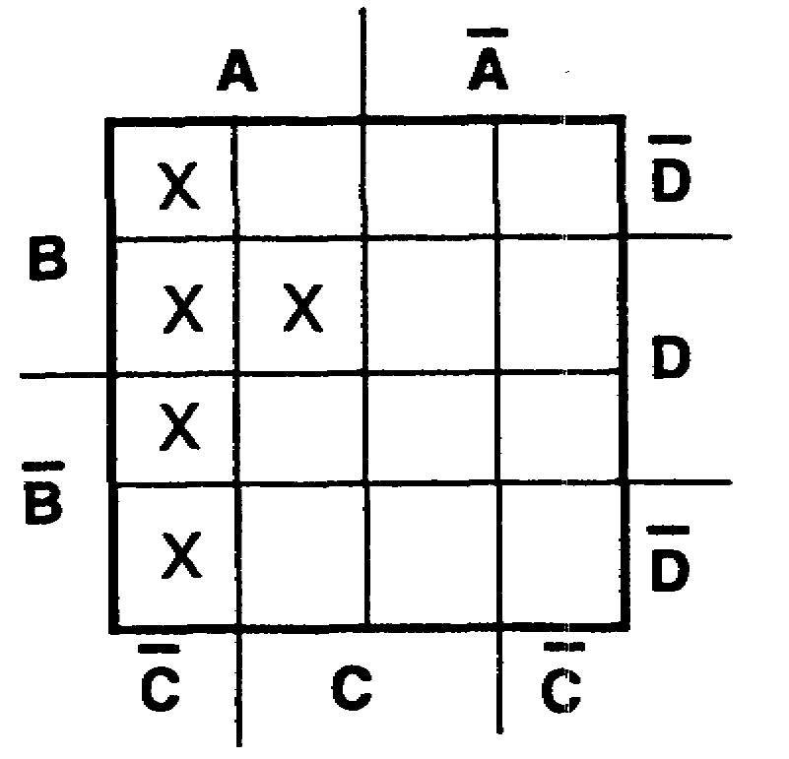

IT0345 1-58

90. (Continued)
The final step is to extract the simplified expression from the plotted Veitch diagram. Look for patterns of eight, four, two, or one plotted square, in that order.

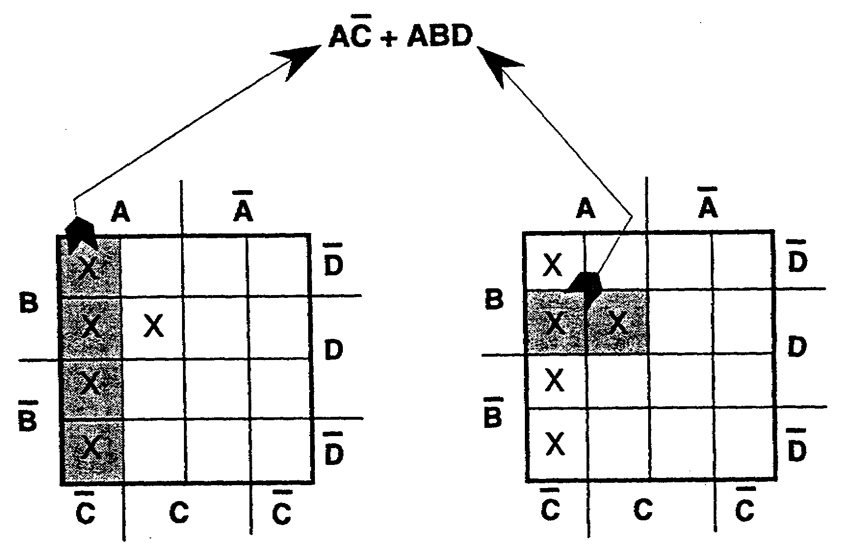

The simplified expression is AC+ABD.

1-59 IT0345

90. (Continued)
Convert the following four-variable expression to minterm form and simplify, using the Veitch-diagram method.
RS + RSTV + RSTV + S(TV +TV) + RV + RS + RSTV

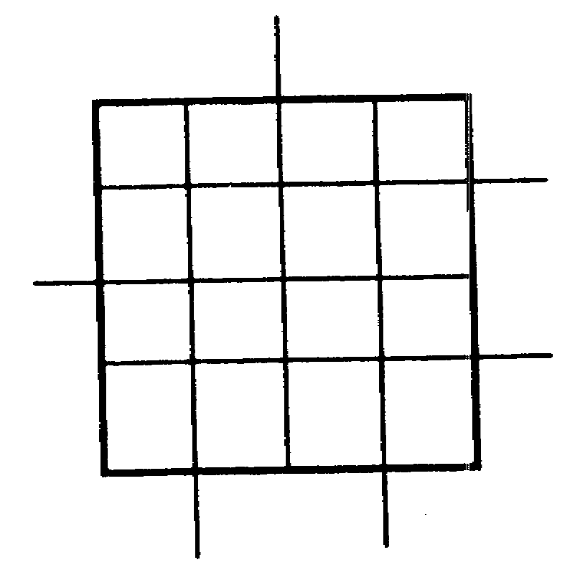

IT0345 1-60

R+S+V
Solutions on
page 1-69.

You have completed this program. Review the objectives on page 1-34. If you do not completely understand an objective, turn to the frame/s indicated by the number/s in parentheses.

1-61 IT0345

SOLUTIONS TO FRAME 73

a.
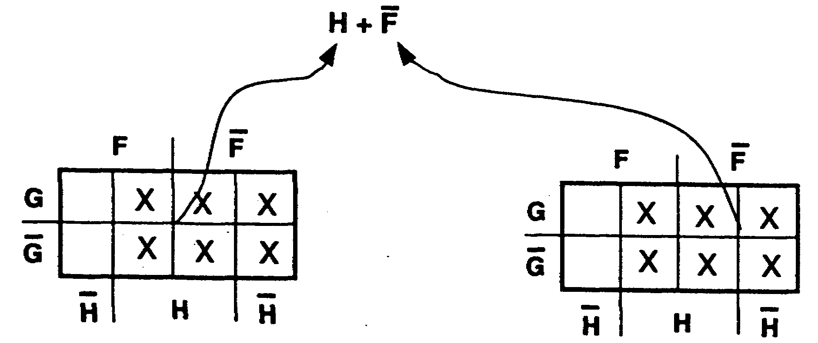

b.

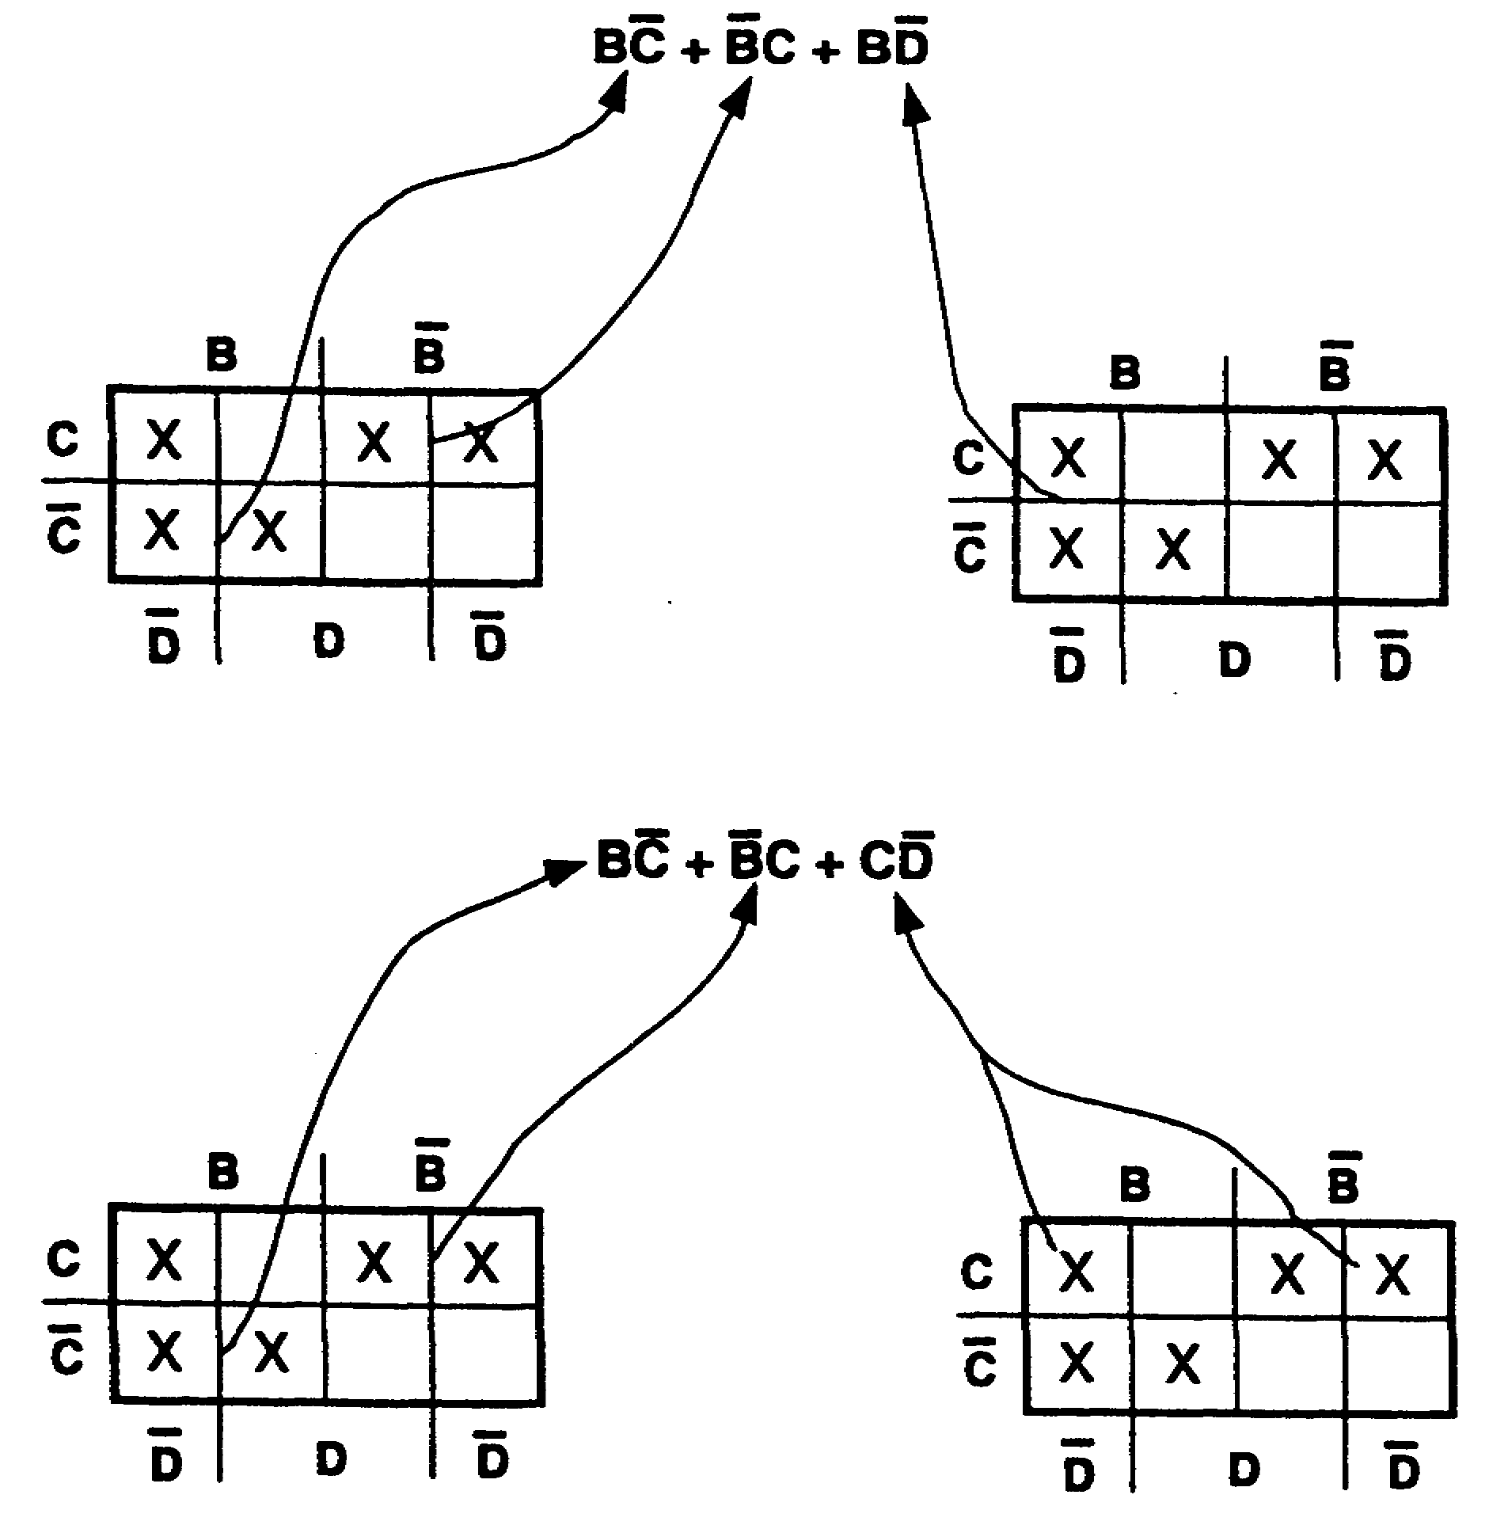

IT0345 1-62

SOLUTIONS TO FRAME 74

a. C (AB + AB) + ABC + A (BC + CA)

Distributive Distributive

CAB + CAB + ABC + ABC + ACA

Commutative Complementary

ABC + ABC + ABC + ABC + O C

UNION

ABC + ABC + ABC + ABC + O

Two groups of two squares plus one
separate square

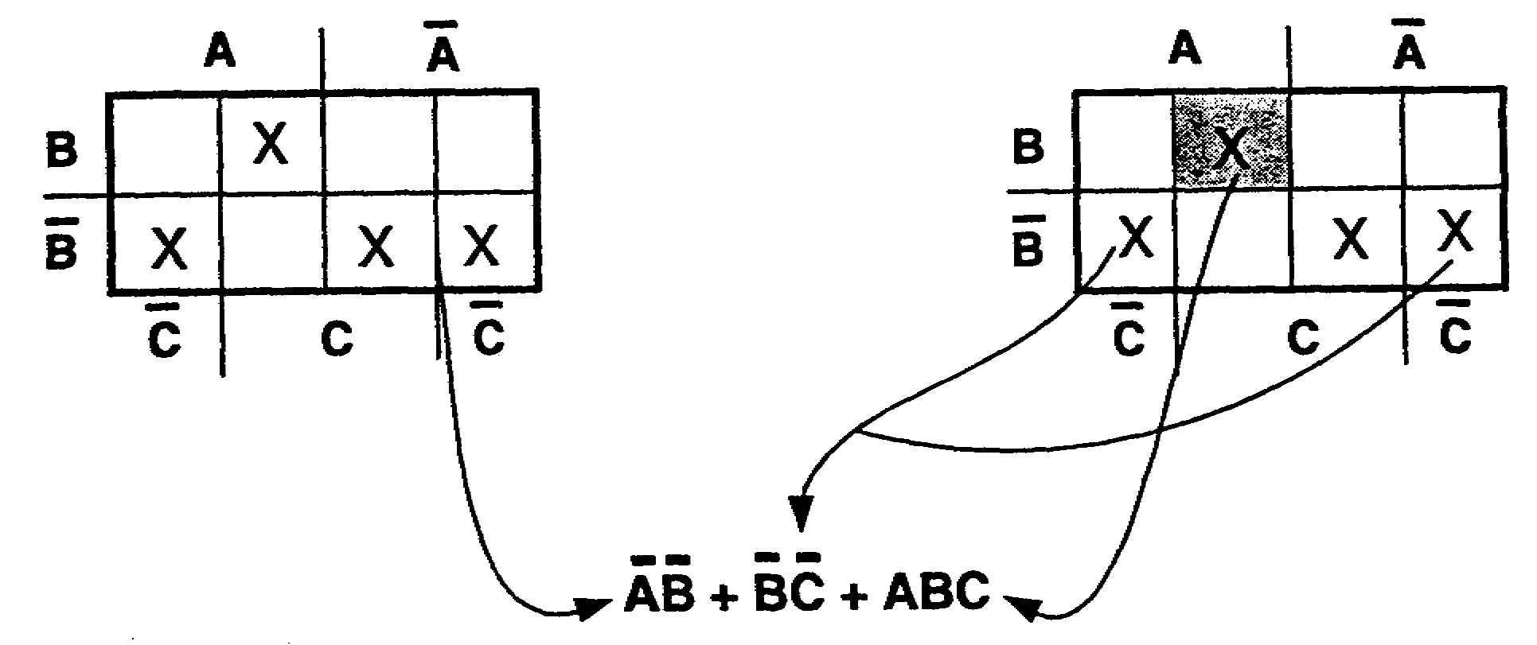

IT0345 1-63

SOLUTIONS TO FRAME 74 (Continued)

b. D + E + F + D(EF + EF) + DEF + +E (DF + DF)

De Morgan's Distributive Distributive
theorem

DEF + DEF + DEF + DEF+ EDF + EDF

Double Commutative
negative

DEF + DEF + DEF + DEF + DEF + DEF

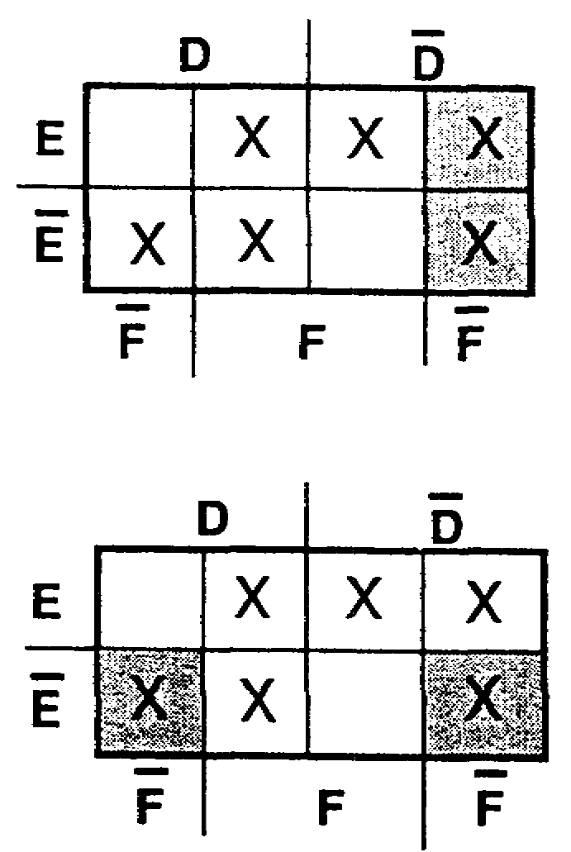

Three groups of two squares

DE + EF + DF

or

Three groups of two squares

EF+ DF + DE

IT0345 1-64

SOLUTIONS TO FRAME 86.

a.

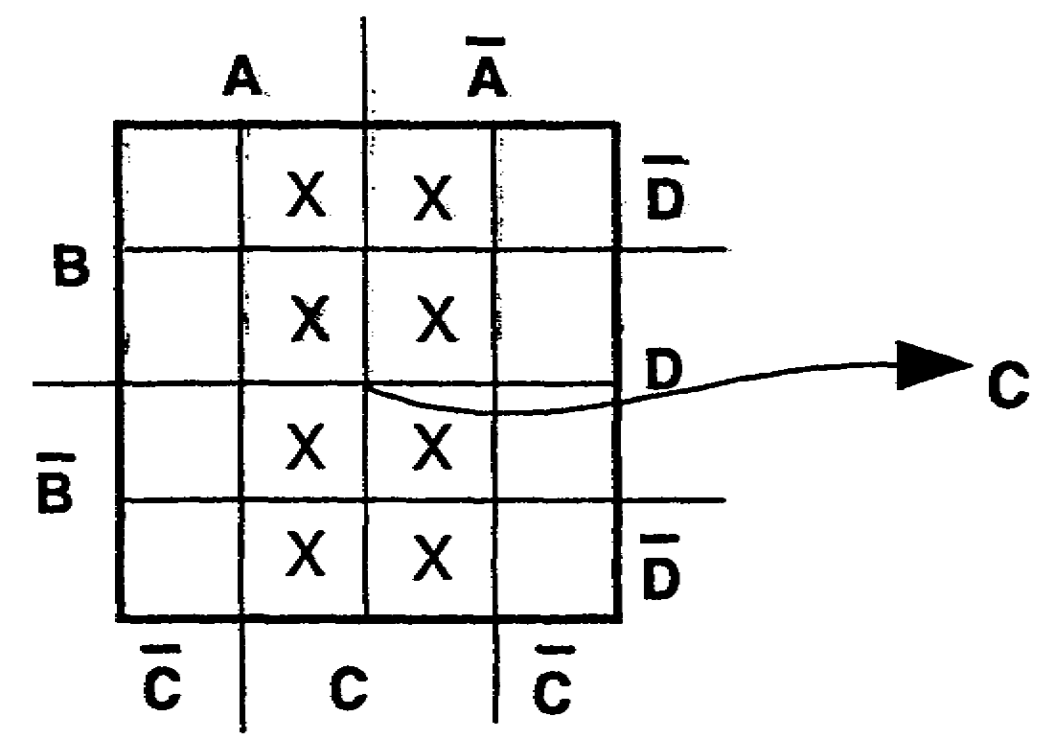

b.

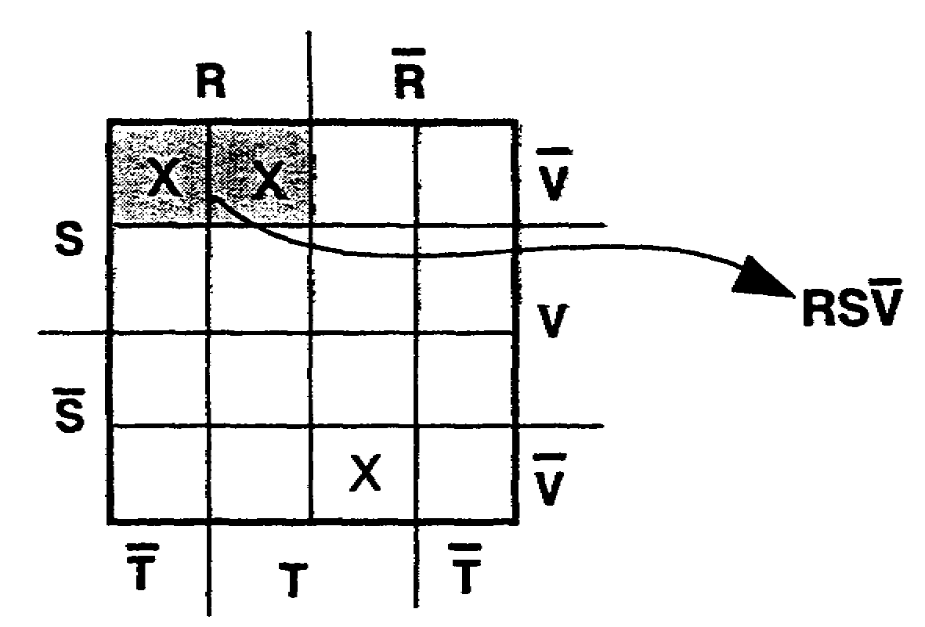

c.
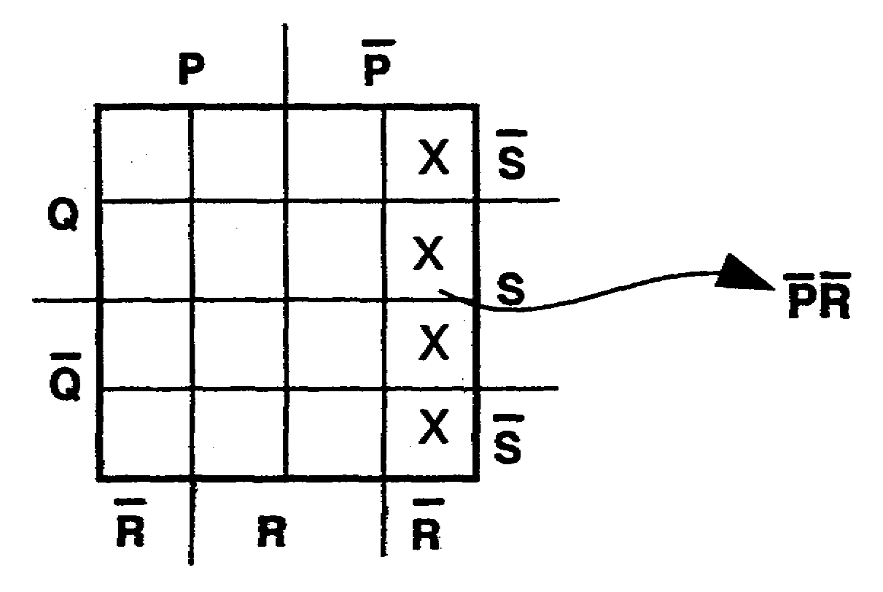

1-65 IT0345

SOLUTIONS TO FRAME 86 (Continued)

d.

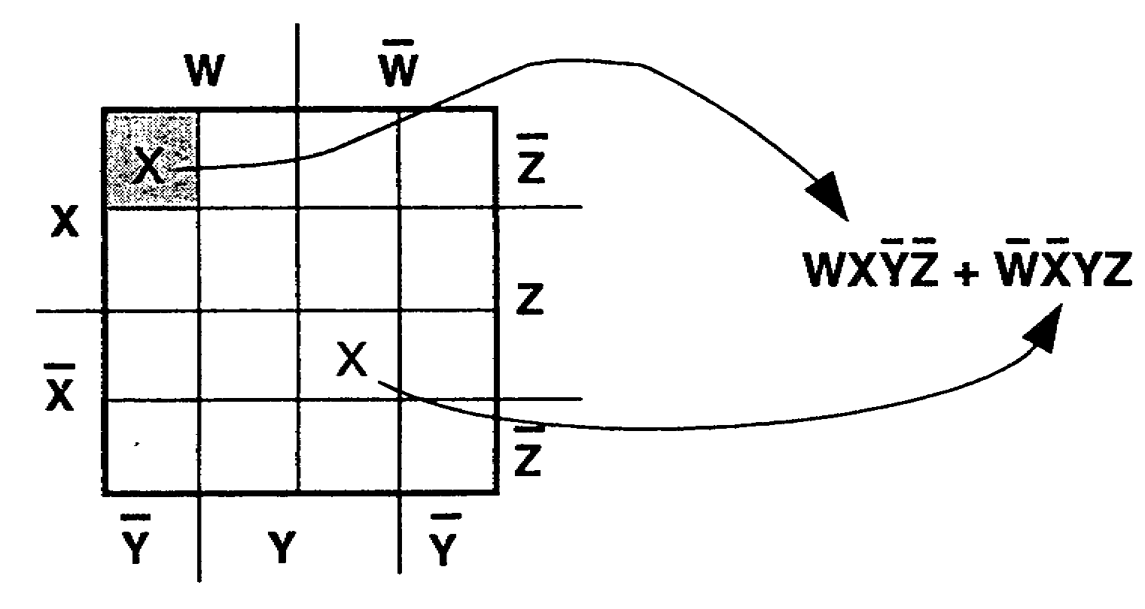

e.
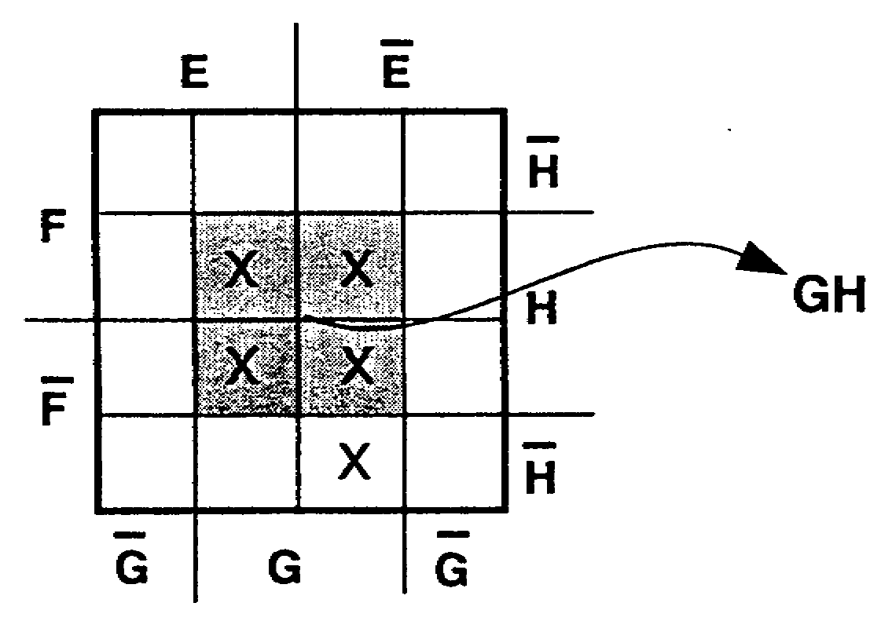

f.

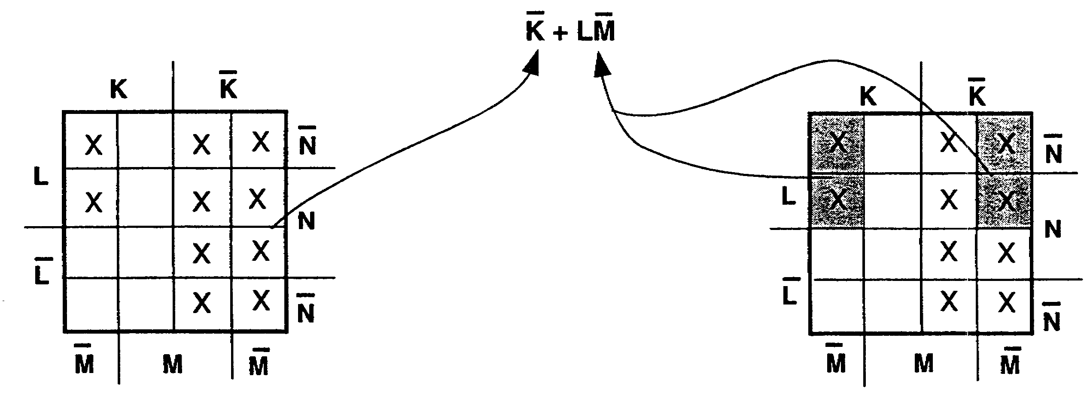

IT0345 1-66

SOLUTIONS TO FRAME 87.

a.

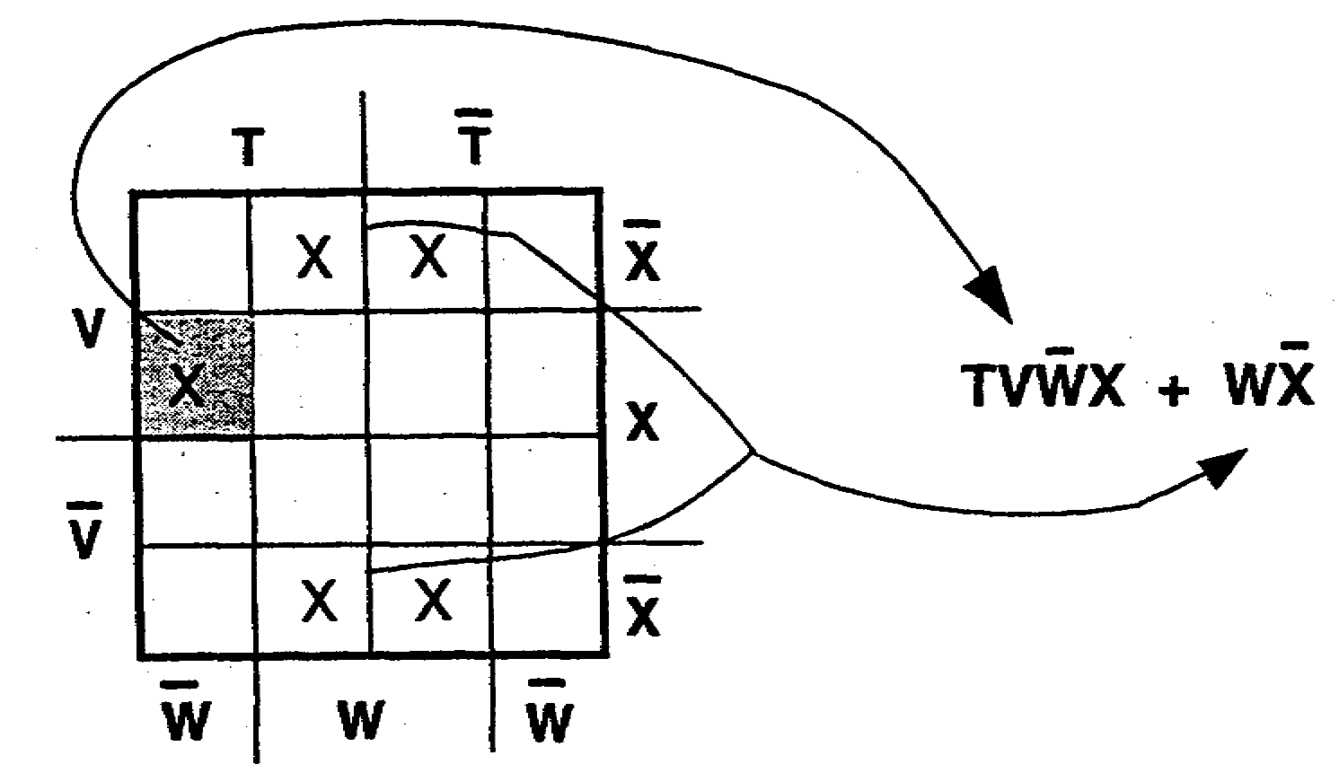

b.

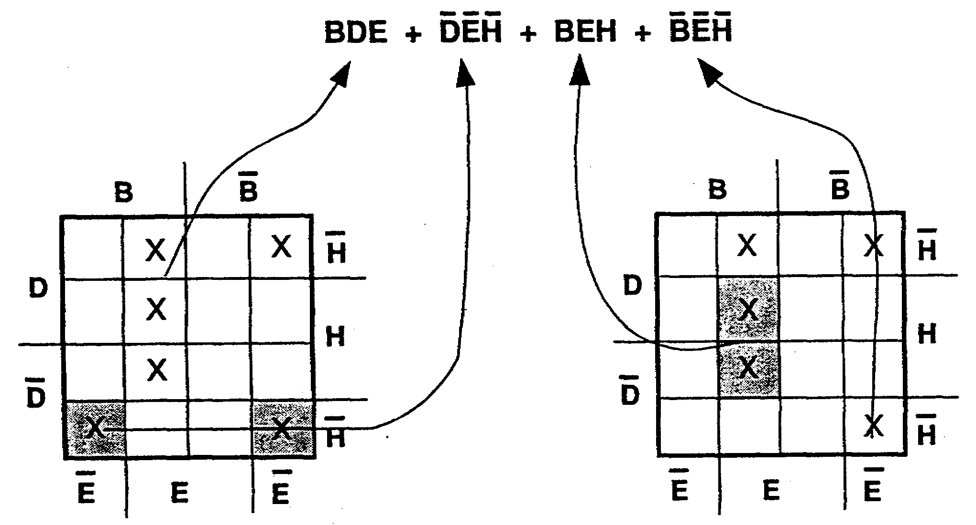

1-67 IT0345

SOLUTIONS TO FRAME 88.

a.

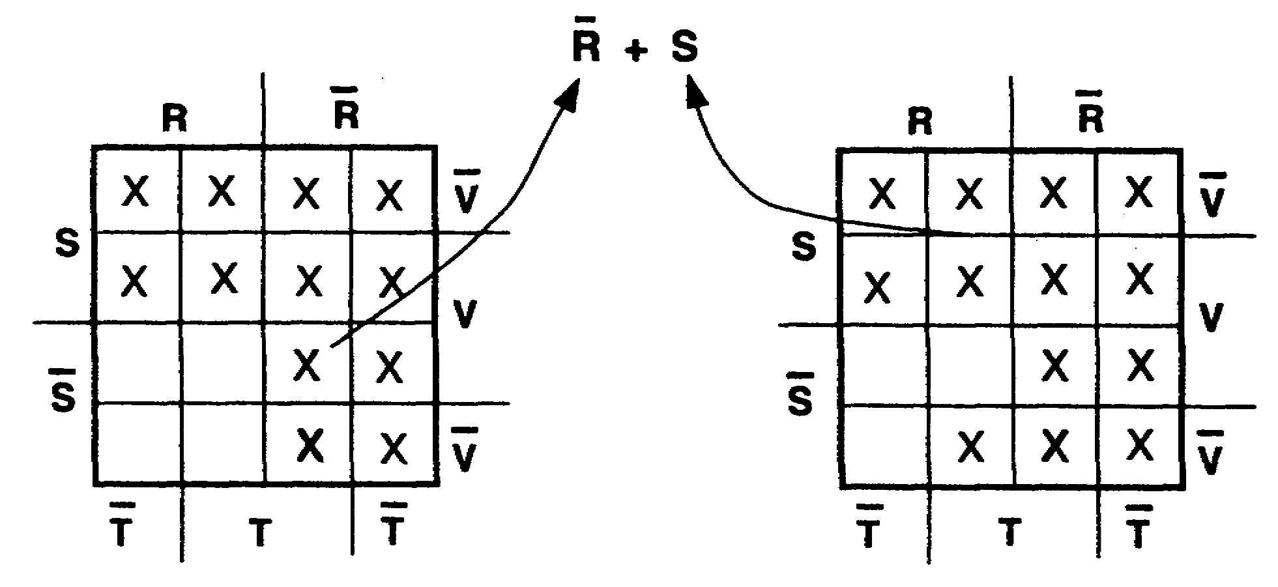

b.

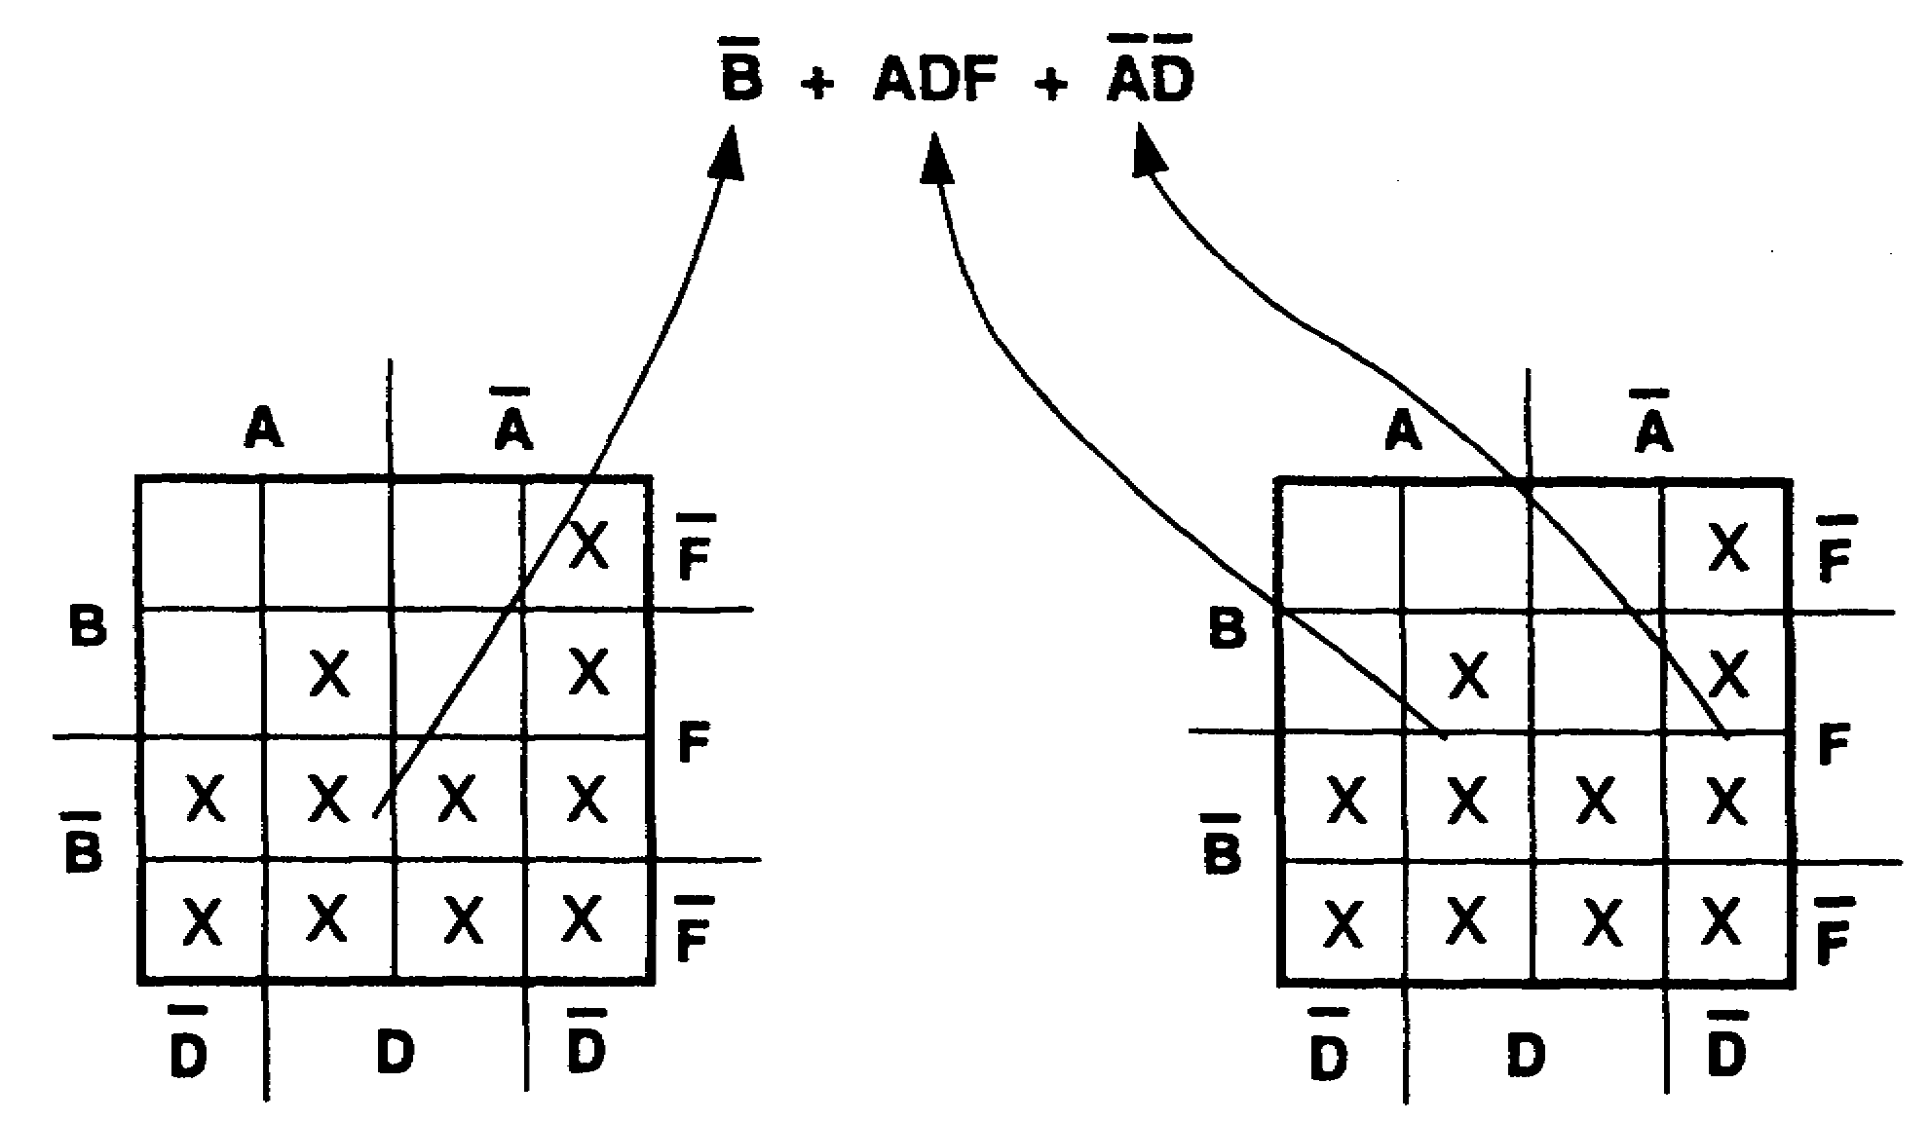

IT0345 1-68

SOLUTION TO FRAME 90.

RS + RSTV + RSTV + S(TV + TV) + RV + RS + RSTV

Double Distributive
negative

RS + RSTV + RSTV + STV + STV + RV + RS + RSTV

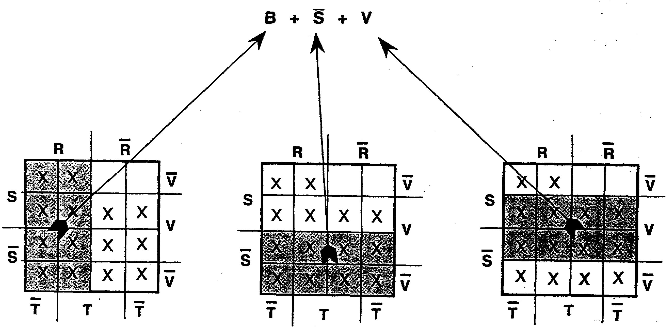

Simplified expression = R + S + V

1-69 IT0345

BASIC LAWS AND COMMON IDENTITIES OF BOOLEAN ALGEBRA

1. IDENTITY: A = A A = A

2. COMMUTATIVE: A B = B A A + B = B + A

3. ASSOCIATIVE: A (BC) =A B C
A +( B + C) = A + B + C

4. IDEMPOTENT: A A = A A + A = A

5. DOUBLE A = A
NEGATIVE

6. COMPLEMENTARY: A A = 0 A + A = 1

7. INTERSECTION: A • 1 = A A • 0 = 0

8. UNION: A + 1 = 1 A + O = A

9. DE MORGAN'S A B = A + B A + B = A B
THEOREM

10. DISTRIBUTIVE: A (B + C ) = A B + A C
A + (B C) = (A + B)(A + C)

11. ABSORPTION: A (A + B) = A A + (A B ) = A

12. COMMON A (A + B) = A B A + AB = A + B
IDENTITIES:
A + A B = A + B A + A B = A + B

13. DEFINITIONS: 0 = 1 1 = 0

MINTERM: Boolean product of a number of variables (no OR, all variables included).

MINTERM-TYPE: A minterm with one or more variables missing.

MINTERM FORM: Composed entirely of minterms and minterm-type terms connected with ORs, but no parentheses or vincula extended over more than one variable or more than one vinculum over a variable.

IT0345 1-70

